DDM Consulting
22357 Columbia Street
Dearborn, MI 48124-3431
313-277-5095
pvs6@cornell.edu

12 June 2017 VIA FEDEX Ground 1283181 – 00005081

President Donald J. Trump
The White House
1600 Pennsylvania Ave NW
Washington, DC 20500
202-456-1111

Subject: Withdrawal from the Paris Climate Accord (Congratulations)

Dear Mr. President:

Thank you for keeping your promise to withdraw the United States from the United Nations Framework Convention on Climate Change (UNFCCC), as specified by the Paris Climate Accord. You have made a brave, correct choice.

With the issue of integrity as central, I share an excerpt from a recent Washington Post (WP) article:

“The Arctic Ocean is warming up, icebergs are growing scarcer and in some places the seals are finding the water too hot, according to a report to the Commerce Department yesterday from
Consul Ifft, at Bergen, Norway.

Reports from fishermen, seal hunters and explorers, he declared, all point to a radical change in climate conditions and hitherto unheard-of temperatures in the Arctic zone. Exploration expeditions report that scarcely any ice has been met with as far north as 81 degrees 29 minutes. Soundings to a depth of 3,100 meters showed the gulf stream still very warm.

Great masses of ice have been replaced by moraines of earth and stones, the report continued, while at many points well known glaciers have entirely disappeared. Very few seals and no white fish are found in the eastern Arctic, while vast shoals of herring and smelts, which have never before ventured so far north, are being encountered in the old seal fishing grounds.”

The basis of this WP article was a report forwarded to the United States Department of State . . . but note . . . neither the basis or the article mentions carbon dioxide.

But let me apologize, my use of the phrase ‘recent’ is misleading . . . as is every damn thing we hear from the NGO news media . . . especially when they are regurgitating rants from the so-called climate scientists . . . or Big Academia, from whom many least expect a lack of integrity.

The overleaf is the original source for the above WP article . . . entitled ‘The Changing Artic’ . . .
it is from the Monthly Weather Review of November 1922 !

12 June 2017 President Donald J. Trump
Page 2 of 25

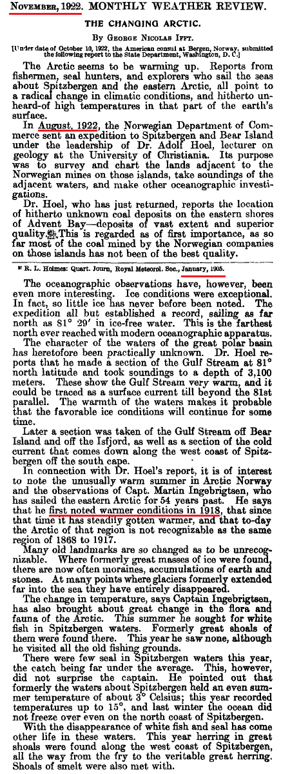

At the time of this publication, the “Father of Global Warming” had not yet been born . . .
12 June 2017 President Donald J. Trump
Page 3 of 25

The Climate Change Imbroglio: An Open Denunciation of Integrity by Big Academia

The archaic definition of imbroglio is “a confused heap.” It is an accurate descriptor of the current state of so-called climate change science.

This imbroglio not only relates to the NGO news media, but to their condominium with Big Academia.

We quote the “Father of Anthropogenic Global Warming” (AGW), Stanford University Professor Stephen Schneider :

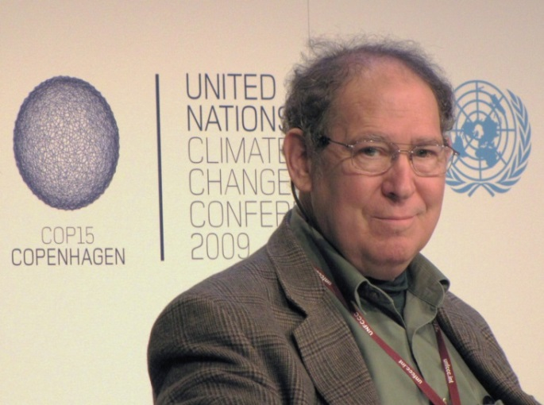

“ On the one hand, as scientists we are ethically bound to the scientific method. On the other hand, we are not just scientists but human beings as well.

To do that we need to get some broad based support, to capture the public’s imagination. That, of course, means getting loads of media coverage. So we have to offer up scary scenarios, make simplified, dramatic statements, and make little mention of any doubts we might have.

Each of us has to decide what the right balance is between being effective and being honest.”

But the open denunciation of (the strict requirement for) integrity by Big Academia is far more subtle, and esoteric, than that demonstrated by Professor Schneider . . . the esoterica involves a simple question that these so-called climate scientists refuse to answer.
12 June 2017 President Donald J. Trump
Page 4 of 25

The Climate Change Imbroglio: Big Academia versus a Simple Question

Please note that I have copied the Ivy League, including my alma mater Cornell University. Not millions, but billions of taxpayer dollars pour into these ‘institutions of higher learning’ under the guise of climate change research, in response to their latest fund-raising term “sustainability.”

The Cornell home page (http://www.cornell.edu/ ) always emphasizes the following section:

Thee fundamental underpinning of the Cornell Center for Sustainability involves carbon dioxide. The climate change imbroglio involves a promotion that is never truthfully quantified, but is forcefully declared as intrinsic to “what we know about climate change” . . . Their central thesis:

Atmospheric carbon dioxide is positively correlated to global temperatures and, most emphatically, the CO2 that is attributable to human activity is thee primary cause of global warming; now re-marketed as “climate change.”

Whether visiting the Center for Sustainability, or Al Gore’s mansions, or the UNFCCC in Paris, the above declaration is deafening. They also claim that this rhetoric enjoys “the consensus of 97 per cent of scientists worldwide.” The latter is a lie.

For example, after our withdrawal from the Paris Accord, California Governor Jerry Brown reiterated this standard “carbon” rant:

“ Well immediate reaction is this is a crazy decision. It is against the facts. It is against science. It is against reality itself. We know we have to decarbonize our future. If we don’t, it is a horror. People will die. Habitat will be destroyed. Seas will rise. Insects will spread in areas they never have before. This is not a game. It is not politics to talk to your base. It is humanity and whether it makes it through the 21st century. California will stay the course.”

We “know” no such thing. In summary, the “consensus” has forcefully and loudly declared the following, and done so for decades :

- Carbon dioxide drives global climate, and is positively correlated to warming.

- Incremental “carbon” from human activity is THEE cause of recent global warming,
with other climate inputs being uncorrelated or of minor import.
12 June 2017 President Donald J. Trump
Page 5 of 25

The Climate Change Imbroglio: Big Academia versus a Simple Question - con’t

Perspective is needed before we get to my ‘Simple Question.’ The following is from the very good Learning Liftoff website. This screen shows that grammar school children can easily learn and calculate a statistical value called correlation coefficient:

I was taught the basic arithmetic concept of correlation in 8th grade by Mr. Robert Edebohls, my Junior High School math teacher at Washingtonville Central High School, in Washingtonville, New York.

12 June 2017 President Donald J. Trump
Page 6 of 25

The Climate Change Imbroglio: Big Academia versus a Simple Question - con’t

For decades the United Nations Intergovernmental Panel on Climate Change (IPCC) refuses to answer my Simple Question:

“ What is the correlation value, and the R-squared value, between atmospheric carbon dioxide in PPM and global temperatures;
please specify the time period for the values you offer? ”

The IPCC, in their never-ending parade of “assessment reports” (AR-1, AR-2, AR-3, AR-4 and AR-5), refuses to state an R-Squared value, and they only insinuate correlation. AR-5 merely states:

"It is extremely likely that more than half of the observed increase in global average surface temperature from 1951 to 2010 was caused by the anthropogenic increase in greenhouse gas concentrations . . .”

Their phrase ‘extremely likely’ is feel-goodery, and has no connection to the rigors of science. We must again emphasize, the crux of their imbroglio is that atmospheric CO2, especially from human activity, drives global climate and is positively correlated to recent alleged “global warming.”

In late 2009, my suspicions about Big Academia in these matter were exposed, worldwide, by a travesty known as ClimateGate. Big Academia wants us to forget about ClimateGate. Not a chance.

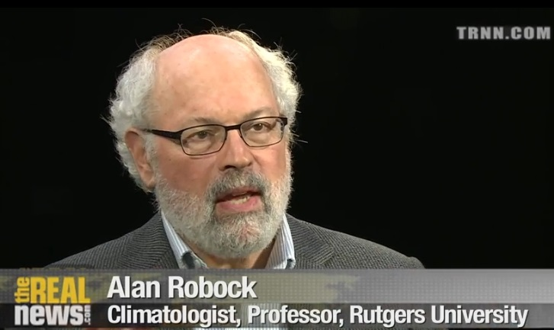
In the context of ClimateGate
I interviewed experts such as Professor Alan Robock of Rutgers University, former researcher for the National Oceanic and Atmospheric Administration (NOAA), and “contributor” to the IPCC.

When I asked him my Simple Question, he stated:

“ That question is too simplistic. The correlation value is high but correlation does not mean cause and effect.”

Here we have a strident advocate of the Paris Accord declaring that the crux of that Accord is “too simplistic” ?! Robock was very polite, and very generous with his time. But I had asked this climatologist for a number, not an unsubstantiated subjective personal assessment.

Even if you presume that Professor Robock had a basis for his claim that “the correlation value is high,” we are compelled by the second part of his, albeit, unsolicited response.

12 June 2017 President Donald J. Trump
Page 7 of 25

The Climate Change Imbroglio: Big Academia versus a Simple Question - con’t

(A quick tutorial on correlation.)

Professor Robock’s statement , “correlation does not mean cause and effect.” might seem to rebut the argument implied by my Simple Question. It is does not, it supports it !

We examine an example wherein he is correct; there are many. First, we measure and tabulate the increase in a boy’s height over a ten year period from age 1 to age 11. Then, for sake of argument, we assume this ten year period also includes a yearly rise in global temperatures. We then measure and tabulate the latter. We now have two data sets.

Now, we go to the grammar school website (Page 5), input these two data sets, and calculate the correlation value; a number that ranges from negative one to positive one. Because the boy’s height and the global temperatures are both increasing, the calculated R value would be “high” and positive. This would seem to suggest a ‘cause and effect’ connection.

Of course, it is absurd to suggest that this example has merit; there in no cause-effect connection between those data sets; here Robock is correct: “correlation does not mean cause and effect.”

But let us now examine the opposite; where the two data sets are already forcefully declared as being correlated, wherein the merit is so high that it enjoys a “97% consensus.” After all, the very crux of the Paris Accord asserts:

Atmospheric carbon dioxide is positively correlated to global temperatures and, most emphatically, the CO2 that is attributable to human activity is thee primary cause of global warming; now re-marketed as “climate change.”

There is nothing “too simplistic” in their marketing onslaughts directed at the naivety of humanity.

In terms of the Scientific Method, when an effect has a theoretical cause, but the correlation value is very small (positive, negative or zero), then the theory is discarded as false by scientists with integrity. The Paris Accord is based on the exact opposite:

So . . . If their ‘CO2 equals global warming’ connection is true, and therefore correlated, then climate scientists should be specifying/quantifying and proclaiming with unbridled pride their “high” R value . . . from every snow-covered mountain on Planet Earth!

Instead, they refuse to answer my Simple Question.

Al Gore also has no problem asserting the ‘CO2 equals global warming’ connection. In his discredited film, ‘An Inconvenient Truth,’ Gore stands before tabulated graphs, which he alleges depicts his fundamental claim ( these did not ); quote:

“ The relationship is actually very complicated, but there is one relationship that is far more powerful than all the others, and it is this, when there is more carbon dioxide the temperature gets warmer, because it traps more heat from the sun inside. ”

Gore singles-out the crux of the Paris Accord: CO2 is the culprit that drives global warming, as “more powerful than all the others.” That is, he asserts that CO2 is positively correlated to temperatures.
12 June 2017 President Donald J. Trump
Page 8 of 25

The Climate Change Imbroglio: Big Academia versus a Simple Question - con’t

First, they forcefully assert that the ‘CO2 equals global warming’ connection is absolutely true; that increases in CO2 and alleged increases in global temperatures are positively correlated.

But then my Simple Question is derided as “too simplistic.”

On the other hand, simplicity was deemed to be of great utility to the “Father of Global Warming,” Stanford University Professor Schneider, who demanded of his climate colleagues :

“ So we have to offer up scary scenarios, make simplified, dramatic statements, and make little mention of any doubts we might have.”

There are many reasons why Big Academia refuses to answer my Simple Question. Some of these reasons involve the issue of integrity.

In 2009, when the true levels of integrity of portions of Big Academia were exposed by ClimateGate, I interviewed the director at the Cornell Center for Sustainability, Professor Frank DiSalvo. First, I asked him to respond to the documented fraud and outright criminality of the climate scientists as exposed by ClimateGate :

“There’s no doubt people know about it (ClimateGate), and are chagrined by it.”

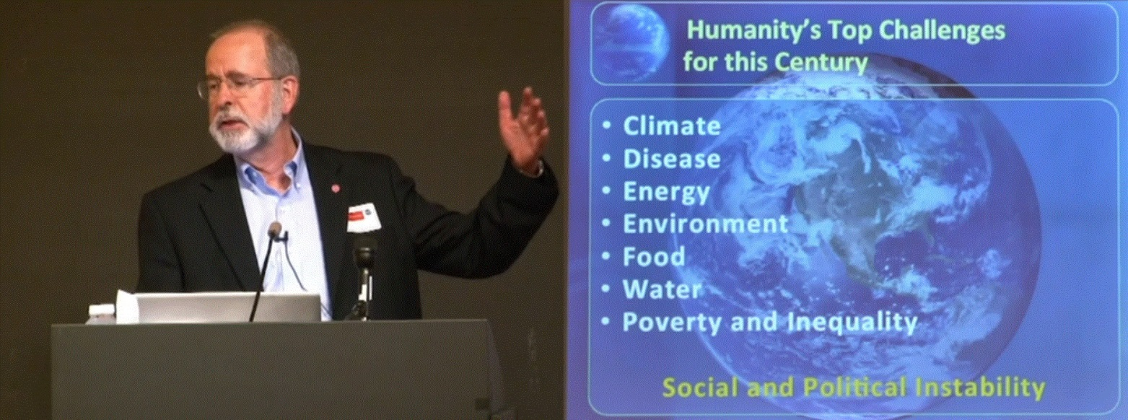

But note the irony . . . according to Cornell University, “Climate” is the priority facing humanity, not ethics or integrity. To further his chagrin I then posed my Simple Question to Professor DiSalvo:

“ What is the correlation value, and the R-squared value, between atmospheric carbon dioxide in PPM and global temperatures;
please specify the time period for the values you offer? ”

12 June 2017 President Donald J. Trump
Page 9 of 25

The Climate Change Imbroglio: Big Academia versus a Simple Question - con’t

Returning to Page 4 above, thee fundamental underpinning of the Cornell Center for Sustainability involves the decades-old assertion that there is a positive correlation between increases CO2 and the alleged increases in global temperatures.

In response to my request for an answer to my Simple Question, DiSalvo asserted the following:

“ There’s no simple one (answer) because so many other factors come in to it. That’s why it’s so difficult.

So, for example, if CO2 does start to cause atmospheric warming, that also causes increases of water vapor going into the atmosphere, which does one of two things, or it does both things. And it’s a question of which predominates. Water vapor itself is a greenhouse gas, in fact it’s the most predominant greenhouse gas in the atmosphere. So, that effect would tend to warm up the atmospheric even more. On the other hand if the water vapor condenses and forms clouds, then you ask what kind of clouds; certain clouds are very reflecting, so that they reflect the sunlight back out into space and that leads to cooling. Other clouds turn out to be absorbing, and they actually will heat the atmosphere; depends on their altitude and their shape, and what’s in the cloud. And so, trying to figure out; that’s just one example, there’s a whole bunch of other things that determine what happens, like ocean currents, and all, and all of these things have to be put it. And they’re all coupled to each other.

So it’s like a giant machine with about, you know, thousands of wheels that are all connected to each other, and I’m going to wiggle one wheel, and ask what happens to the other thousand or how the other thousand respond to produce something on the other side; that’s a hard question. That’s a really tough job.

So, in general, what you can say, what climate scientists try to do, is they look at all the different pieces that they at least presently know about, and say if that one increases what does it do to; and climate change is a lot more than temperature. It has to do with precipitation; not so much global temperature as local temperature that’s important, some places in climate change will actually get colder because they get much cloudier in those places, so it’ll get colder. But then the Artic; in every model that I have looked at, and at least current data suggests the Artic is warming up a lot more than the rest of the planet.

So the questions you ask have to be a lot more detailed than just what’s happening to global temperature. ”

DiSalvo’s very first utterance provokes Page 5 above. We dissect his response since it too is another onslaught directed . . . this time . . . at the presumed naivety of the undersigned.

What follows demonstrates that my Simple Question is not “a really tough job.”

12 June 2017 President Donald J. Trump
Page 10 of 25

The Climate Change Imbroglio: Big Academia versus a Simple Question - con’t

Of the twenty-odd non-responses and non-answers that I have received to my Simple Question, from so-called climate scientists, DiSalvo’s delivery and tone was the most polite. But it was no more than a convoluted, pseudo-sophisticated diversion.

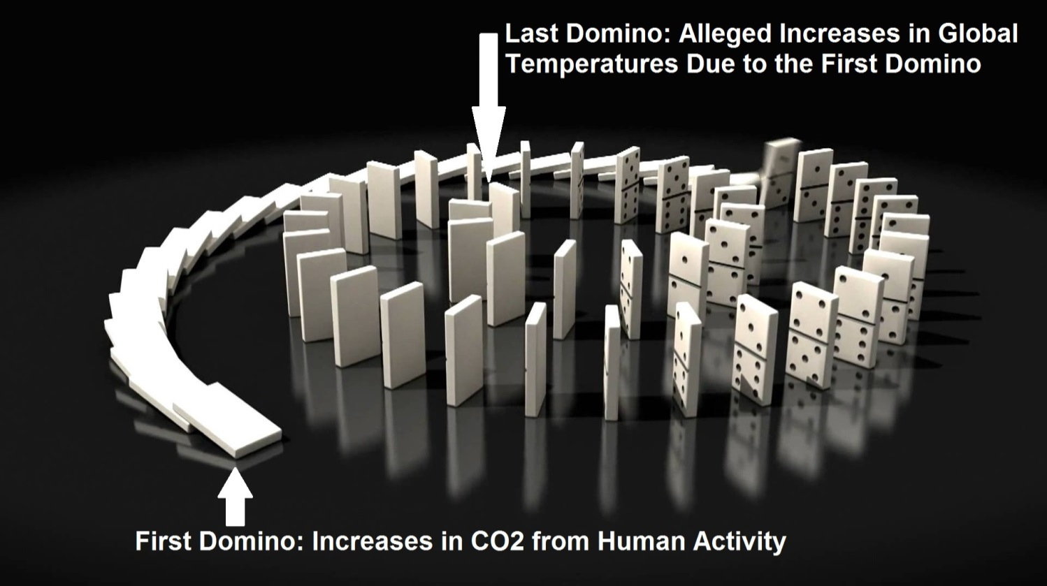

DiSalvo’s career is based on “settled science,” that the increase in CO2 from humans is positively correlated to alleged increases in global temperatures. My Simple Question should be welcomed.

It was in that context that I did not ask him for all the intermediate couplings and their individual correlation values. I asked for the correlation value between HIS first domino and HIS last domino (as depicted above). Consistent with the claim that ‘CO2 equals global warming’ :

- I did not ask DiSalvo for the correlation between CO2 and water vapor,
- I did not ask DiSalvo for the correlation between CO2 and clouds that reflect and cool,
- I did not ask DiSalvo for the correlation between CO2 and clouds that absorb and warm,
- I did not ask DiSalvo for the correlation between CO2 and shapes of clouds,
- I did not ask DiSalvo for the correlation between CO2 and what is inside clouds,
- I did not ask DiSalvo for the correlation between CO2 and ocean currents,
- I did not ask DiSalvo for the correlation between CO2 and “a whole bunch of other things”,
- I did not ask DiSalvo for the correlation between CO2 and wiggling wheels,
- I did not ask DiSalvo for the correlation between CO2 and “giant machines.”

DiSalvo’s response lacks professional integrity . . . With a Bachelor’s degree in physics from MIT, a PhD in Applied Physics from Stanford, DiSalvo is FULLY AWARE that the intermediate dominos do not, in any way, obviate an answer to my Simple Question.

His was a non-answer. Such is not the essence of what he conveys to students. And it is certainly not what he conveys to humanity when fundraising funds for “reduction of Cornell’s carbon footprint.”

12 June 2017 President Donald J. Trump
Page 11 of 25

The Climate Change Imbroglio: Big Academia versus a Simple Question - con’t

One might argue that all of this has changed, and the ‘CO2 equals global warming’ rant has been modified, or diminished as their PR and climate science priority. Not a chance!
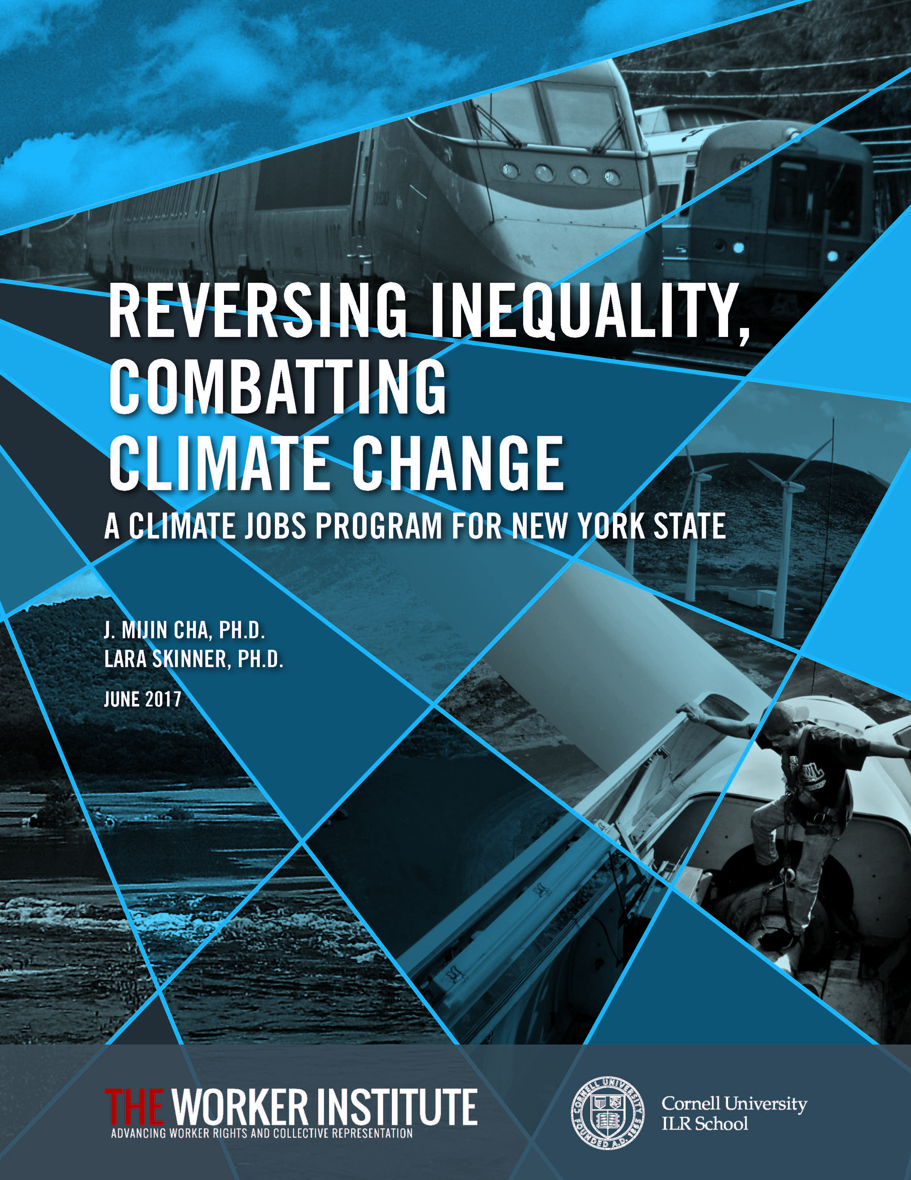
Just a few days ago, available directly from its home page, Cornell University published a taxpayer funded Malthusian ruse called:

REVERSING INEQUALITY, COMBATTING CLIMATE CHANGE : A Climate Jobs Program for New York State

Now, we have “climate jobs” ?!

But a direct question could be asked:

How many of the proposed “climate jobs” are oriented at quantities or factors other than
carbon dioxide?

To test for an answer, I analyzed this 68-page report, searching for the “many other factors.”

That is, I looked for those terms that are alleged to obviate an answer to my Simple Question. A tabulation of these is shown in the table below:

“Many Other Factors” Terms Usage in New York ‘Climate Jobs’ Report | Frequency in the New ‘Climate Jobs’ Report
water vapor | 0
clouds that reflect and cool | 0
clouds that absorb and warm | 0
shapes of clouds | 0
what is inside clouds | 0
ocean currents | 0
a whole bunch of other things | 0
wiggling wheels | 0
giant machines | 0
Memo: Carbon or Carbon Dioxide | 61

“ What is the correlation value, and the R-squared value, between
atmospheric carbon dioxide in PPM and global temperatures;
please specify the time period for the values you offer? ”
12 June 2017 President Donald J. Trump
Page 12 of 25

The Climate Change Imbroglio: Big Academia versus a Simple Question - CONCLUSION

Although unsolicited, DiSalvo also emphasizes, “Water vapor itself is a greenhouse gas, in fact it’s the most predominant greenhouse gas in the atmosphere.” Correct. But since it was irrelevant to my Simple Question, I did not ask him to assess the effects of the H2O emissions from nuclear power plants, such as Beaver Valley in Pennsylvania; a short drive from the Cornell University campus:

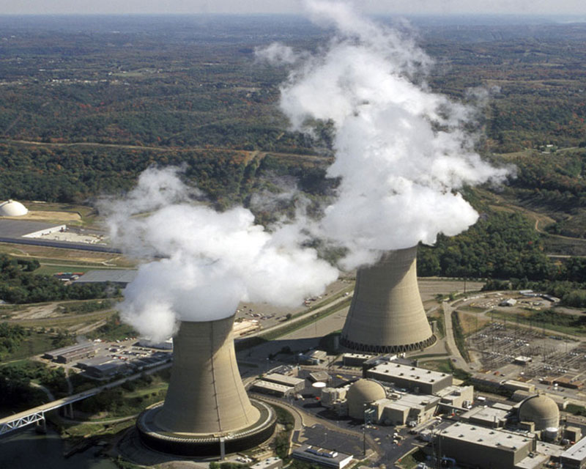

In his film ‘An Inconvenient Truth,’ Al Gore says that we have climate data covering “650,000 years.” There is so much data, an answer to my Simple Question can be calculated by grammar school students . . . or meteorologists . . . values that implicitly account for the intermediate dominos:

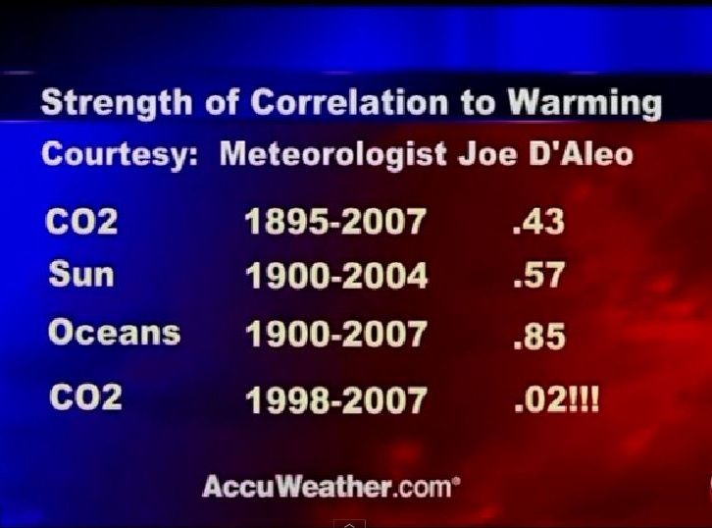

During the time that I was being rebuffed by Cornell University, Rutgers University, NASA, NOAA, various ClimateGaters, various AGW proponents, and the like, I spoke with retired meteorologist Mr. Craig James who had also calculated what are called conjoint values for similar time periods:

In James’ opinion, the solar-ocean conjoint calculated for similar periods is +0.88 !
12 June 2017 President Donald J. Trump
Page 13 of 25

The Climate Change Imbroglio : Their Unbridled Vileness

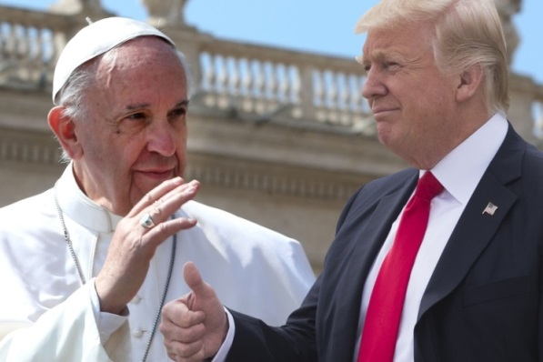
On May 24, 2017, Pope Francis handed you a signed copy of his 184-page ‘Encyclical Letter, Laudato Si` of the Holy Father Francis on Care for Our Common Home.’ The Washington Post declared that his letter:

“. . . called for a new partnership between science and religion to combat human-driven climate change.”

Upon reading this two-year-old tome, I noted he used the term carbon or carbon dioxide seven times.

So the pope also correlates the notion that carbon dioxide drives “climate change.”

But for sake of comparison, given the tacit approval of the papacy, let us assume a “partnership between science and religion” when enforcing a faith in the notion that ‘CO2 equals global warming.’

Picture the following . . . the otherwise faithful have gone astray; they do not practice upon the papal edicts of “human-driven climate change.” Hearing of their blasphemy, Pope Francis pronounces the following diatribe to all Christians, Catholics in particular (fictional) :

‘ I would like to say we're at a point where global warming is impossible to deny. Let's
just say that global warming deniers are now on a par with Resurrection Deniers,
though one denies the past and the other denies the present and future.’

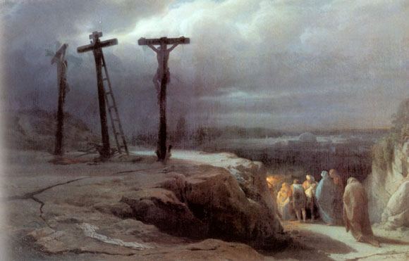

Pope Francis would never state anything so vile. And he certainly did nothing close in Laudato Si`. One can imagine the outrage!

But the Pope has failed to chastise the individuals that have already deployed the very same vileness; a vileness that is unprecedented in recent science . . . in fact, the above fiction is a paraphrasing of the next well-known quote.
12 June 2017 President Donald J. Trump
Page 14 of 25

The Climate Change Imbroglio : Their Unbridled Vileness
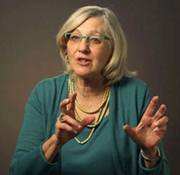
“I would like to say we're at a point where global warming is
impossible to deny. Let's just say that global warming deniers
are now on a par with Holocaust deniers, though one denies
the past and the other denies the present and future.”

Ellen Goodman of the Boston Globe.

- What follows is a small sampling of equivalent vileness:
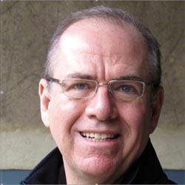
“ Currently, about 300 thousand people die every year from the
effects of climate change, with another 325 million seriously
affected, primarily because of reduced access to fresh and
safe drinking water. At its core, global warming denial is like
Holocaust denial, an assault on common decency. ”

Banker, David Federer.

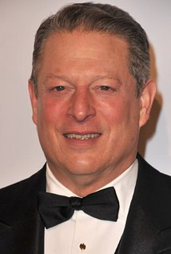
" Clouds of a different sort signal an environmental holocaust
without precedent. Once again, world leaders waffle, hoping
the danger will dissipate. Yet today the evidence is as clear
as the sounds of glass shattering in Berlin."

Filmmaker Al Gore.

" I wonder what sentences judges might hand down at future international criminal tribunals on those who will be partially
but directly responsible for millions of deaths from starvation,
famine and disease in decades ahead. I put this in a similar
moral category to Holocaust denial."

Mark Lynas, author of the book, The God Species: How the Planet Can Survive the Age of Humans.’

12 June 2017 President Donald J. Trump
Page 15 of 25

The Climate Change Imbroglio : Their Unbridled Vileness – con’t

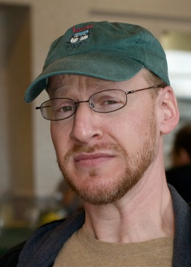
" A lot of them complain because they say the word denial puts
them in the same bin as holocaust deniers. That's too bad. But
the thing is, they do have something in common: a denial of
evidence and of scientific consensus. "

Phil Platt, Big Bang Theory astronomer.

" An Inconvenient Truth is so convincing that it makes
opposers of the argument as credible as Holocaust deniers. "

Jon Niccum, NGO news reporter.

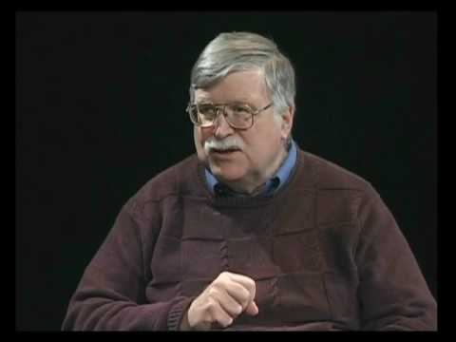
“Bluntly put, climate change deniers pose a
greater danger than the lingering industry that
denies the Holocaust.”

Joel Connelly, NGO News reporter

"Others working to derail this critical piece of legislation will
be seen as the Adolf Hitler’s of our day, contributing to a
holocaust vastly eclipsing the horrors of World War II."

Chad Kister, author of ‘How Global Warming is Destroying One
of the World's Largest Wilderness Areas’ (The Artic).

12 June 2017 President Donald J. Trump
Page 16 of 25

The Climate Change Imbroglio : Their Unbridled Vileness – con’t

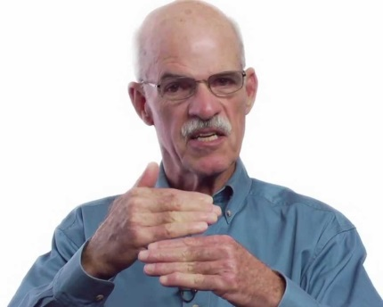
" Those who abjure global warming are not skeptics;
they are deniers. To call them skeptics is to debase
language as much as to call the Ku Klux Klan ‘prejudiced, Holocaust deniers ‘biased,’ or Flat-Earthers ‘mistaken.’ ”

James Powell, National Physical Science Consortium.

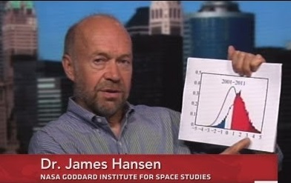
“ If we cannot stop the building of more coal-fired power plants, those coal trains will be death trains – no less gruesome than if they were boxcars headed to crematoria . . . ”

James Hansen, former member of the taxpayer funded vested interest group NASA.

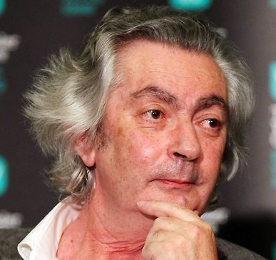

" Denialism, a concept that was first widely used,
as far as I know, for those who claimed that the
Holocaust was a fraud, is the concept I believe
we should use."

Professor Robert Manne of La Trobe University,
Melbourne, Australia

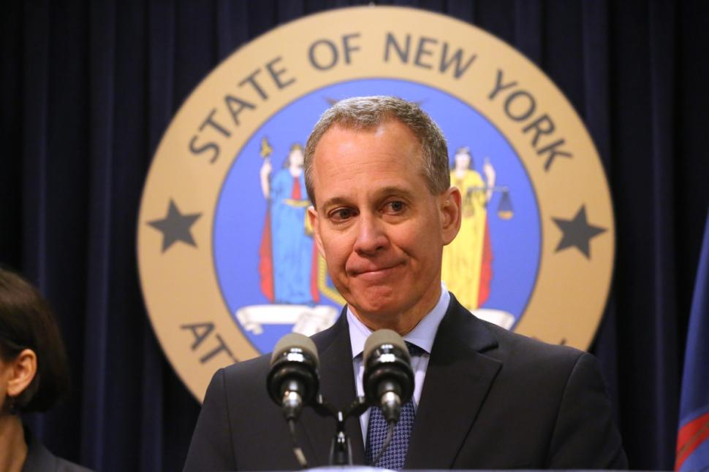

“They (Exxon-Mobil) have been funding organizations that are climate change
deniers.”

New York Attorney General Eric T. Schneiderman,
deploying “denier” vernacular when alleging fraud by now Secretary of State Rex Tillerson,
ex CEO of Exxon-Mobil.

12 June 2017 President Donald J. Trump
Page 17 of 25

The Climate Change Imbroglio : Their Unbridled Vileness – CONCLUSION

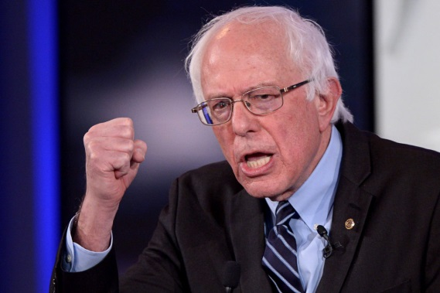

" It (climate change denial) reminds me in some
ways of the debate taking place in this country
and around the world in the late 1930s – there
were people - who said 'don't worry! Hitler's
not real! It'll disappear! "

Senator Bernard Sanders.

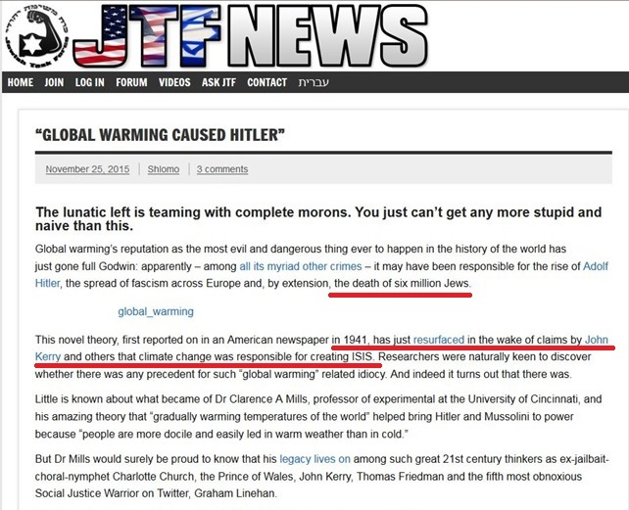

The above is a small sampling of the desperate status and ever diminishing stature of those academicians, climate scientists, and their mouthpieces in the NGO media, that are irretrievably tethered to their own failed notion . . . that ‘CO2 equals global warming.’

But it is far more . . . it is indicative of their collective inveracity . . . an inveracity that will soon advocate, enact, and then enforce ‘censorship as science.’
12 June 2017 President Donald J. Trump
Page 18 of 25

Yad Vashem, Climate Bolsheviks, and Big Academia – Censorship as Science

It is unknown whether; during your May 24, 2017 visit to Yad Vashem, you questioned its director, Robert Rozett, for soliciting and receiving the censorship of what Americans are allowed to read. But you are aware that Rozett characterized his demand to Amazon billionaire CEO Jeff Bezos as a request to “curb the spread of hatred.” Intellectual censorship curbs hatred?

To the best of my knowledge, people like Rozett have never chastised, at any level, the charlatans on pages 14 thru 17 . . . for blaspheming the portent of Yad Vashem. One wonders why.

However, it appears your role as the American president, and your declarations about “America First” have submitted to restrictions that potentially violate your duty under the United States Constitution.

At your June 1, 2017 Rose Garden news conference, where you withdrew the US from the Paris Accord, declaring that you “were elected to represent the citizens of Pittsburgh, not Paris,” you failed to alert Americans that a censorship of what they can read in regard to climate science is also a mere legalistic stepping stone away . . .

You are not alone in your accommodation, if not participation, in allowing a foreign NGO to dictate what America is allowed to read or watch or think . . . about . . . anything :

But . . . contrary to their self-absorbed self-image . . . Big Academia is in lock-step with both you and Jeff Bezos and Yad Vashem . . . we are at the point where making “Climate Denial” a criminal offense with mandatory incarceration . . . is merely . . . academic.

12 June 2017 President Donald J. Trump
Page 19 of 25

Yad Vashem, Climate Bolsheviks, and Big Academia – Censorship as Science - con’t

That last paragraph of page 18? The rantings of a loon? Apparently I am not alone . . . but in the opposite sense from those that have degraded and debased science to a level not seen since the brutal murdering of the Christian czar and his entire family by the Jacob Schiff funded Bolsheviks:

If there was a single operative in the drawn-out existence of the Soviet Union, it was censorship.

In truth, millions were murdered, and the worst environmental disaster in human history (World War II) occurred because of this “meddling.”

As you and Yad Vashem are fully aware, so-called “sovereign nations” have already made public disagreement with any aspect of the Shoah Theology punishable with mandatory incarceration. The list of “sovereign nations” continues to grow, and currently includes:

Australia, Austria, Belgium, Bosnia-Herzegovina, Czech Republic, France, Germany, Hungary, Israel, Liechtenstein, Lithuania, Luxembourg, Netherlands, Poland, Portugal, Romania, Spain, Switzerland.

12 June 2017 President Donald J. Trump
Page 20 of 25

Yad Vashem, Climate Bolsheviks, and Big Academia – Censorship as Science - con’t

Again, is the undersigned a loon? Or has a legalistic Nuremburg-styled criminal connection already been publically proposed which links the imprisonment of “Holocaust Deniers” to that of “Climate Deniers”? Similar to the recent readership ban implemented in the USA by Yad Vashem regarding “Holocaust Denial,” is this Climate Denier imprisonment proposal also advocated under the guise of “curbing the spread of hatred” ?

A few examples among many:
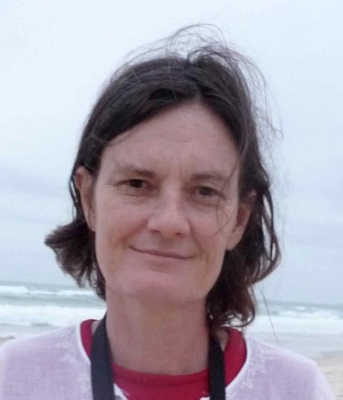

" David Irving is under arrest in Austria for
Holocaust denial. Perhaps there is a case
for making climate change denial an offence –
it is a crime against humanity after all. ”

Margo Kingston, Member of the NGO News media
in Australia, where mandatory incarceration of
“Holocaust Deniers” is already law.

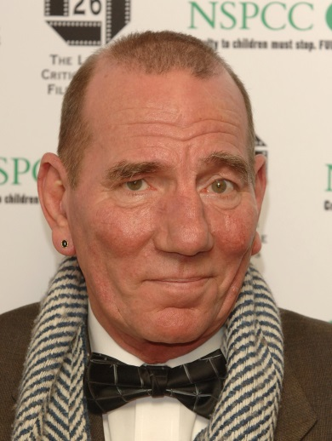

“There are now proposals that
‘global warming deniers’ be treated
the same as ‘Holocaust deniers:
professional ostracism, belittlement,
ridicule and, even jail.”

Peter William Postlethwaite, Movie Industry

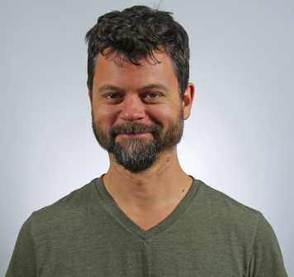
" It's about the climate-change denial industry.
We should have war crimes trials for these
bastards - some sort of climate Nuremberg. "

David Roberts, NGO news reporter.

12 June 2017 President Donald J. Trump
Page 21 of 25

Cornell University recently welcomed its new 14th president, Ms. Martha Pollack. A sampling of her quotes prior to inauguration:

“This is an educational institution, so I prefer to look at this as an opportunity where we, as a community, are
educating one another about the
value of free speech.”

“By far the most important (value) is integrity. Without integrity, you don’t have trust, and without trust, you don’t get anywhere. I think that when two people trust each other, you can make lots of progress even if you vehemently disagree. For me, starting from
a point of integrity is essential.” *

* To her credit, President Pollack seems to be in disagreement with Israeli Educational Minister Naftali Bennett who recently advocated limiting academic freedoms and free speech, on the basis
of one’s “political worldview.”

As reported in the Cornell Chronical:

“Her passion also shone through when describing her ‘fundamental, unwavering commitment’ to free speech. That means free speech should be afforded to everyone, she said, and not just people with whom you agree.

‘That can be difficult,’ she said. ‘That means you have to be willing to accept offensive speech. But history has shown that when you take away free speech and start clamping down on freedom of expression, it’s marginalized groups that suffer most.’”

Her background is primarily Big Academia, so these good, but trendy proclamations are not surprising. Her biography gives no indication that her alleged “fundamental, unwavering commitment” to these values has been thoroughly tested at levels such as personal sacrifice, etc.

For example, I can assure you that President Pollack, as well as the entirety of Big Academia, is fully aware of the recent “Holocaust Denial” censorship stunt deployed by Yad Vashem and their
new lackey at Amazon.com:

But nowhere will you find statements by President Pollack, or any administrator of any educational institution whom touts from one side of their mouth “free speech,” and therefore condemns this recent Bolshevik-styled censorship. For example, to the best of my knowledge, no outrage has been lodged by Big Academia regarding the condominium between Yad Vashem and Amazon.com.

12 June 2017 President Donald J. Trump
Page 22 of 25

Yad Vashem, Climate Bolsheviks, and Big Academia – Censorship as Science – CONCLUSION

We can presume that Cornell University President Pollack is aware of the statement samplings of the charlatans shown on Pages 14 through 17 above.

We can presume Pollack’s familiarity with the statements of Professor Schneider (Page 3 above). She knows that such violates the tenets of the Cornell University Code of Academic Integrity In that context and others, I am deeply “chagrined” if my alma mater is in-any-way associated with :

- The Climate Change imbroglio which openly requires denunciation of personal and professional integrity

- The enforcement or encouragement of censorship

- Operating philosophies and public posturing that reek of duplicity

- Slander / Libel and the many other forms of vitriol and diatribe

- The notion that the rigors of the Scientific Method will be subjected to and/or answerable to various belief systems (Shoah, Catholicism, etc.)

- Open or tacit threats of incarceration against those with whom there is alleged
“vehement disagreement.”

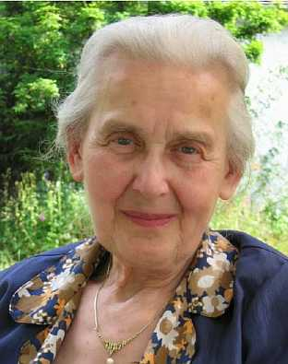
Nowhere will you find statements by any administrator
of Big Academia condemning the recent Bolshevik-styled
Yad-Vashem/Amazon censorship.

But this complicity already has a parallel precedent . . .

You will not find from Big Academia, most especially
from their highly vaunted “Law Schools,” open condemnation of the viciousness demonstrated in the fate
of 88-year-old Ms. Ursula Haverbeck:

With these complicit behaviors, legal precedents, and now open promotions of “Climate Denier” laws already in plain view, can enactment in the USA of this Bolshevik-styled tyranny be not far behind?

Mr. President, with the current epoch defined by the picture at the bottom of Page 13; and with so much ego and money involved . . .

The answer is an emphatic, “NO!”

12 June 2017 President Donald J. Trump
Page 23 of 25

Conclusions

- Congratulations on your decision to withdraw from the Paris Climate Accord; as its pundits refuse to state a scientifically defensible correlation value to its alleged genesis:
‘CO2 equals Global Warming.’

- At present, the taxpayer funded vested interest group called NASA is still ranting about:

“unprecedented loss of ice in the Artic.”

Many had challenged these absurd proclamations. Recently, since our push-back, NASA has now deployed a revised, coyly worded rhetoric:

“the lowest in the satellite record.”

When I broached the 1922 reports (Page 1/2 above), NASA refused to comment. When I asked the External Relations to acquire and assert an answer to my Simple Question, NASA refused to answer. As of this letter I have still not received a response or an answer.

In conversations I have asked about the well-known fact that for decades planet Mars and the outer planets have exhibited “Global Warming.” This planetary warming is ongoing.

- Central to the Paris Accord (and many other earlier IPCCs), the ‘CO2 equals Global Warming’ theory is asserted as true, and indeed forms the fundamental basis of that Accord. If this basis is true, that increases of CO2 drives increases in global temperature, then these two data sets will be mathematically correlated, and the value will be positive. If the cause-effect relationship is direct, or very strong, the correlation value will be “high.”

- You do not need to be a highly-trained scientist to calculate the correlation value between two data sets; grammar school children are routinely taught this basic arithmetic concept.

- Big Academia refuses to participate in the portent of my Simple Question (page 6 above), but they tacitly participate in the vileness that, “Climate Deniers” are equivalent to “Holocaust Deniers.”

- The physical world and its processes have no regard for human beliefs or theological dogmas. The rigors of the Scientific Method dictate that pronouncement of a physical fact must be based on precise experimentation that is representative of the alleged fact, and is repeatable.

- Given that the groups which instigated the recent “Russia narrative” are the same or similar to those that enforce the ‘CO2 equals Global Warming’ dogma, and therefore share similar behavioral characteristics, it is unlikely that either group will ever fully admit that they were wrong.

- With complicit behaviors, legal precedents, and people openly advocating “Climate Denier” laws (which they demand must also include mandatory imprisonment), enactment of this Bolshevik-styled tyranny in the USA will be attempted.

12 June 2017 President Donald J. Trump
Page 24 of 25

Personal Notes

- Understandably it would appear to the reader that I have singled out Rutgers University Professor Alan Robock and Cornell University Professor Frank DiSalvo for ridicule. In fact my inclusion of them was for the exact opposite reason: Both were gracious, polite, and generous with their time. I am in disagreement with their responses, but their professional demeanor indicates that they were open to debate/discussion. The other “scientists” that I attempted to interview were so rude, so condescending and so self-absorbed that my attempts were a waste of time; one going so far as to declare that the undersigned was “just a denier,” and demanded that I have no further contact with them, threatening me with “legal action” if I did so. Such people are not worthy of mention.

- What does anyone have to gain by studying these subjects in earnest, and stating disagreement with the thesis that ‘CO2 equals global warming’ if in fact they found otherwise?! The lawsuit by New York against Exxon-Mobil might prevail, but only if this thesis is undebatable. It that context it is repulsive that these subjects are diverted from scientific rigor when money is the crux, and then further reduced by the adolescent diatribe of “Climate Denier equals Holocaust Denier.” I have nothing personal to gain by expressing my doubts or concerns. If the latter interrupts the cash flow of others I apologize, but such was consequential, not intentional.

Requests

- During the June 6 edition of ‘Morning Joe,’ EPA Administrator Scott Pruitt was pummeled by Joe Scarborough with the outburst, “It’s a simple question.” Neither offered an answer to my Simple Question. Please direct Mr. Pruitt to do so:

“ What is the correlation value, and the R-squared value, between atmospheric carbon dioxide in PPM and global temperatures;
please specify the time period for the values you offer? ”

(Please assume that we will scrutinize this EPA response, especially the sources of and the quantities declared as the so-called “temperature record.” Again . . . ClimateGate?!)

- When/if Mr. Pruitt confirms correlation values near those shown on Page 12, then it would be incumbent upon all of us to refocus our efforts on the hard lessons, good efforts, and true priorities of environmental protection.

For example, in the context of true environmental protection, the spending of billions on trendy but demonstrably ineffective “wind farms,” or the spending of trillions (worldwide) on ludicrous schemes such as “Carbon Sequestration” must be scrapped. There are far more crucial and meritorious environmental and infrastructure projects in need of our efforts/funding: Flint, Michigan?

Thanking you in advance, I remain,

Respectfully yours,

Paul V. Sheridan

Attachment
12 June 2017 President Donald J. Trump
Page 25 of 25

Subject: Withdrawal from the Paris Climate Accord (Congratulations)

Courtesy Copy List

Ms. Martha E. Pollack  Office of the President  Cornell University  300 Day Hall  Ithaca, NY 14853  607-255-5201 | Ms. Christina Hull Paxson, President  President’s Office  Brown University  Providence, RI 02912  401-863-2234
Mr. Lee C. Bollinger, President  Office of the President  Columbia University  Mail Code 4309  535 West 116th Street,  New York, NY 10027  212-854-1754 | Ms. Amy Gutmann, President  Office of the President  University of Pennsylvania  Room 100  1 College Hall  Philadelphia, PA 19104  215-898-7221
Mr. Philip J. Hanlon, President  Office of the President  Dartmouth College  207 Parkhurst Hall  Hanover, NH 03755  603-646-2223 | Ms. Drew Gilpin Faust, President  Office of the President  Harvard University  Massachusetts Hall  Cambridge, MA 02138 USA  617-495-1502
Mr. Christopher L. Eisgruber  Office of the President  1 Nassau Hall  Princeton University  Princeton, NJ 08544  609-258-6100 | Mr. Peter Salovey, President  Office of the President  Yale University  105 Wall Street  New Haven, CT 06511  203-432-2550
Secretary Rex W. Tillerson  US Department of State  2201 C Street, NW  Washington, DC 20520  202-647-4000 | Mr. Scott Pruitt, Administrator  Mail code: 1101A  Environmental Protection Agency  1200 Pennsylvania Avenue, N.W.  Washington, DC 20460  202-564-4700

