22357 Columbia Street
Dearborn, MI 48124-3431
313-277-5095
pvs6@cornell.edu

18 September 2020 Via FedEx AirBill 8007 – 9341 - 6373

President Donald J. Trump
The White House
1600 Pennsylvania Ave NW
Washington, DC 20500
202 - 456 - 1111

Subject: The “Law & Order” Presidential Candidacy of Donald J. Trump (3 November 2020)
Reference: My Letter to United States Attorney General William F. Barr of 28 August 2020

Dear Mr. President:

You cannot campaign or preside with credibility as the Law & Order president while coddling a criminal in your mist; in your inner circle, and simultaneously declaring that you are a man of God Jesus:

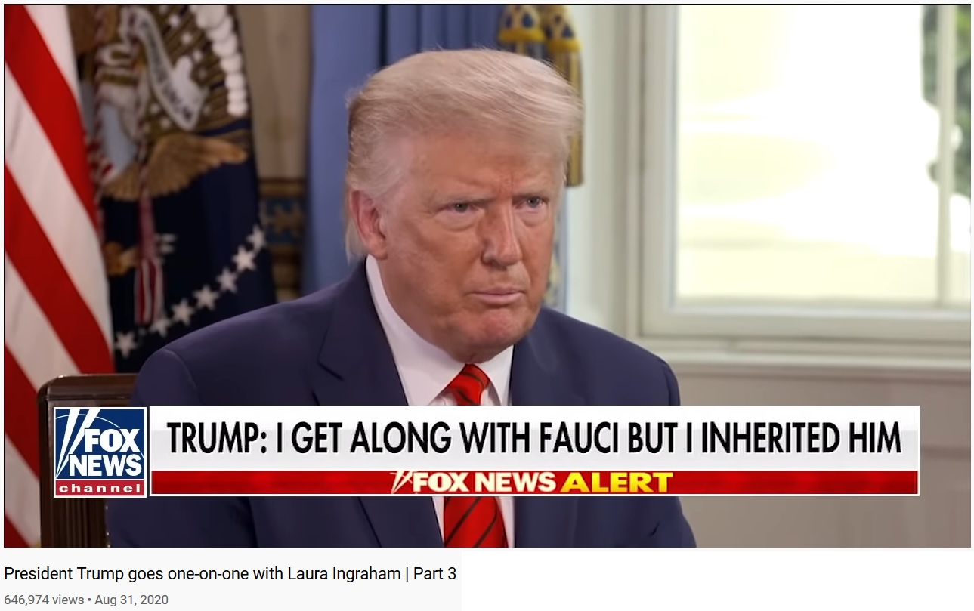

Your phrase “inherited him” might be appropriate to a stray animal that you decided to take on.

Your “inherited him” phrase should not be in-reference to a person that resides in one of the most crucial and powerful positions in your Administration. That position should be staffed with a person openly and enthusiastically praised by you . . . as someone with a reputation for selfless public service to America, with a record unfettered in-the-slightest by surreptitious agenda; a person with an unrivaled and unassailable history of professional conduct and competence . . .
18 September 2020 President Donald J. Trump
Page 2 of 10

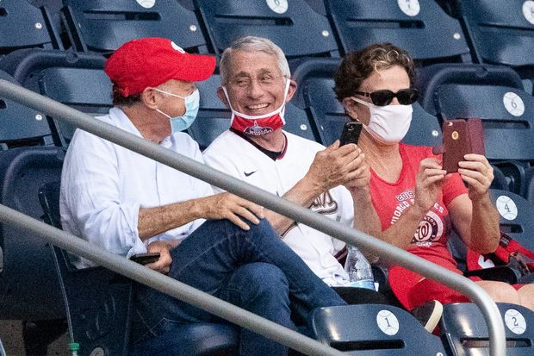

Within walking distance from the above photograph, black body bags with the corpses of people that were victimized by (what has been labeled as) “SARS-CoV-2” were being dumped into a huge pile at a hidden loading dock in our birth town of New York City . . . do you remember complaining about that scene?

With your “body bags” complaint in-mind, we now connect the vileness of that Fauci photograph to an interview of a person that DOES HAVE a reputation for selfless public service, a person that DOES HAVE a record unfettered by surreptitious agenda; a person that DOES HAVE an unrivaled and unassailable history of professional conduct and competence . . . so-much-so that the Godless criminals of the Chinese Communist Party (CCP) have openly threatened her life: Dr. Li-Meng Yan:

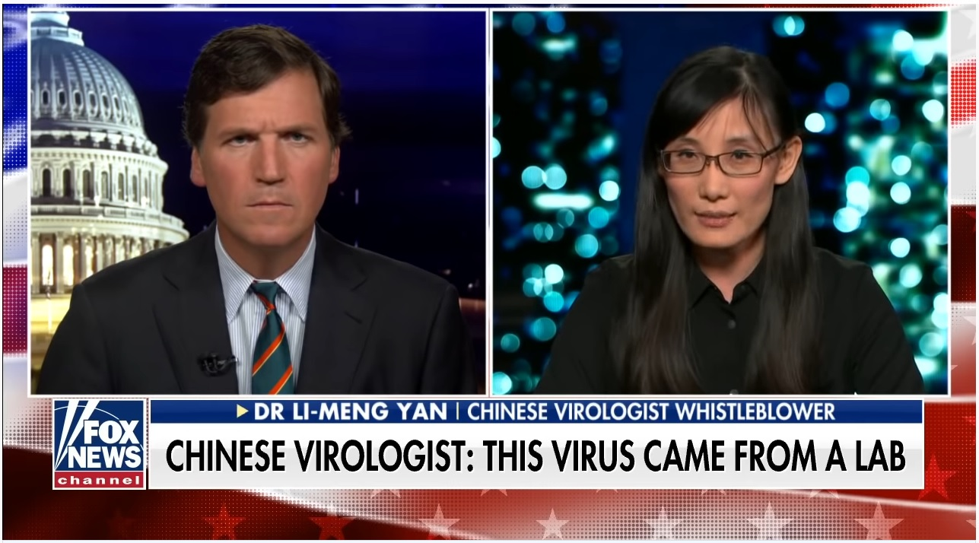
18 September 2020 President Donald J. Trump
Page 3 of 10

To make that stark comparative connection, between Dr. Anthony “inherited him” Fauci
versus Dr. Li-Meng Yan, we review recent headlines:

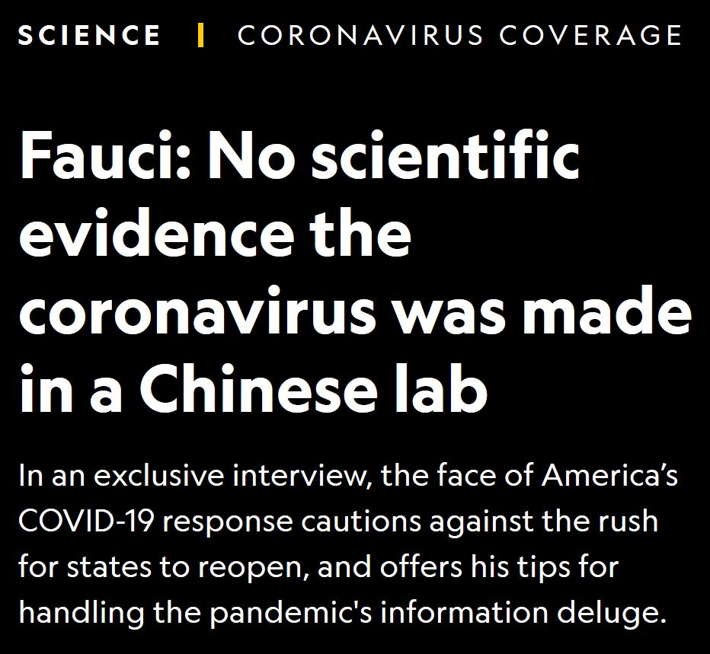

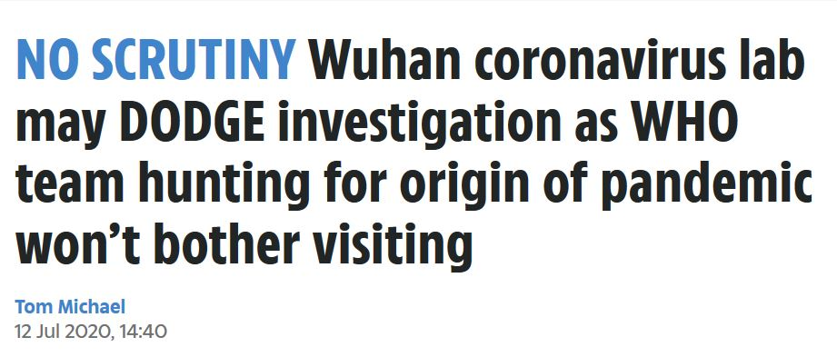

Given these, and the headline atop the next page, as far as we know the CCP has not threatened
Dr. Anthony “inherited him” Fauci . . .

18 September 2020 President Donald J. Trump
Page 4 of 10

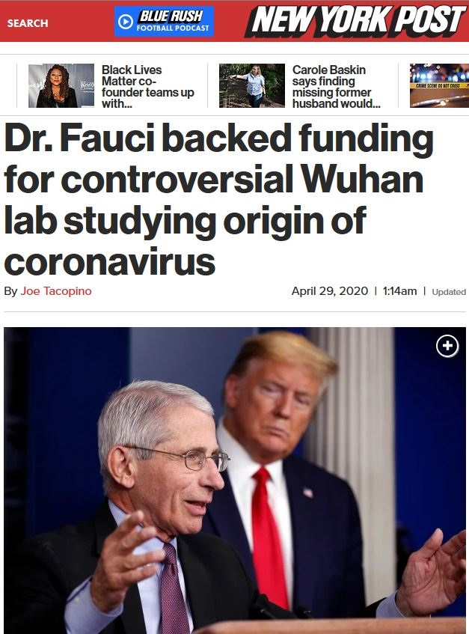

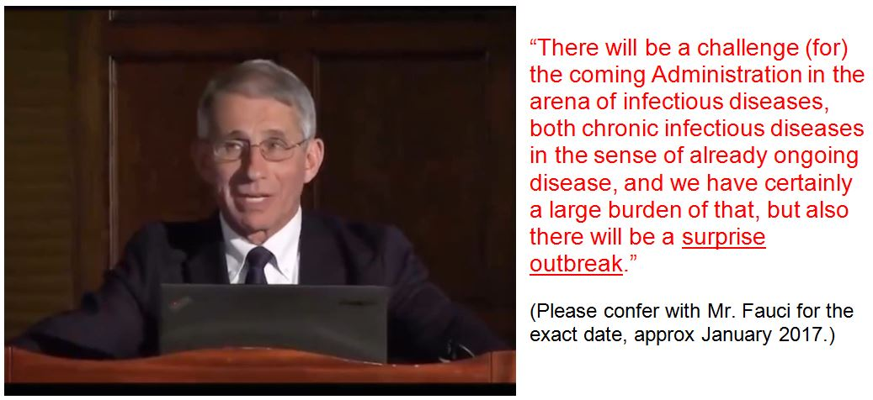
18 September 2020 President Donald J. Trump
Page 5 of 10

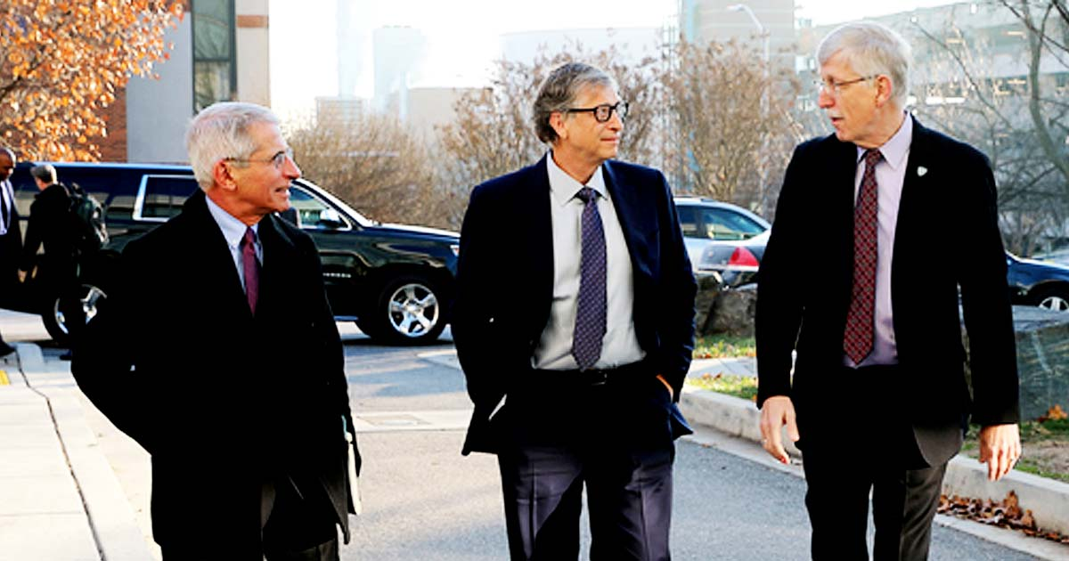

In the context of the vileness implied by the above photograph, wherein so-called public servants are catering to a self-absorbed billionaire de-population globalist, we note some recent headlines:

1. New CDC Report Shows 94% of COVID-19 Deaths in U.S. had Contributing Conditions: “According to the report, only 6% of deaths have COVID-19 as the only cause mentioned, revealing that 94% of patients who died from coronavirus also had other ‘health conditions and contributing causes.’”

2. Your Coronavirus Test Is Positive. Maybe It Shouldn’t Be:
“Some of the nation’s leading public health experts are raising a new concern in the endless debate over coronavirus testing in the United States: The standard tests are diagnosing huge numbers of people who may be carrying relatively insignificant amounts of the virus. Most of these people are not likely to be contagious . . .

3. Study: COVID-19 Lockdowns Over 10 Times More Deadly Than Pandemic Itself:
“Simply put, we have drawn upon existing economic studies on the health effects of unemployment to calculate an estimate of how many years of life will have been lost due to the lockdowns in the United States, and have weighed this against an estimate of how many years of life will have been saved by the lockdowns. The results are nothing short of staggering… thelockdowns will end up costing Americans over 10 times as many years of life as they will save from the virus itself.”

4. Attorney Files Lawsuit to Remove Gov. DeWine's COVID-19 Emergency Order:
“As the state continues to double down on this continued fraud, going so far as to create FEMA ‘concentration camps,’ we are shining the light…on the dark reality of the COVID response.”

5. Judge Rules Pennsylvania Gov. Tom Wolf’s COVID-19 Shutdown Orders Unconstitutional: “The federal judge ruled forcing businesses to shut down entirely and Gov. Tom Wolf’s stay-at- home order are both unconstitutional. Some business owners say they’ve been waiting to hear a ruling like this for months.”

6. COVID-19 emails from Nashville Mayor's Office Show Disturbing Revelation:
“Emails between the mayor’s senior advisor and the health department reveal only a partial picture. But what they reveal is disturbing.”

7. NIH Director: I Could Not Imagine Carrying Out Order to Fire Dr. Fauci:
“‘This is a remarkable scientist who has led NIH’s efforts in infectious disease with great distinction for more than 30 years and who continues to be our lead in vaccines…for Covid-19,’ Collins told STAT. ‘The idea of losing that leadership at this critical moment for our nation is unthinkable.’”
18 September 2020 President Donald J. Trump
Page 6 of 10

Unthinkable!? Tens-of-thousands of body-bags associated with nursing home deaths; but not a thought from NIH Director Dr. Francis Collins? PCR testing protocols that are not merely known to be misapplied, but deployed as a fraud; and not a thought from Dr. Collins? Hundreds of thousands of American and global deaths known to be FALSELY attributed to “SARS-CoV-2,” but not a thought from Dr. Collins? Hundreds of peer-reviewed studies indicating that face masks are not effective and in most instances are harmful, but not a thought from Dr. Collins? An open courtesy copy recipient of my 21 July 2020 to his subordinate Dr. Fauci, but not a thought from Dr. Collins?

Perhaps we should assist Dr. Collins’ thinking with a quote from Dr. Anthony “inherited him” Fauci:

“We would really like to see the data, because if there is asymptomatic transmission (of “SARS-CoV-2”) it impacts certain policies that you do regarding screening, etcetera. But the one thing historically people need to realize, that even if there is some asymptomatic transmission, in all the history of respiratory borne viruses of any type, asymptomatic transmission has never been the driver of outbreaks. The driver of outbreaks is always a symptomatic person. Even if there is a rare symptomatic person that might transmit, an epidemic is not driven by asymptomatic carriers.”

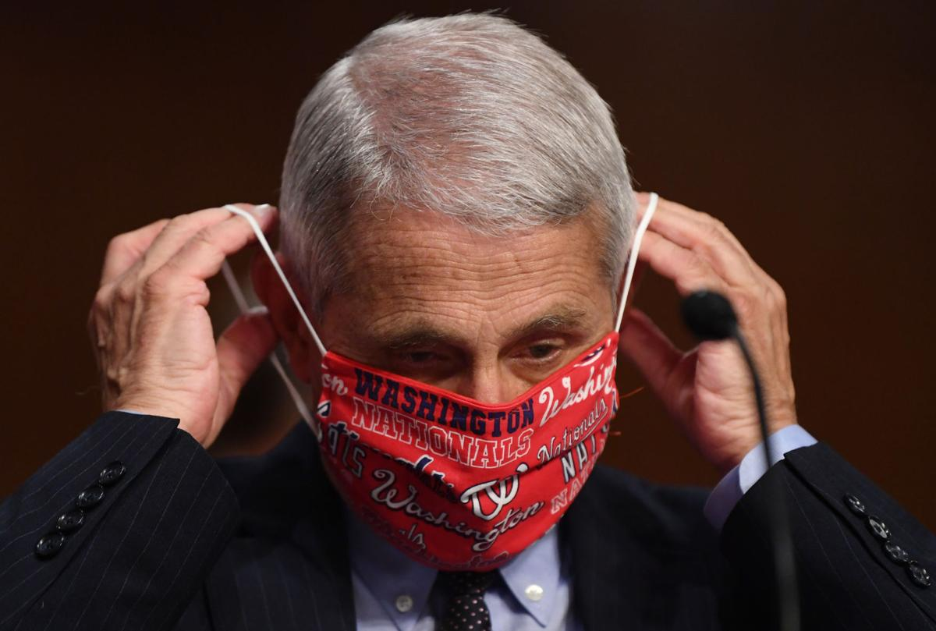

Given his emphatic statement; one never reported by the Fake News bozos, and given the photograph above, are we to assume that Dr. Fauci is indeed a “carrier”?
18 September 2020 President Donald J. Trump
Page 7 of 10

The Vaccine Canard : The Vested Interests and “Big Academia”

By this title I am not referring to the studied positions of Mr. Robert F. Kennedy Jr., or that of Dr. Scott Atlas who was recently libeled by vaccine vested interests at Stanford University; his attorney
Mr. Marc Kasowitz is demanding public retraction in lieu of an open lawsuit for defamation.

But Big Pharma, Dr. Fauci, and Stanford University are not the only vaccine vested interests in focus.
Nor is defamation the only legal issue. Legalities and Big Academia in-general are contextual.

One of the most vile, the most insidious prospects benefiting the vaccine vested interests, and their all-out push for global vaccination for “SARS-CoV-2” (for now) is the legal position they orchestrated through the United States Congress, and the latter’s counterparts in the United States Supreme Court (USSC).

Prior to November 2016, in Mutual Pharmaceutical Co., Inc. v. Bartlett, the USSC granted the defendant near blanket immunity, in essence declaring that Big Pharma “could not be held liable and did not have to pay anything at all.” A legislative precursor to this type of legal ruling came with the Public Readiness and Emergency Preparedness Act in 2005.

The legal details and the ongoing rhetoric would over-burden this instant letter, but this needs to be made personal: If Mr. Barron Trump, or First Lady Melania Trump, or Mr. Eric Trump, or Ms. Tiffany Trump are vaccinated, and later develop severe health problems (or death) which can be directly connected to a faulty vaccine, your legal recourse against the offending Big Pharma is basically and increasingly non-existent. In your campaign vaccine rhetoric, you never mention this legal reality to the voters.

One of the most notorious vaccine vested interests, the one being chaperoned by Dr. Collins and Dr. Fauci, posed in the middle of Page 5 above, is billionaire globalist Mr. Bill Gates. On the campus of my alma mater, Cornell University; a building I have attended many times, the Bill & Melinda Gates Hall:

It is not unreasonable to presume that the tens-of-millions-of-dollars in Gates’ investment in Cornell University will render not merely praise, but possibly undue influence, and in areas not directly connected to the overt purpose of Gates Hall. That is, my use of the word ‘investment’ is specific.
18 September 2020 President Donald J. Trump
Page 8 of 10

The Vaccine Canard : The Vested Interests and “Big Academia” – con’t

Under Tab 1 below you will find my 28 August 2020 letter to U.S. Attorney General William P. Barr. On Page 9 you will find “Item 3” :

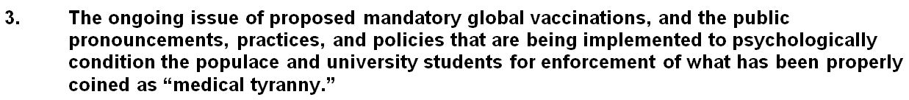

The connection between Gates and the current president of Cornell University is anything but tentative. Under Tab 2 below you find my letter to Dr. Fauci of 21 July 2020. On the last page of the cover you note that Ms. Martha Pollack is an open recipient of that Fauci letter; she received that letter long-prior to making the following utterly false declaration to the returning Cornell University students:

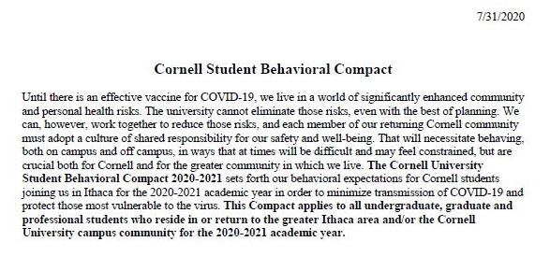

Mandatory Vaccination as a Requirement of University Admission

As has been demonstrated on a global scale, the notion promoted by Pollack that the only way to reduce the risk of SARS-CoV-2 to our “community and personal health” is through a vaccine, is not merely mistaken; it is a bold-faced lie. Indeed, implicit and endemic to the lead-off words Pollack chose for this ‘Cornell Student Behavioral Compact’ reeks of at least one major vested interest agenda item:

Through the undue influence and false rhetoric of vested interests, ranging from the Bill & Melinda Gates Foundation to Cornell University graduate Dr. Anthony Fauci to the World Health Organization to Big Pharma; and through the enactment of a legal framework / precedent that also inoculates Big Academia from product liability, the vested interest agenda item of establishing mandatory vaccination as a requirement of university admission. The steps already implemented serve to embolden my suspicion that such is not merely incompetent, but part of a broad criminal conspiracy.

18 September 2020 President Donald J. Trump
Page 9 of 10

Conclusion and Request

Attached under the tabs below are the following letters:

Recipient | Subject | Tab Number
Attorney General William P. Barr  U.S. Department of Justice  – 28 August 2020 | Demand for Criminal Investigations Relating  to “COVID-19 Pandemic” | 1
Dr. Anthony S. Fauci, Director NIAID  – 21 July 2020 | Official Response to SARS-CoV-2 / COVID-19 Related Questions | 2
First Lady Melania Trump  – 23 July 2020 | Question Regarding Mr. Barron Trump | 3
Dr. R. Albert Mohler, Jr., President  Southern Baptist Theological Seminary – 3 August 2020 | Southern Seminary and Boyce College –  Covenant and Commitment | 4
Mr. Wilson Masilingi, Ambassador  Embassy United Republic of Tanzania – 7 August 2020 | Letters to Dr. Anthony Fauci, and  First Lady of the United States Melania Trump | 5
President Donald Trump /  Vice President Mike Pence  – 13 August 2020 | My Letter to Dr. Anthony S. Fauci of 21 July 2020 | 6

You are not the only person that inherited Dr. Anthony Fauci, and his person, his associates and their collective deeds, allegedly done in the name of our safety & well-being is questionable. Relating to your
31 August 2020 statement that you “inherited him,” on the last page of the cover to Tab 2 you will see that I had stated to Dr. Fauci a month earlier:

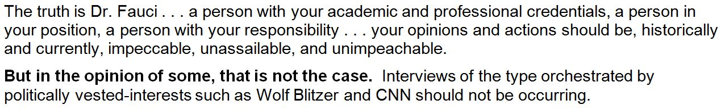

Ongoing headlines do not rebut the concerns implied; especially the recent interview by Tucker Carlson of Dr. Li-Meng Yan (please see pages 2 through 6 above). In this new additional context, please direct U.S. Attorney General William Barr to respond to my letter of 28 August 2020 (Tab 1).

Respectfully yours,

Paul V. Sheridan
Attachments

18 September 2020 President Donald J. Trump
Page 10 of 10

Courtesy Copy Recipients

Attorney General William P. Barr  US Department of Justice  950 Pennsylvania Avenue, NW  Washington, DC 20530-0001  202-514-2000  Via FedEx Ground-Bill 1283181-00005340 | Vice President Michael R. Pence  The White House  1600 Pennsylvania Ave NW  Washington, DC 20500  202-456-1111  Via FedEx AirBill 8007-9341-6329
Dr. Anthony S. Fauci, Director  NIAID  5601 Fishers Lane  Rockville, MD 20892  301- 496 – 5717  Via FedEx Ground-Bill 1283181-00005??? | Dr. Francis S. Collin, Director  National Institute of Health  9000 Rockville Pike  Bethesda, MD 20892  301-496-4000  Via FedEx Ground-Bill 1283181-00005357
President Martha E. Pollack  Cornell University  300 Day Hall  Ithaca, NY 14853  607-255-5201  Via FedEx Ground-Bill 1283181-00005364 | Dean Augustine M.K. Choi  Weill Cornell Medical College  1300 York Avenue  New York, NY 10065  212-746-5454  Via FedEx Ground-Bill 1283181-00005371
Mr. Tom Fitton, President  Suite 800  425 Third Street SW  Washington, DC 20024  888-593-8442  Via FedEx Ground-Bill 1283181-00005??? | Mr. Thomas Renz, Esq. *  Renz Law LLC - Suite 162  1907 W State Street  Fremont, Ohio 43420  419-351-4248  Via FedEx Ground-Bill 1283181-00005???

* Please see Item 4, Page 5 of 10 above.

