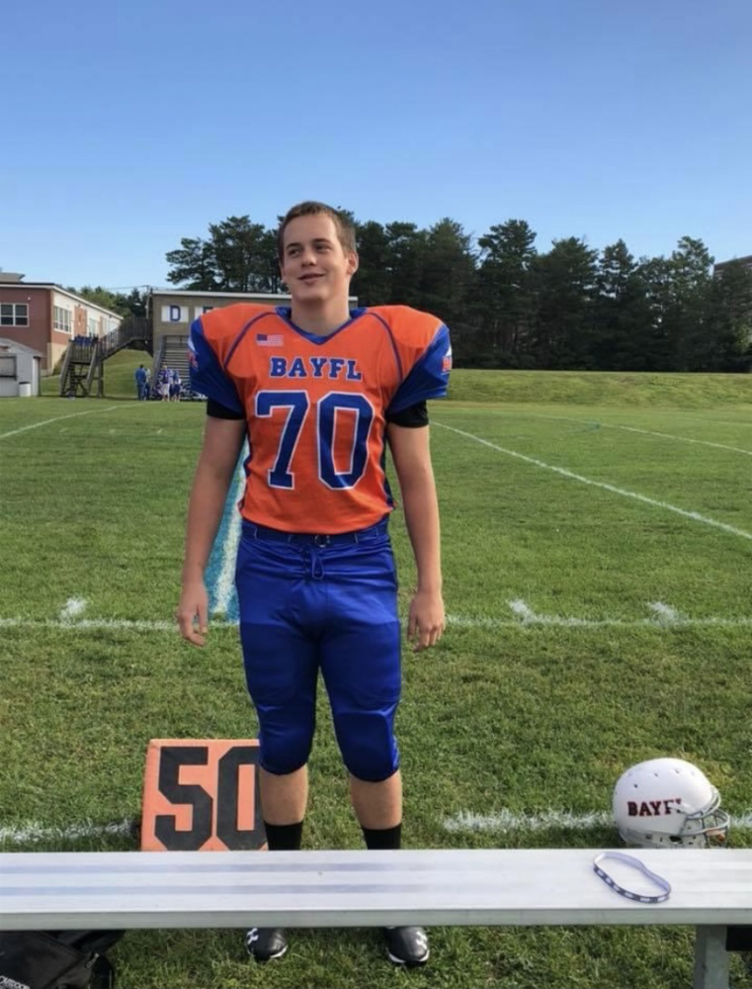

Spencer William Smith
September 11, 2004 - December 4, 2020
Rest in Peace

“ The truth is, for kids K through 12, one of the safest places they can be from our perspective is to remain in school. "
Dr. Robert Redfield, November 19, 2020

