DDM Consulting
22357 Columbia Street
Dearborn, MI 48124-3431
313-277-5095
pvs6@Cornell.edu

1 September 2017 VIA FEDEX AIRBILL 8007 - 9341 - 6112

Mr. Joseph M. Arpaio
12808 North Via Del Sol
Fountain Hills, AZ 85268-8559
602-876-1801

Subject: The Horrific Consequences of OBEYING Illicit Court Orders

Reference 1: Pardon of Sheriff Arpaio by President Donald Trump

Reference 2: The United States Department of Justice (DOJ)

Reference 3: My Letter to Sheriff Joe Arpaio of 26 August 2016

Dear Mr. Arpaio:

This letter is a follow-up to Reference 3. Here I specify the similarities of the corruption we are enduring, with a key mutual element of that corruption: the United States Department of Justice (DOJ).

Some perspective on Reference 1 . . . In 1995 I had made the servile decision to OBEY an illicit and politicized court order. My lack of fortitude contributed to the death of nine-year-old Brandon Auer:

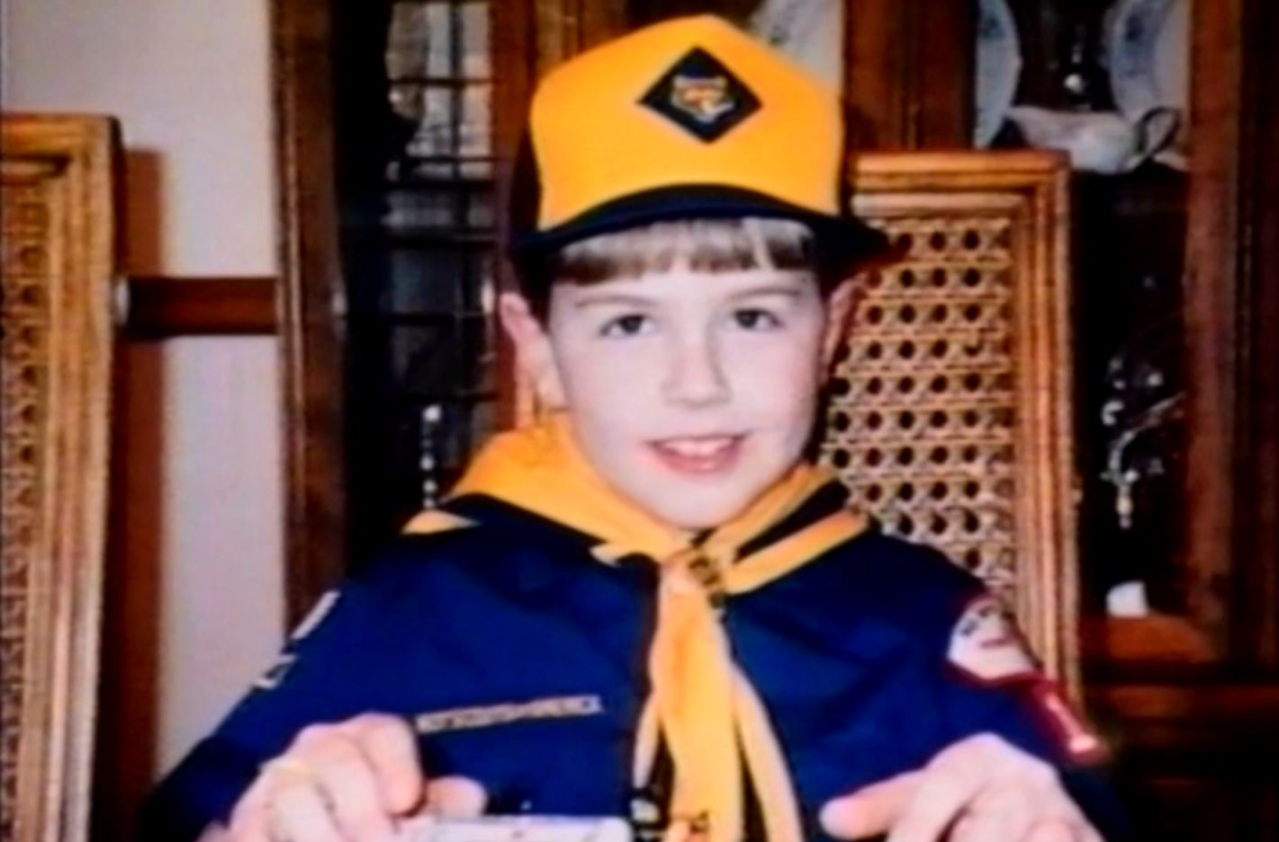
1 September 2017 Mr. Joseph M. Arpaio
Page 2 of 11

Brandon was only nine-years-old when he was a victim of manslaughter. I was complicit in this crime. Brandon’s death was an indirect result of my groveling before an illicit Michigan court order.

The Oakland County Court is within viewing distance of my former employer, Chrysler Corporation. The latter had been secretly “settling and sealing” litigations wherein horrific injury and/or death was caused by a safety defect. The highest levels of Chrysler executive management, including my immediate bosses, were fully aware of the defect in our minivan vehicles.

The Michigan court order against me was obtained during the Christmas holidays of 1994, a timeframe specifically targeted for my known absence. Therefore the order was obtained ex parte, under the routine corporate ruse of “trade secrets.” It demanded, under penalty of arrest, that I remain silent regarding my detailed knowledge of the minivan safety defect. The order was issued by a judge who was aware (1) that I was out-of-town, (2) that no effort had been made to notify me of the hearing, and (3) she was obviously aware that I was not represented by counsel during her hearing of 27 December 1994.

Subsequently, and relevant to your presidential pardon, every time a jury learns the facts, and specifically the actions of the judge pictured below, said jurors are infuriated. Such stems from the consequences of the judge-only “muzzle order,” which is directly connectable to the criminal manslaughter of Brando Auer.

The original three key legal individuals involved in the death of Brand Auer, via a judge-only “muzzle order” against my First Amendment rights are shown here:

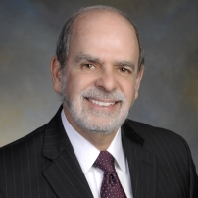 | Internal Chrysler Product Litigation Lawyer  Lewis Goldfarb
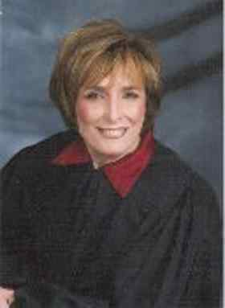 | Judge Hilda Rosenberg (Gage)

1 September 2017 Mr. Joseph M. Arpaio
Page 3 of 11

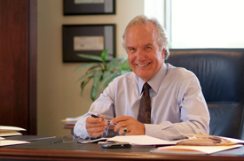 | External Chrysler Employment Lawyer  Thomas Kienbaum

The two attorneys, Goldfarb and Kienbaum, were fully aware of the closed door conspiracy involving the United States Department of Justice. The DOJ conspiracy was necessarily coincident with their ex parte “muzzle order” against me. But their judge-only tactics do not end there.

An upcoming trial involved the same defect that caused the death of Brando Auer. The National Highway Traffic Safety Administration (NHTSA) had declared in a secret Washington D.C. meeting, quote:

“ . . . a safety defect that involves children”

It was this secret NHTSA report that motivated the now-alarmed conspirators to converge: NHTSA, Chrysler and the DOJ. It was this defect that the Swamp conspired to hide from future victims, such as the parents of Brandon Auer.

Fully known to the conspirators, my internal Chrysler documents and presentations had already declared that very same defect status . . . years earlier. This defect was the true motivation of the judge-only “muzzle order” in Michigan . . . not some convoluted ruse about “trade secrets.”

These and many other facts led to the following revisions in my behavior:

- I refused to be complicit to an illicit judge-only “muzzle order.” I now made my person openly available for testimony in death and severe injury cases nationwide, and in Canada!

- The co-conspirators were now knowledgeable of my awareness of their secret NHTSA meeting, wherein my internal presentations of a ‘safety defect’ status had been officially confirmed by the expenditure of taxpayer dollars.

- The co-conspirators were now knowledgeable of my awareness of their NHTSA-Chrysler-DOJ criminal conspiracy, and that I was intending to testify on that issue in-particular (Attachment 1).

Reacting to these facts, ex-President of the Michigan Bar Association Thomas Kienbaum (pictured above) then orchestrated another judge-only action; he did so in lockstep with an upcoming trial which involved the same defect that killed Brando Auer. In a blatant attempt to intimidate, and to divert from the true issue, Kienbaum made up a fairy tale; that my ABC News 20/20 interview of March 1995, four YEARS earlier, had caused “$82,000,000.00 in damages.” Not merely farcical, an abject fraud.
1 September 2017 Mr. Joseph M. Arpaio
Page 4 of 11

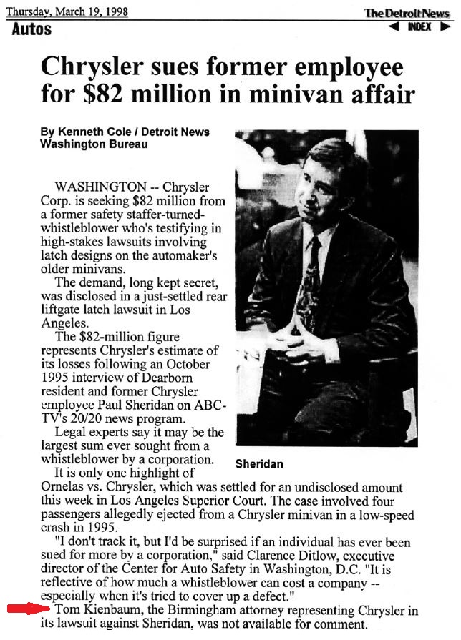
1 September 2017 Mr. Joseph M. Arpaio
Page 5 of 11

Let us put the above headline in perspective with respect to the US Department of Justice:

- No individual person in global human history has been sued for more than me.

- The Department of Justice was fully aware of my circumstances leading up to the $82,000.000 lawsuit, and how such was connected to their criminal conspiracy in behalf of NHTSA and Chrysler.

- Senator Orrin Hatch, then Chairman of the Senate Judiciary Committee, was fully aware of the DOJ-NHTSA-Chrysler conspiracy, and of my person in its regard.

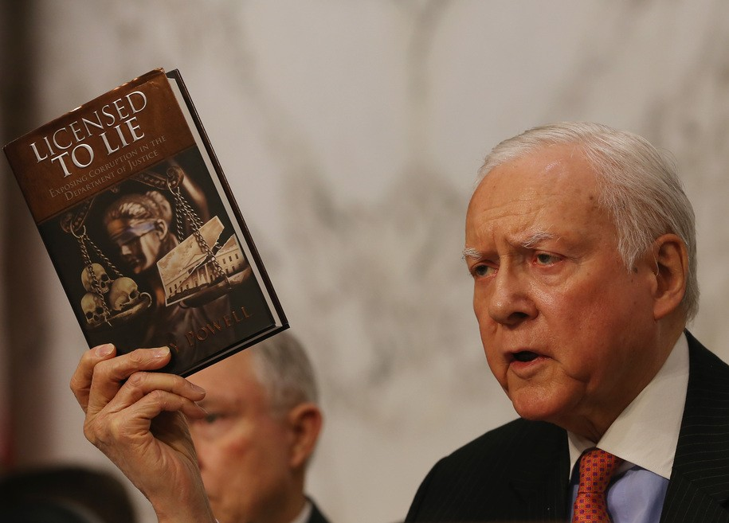

Regarding that last point, I cannot add to the revulsion among the knowledgeable that have reviewed Attachment 2. Hatch was in-receipt of the following Chrysler document excerpt (Attachment 3):

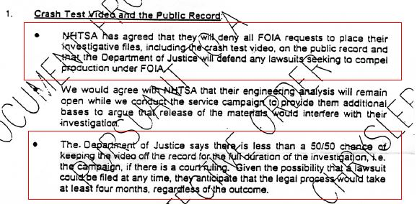
1 September 2017 Mr. Joseph M. Arpaio
Page 6 of 11

Please direct your attention to the NHTSA quote on Page 3 above. The salient fact is that their investigation had been concluded, and a safety defect had been declared (in the ‘CONCLUSIONS’ section of their secret report). Combine this with the last paragraph of the Chrysler internal document shown on Page 5:

- In essence the verbiage of Chrysler’s last paragraph declares that there was no ongoing investigation; in truth there was only an ongoing public relations “campaign.”

- But the relevant issue is the DOJ ruse, they need only allege that an investigation is “ongoing” to justify their denial of Freedom of Information Act (FOIA) requests. This ruse is enforced and endorsed by the Swamp.

In Reference 3 I had gone into great detail, directly connecting this DOJ/FOIA ruse to the manslaughter of Brandon Auer. Specifically I stated:

“Without the direct involvement of the DOJ (and emboldening of the co-conspirators resulting from such), the “denial of FOIA requests” would not have been possible.

It was during the ten-month time period, the time during which this criminal conspiracy was being enforced, that Brandon was murdered . . . at the time of his murder, his parents had no idea that closed-door DOJ criminal activity was its cause.

Had the crash test videos been released immediately after the defect status was confirmed, there is no doubt that parents nation-wide would have responded to that information with alacrity. Instead, this crucial information was concealed from them by your new adversary . . . the US DOJ.”

Brandon Auer was not murdered by an “illegal alien.” Brandon was murdered as a direct result of a corrupt and corruptible United States Department of Justice . . . but Brandon was merely one of many DOJ conspiracy victims, many of whom were horribly injured.

At no time did any “rights” organization, such as the ACLU, or the DOJ Public Integrity Section stand up for Brandon Auer.”

INTERMISSION

My intention is not to embroil you in the specific shenanigans that I endured, and continue to endure, in automotive safety. With your circumstances as context, my purpose is to document that the generalities with respect to the DOJ are not new; that such will characteristically lead to the tragic death and injury of innocent citizens: Death by a safety defect is no more final than murder by an illegal alien.

Most importantly, the characteristics of these upcoming illegal alien related tragedies are connectable to the ongoing shenanigans of the DOJ. For example, a very recent report states:

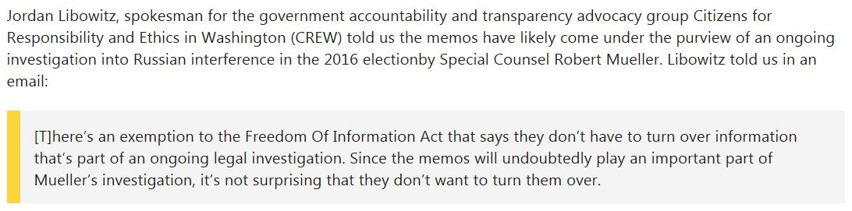

Sound familiar versus the internal Chrysler document verbiage, which rambled, “for the full duration of the investigation, i.e. campaign” ?
1 September 2017 Mr. Joseph M. Arpaio
Page 7 of 11

When I was victimized by the US Department of Justice, and later nine-year-old Brandon Auer and others, these following two individuals were in power:

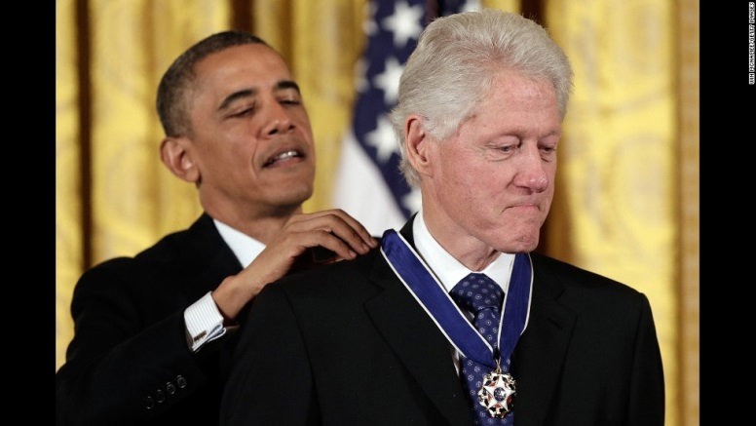 | 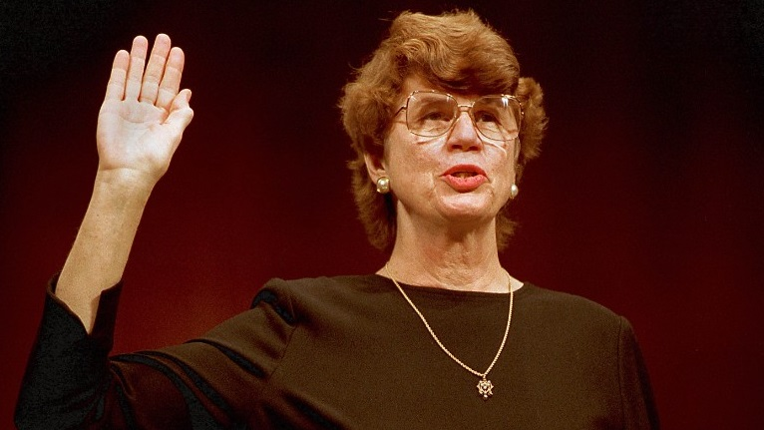

At left President Obama is awarding President William Clinton with a ‘Medal of Freedom.’ At right is Attorney General Janet Reno, the co-conspirator that assured that my First Amendment freedoms were nullified. Please again look at the picture on Page 1 above.

During your victimization by a judge-only verdict, the following two individuals were in power and, as we have seen, they are essentially still in power regarding your “ruled from the chamber” conviction:

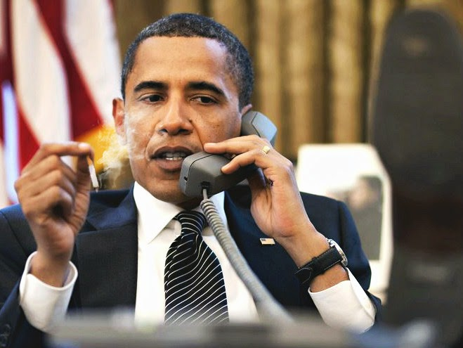 | 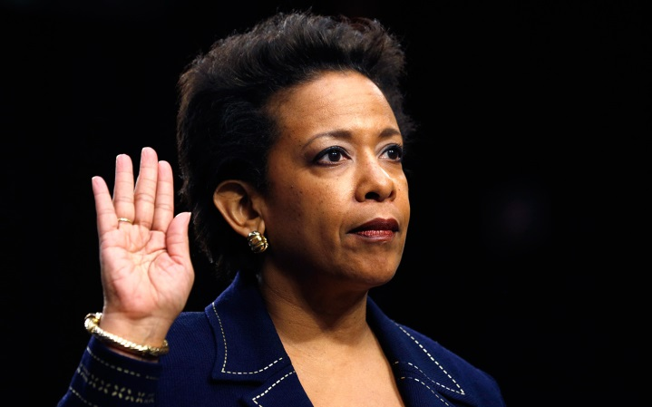

Contrary to the decades-old non-governmental news media rhetoric, that it is the “Left” that protects individual rights and access to due process, in my hard won experience, and now perhaps yours; that rhetoric is BLATANTLY AND DEMONSTRABLY FALSE, and the documented activities of the DOJ while under the control of the “Left,” prove it:

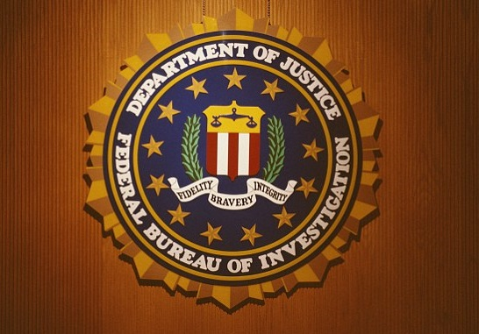
1 September 2017 Mr. Joseph M. Arpaio
Page 8 of 11

“Fidelity, Bravery, Integrity” ? Proclaim that at the grave site of the young boy pictured on Page 1 above? Perhaps that DOJ placard should be affixed to the grave site of Mr. Grant Ronnebeck?

Your attorney, Mr. Mark Goldman, recently provided the media with the following, a ruling that is well-known to current US Attorney General Jefferson Sessions (Attachment 4):

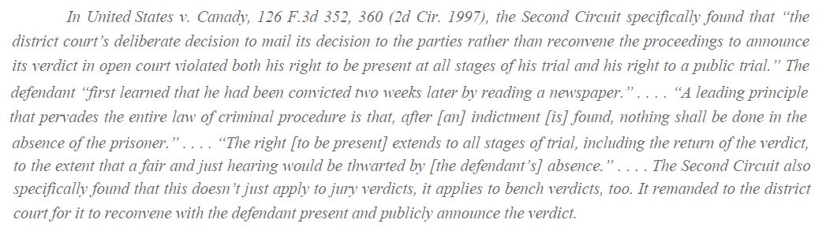

The very dangerous and highly promoted ruse is that the US Department of Justice acts as an independent and non-political agency; that their central guidance is the ‘Rule of Law.” The non-governmental news media also promotes that courts are disconnected from politics; also devoted to the ‘Rule of Law.’ Rubbish!

- Are we to believe that Judge Susan Bolton was not “enjoined” to proceed in your matter on the basis of her professional knowledge of the above Second Circuit ruling of TEN YEARS AGO?!

- Are we to believe that the basic rights of the accused or convicted, as merely reaffirmed by this ruling, were previously unknown to Judge Susan Bolton?

- Are we to believe that a President Clinton nominee, Judge Bolton, ruled on your issue, from the confines of her chambers, in a manner utterly devoid of political considerations?

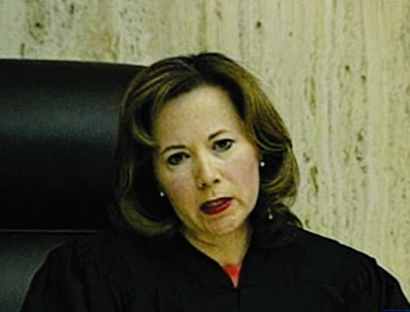

1 September 2017 Mr. Joseph M. Arpaio
Page 9 of 11

Conclusions

- Had I the courage and wherewithal to disobey the illicit ex parte order issued against me during the Christmas holidays, by a Michigan judge that later received Appeals Court campaign funds from the same Chrysler lawyers that rallied around the criminal conspiracy facilitated by the US Department of Justice, nine-year-old Brandon Auer would still be alive. Brandon would have been protected by his family’s knowledge of a safety defect that I had presented to Chrysler executives years earlier.

- Conclusion #1 has at least two illicit and illegal parallels to the “ruled from the chamber” stunt of Judge Susan Bolton regarding her ex parte ruling alleging your guilty verdict of contempt of court:

- You were not present or represented by counsel when a verdict of “guilty” was rendered by Judge Bolton.

- Slithering in the background were the politically motivated DOJ lawyers. Such are very similar in lack-of ethical character to those that had previously orchestrated fraudulent denials of FOIA requests involving critical safety defect information. The caption of Page 6 above suggests a leit motif at the DOJ.

- Proceed with all diligence in your appeal which demands a trial-by-jury wherein, in stark contrast to the ex parte stunt of Judge Bolton, the ‘finding of facts’ can be based on actual evidence and actual testimony which can be reliably used to lawfully adjudge your guilt or innocence:

- The various Michigan judges shuttered at the thought of my case(s) being tried in open court, in front of a jury. Owing to small town political corruption, we had confirmed ongoing personal relations and private activities between those judges and the Chrysler lawyers, not limited to weekly tennis! This confrontation ushered in a similar “ruled from the chamber” stunt wherein my case was secretly dismissed. The DOJ was pleased.

- Not only is there direct on-point legal precedent, but the United States Constitution provides for the granting of an open trial-by-jury in your Contempt of Court issue.

- Relating to Conclusion #3b, and the discussion on Page 8 above, I am of the opinion that not only should Judge Susan Bolton be removed from the bench, but her Bar Association membership should be suspended pending a full investigation of events leading to her ex parte ruling:

- I am confident that Judge Bolton might feign ignorance of the avoidable tragedy surrounding the murdering of 21-year-old Arizona taxpayer Mr. Grant Ronnebeck, by the illegal Mexican alien Apolinar Altamirano:

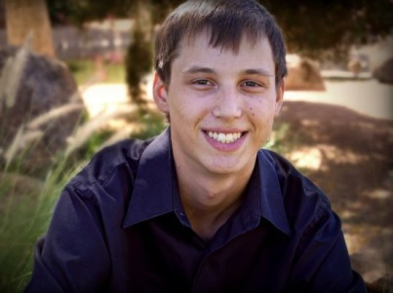 | 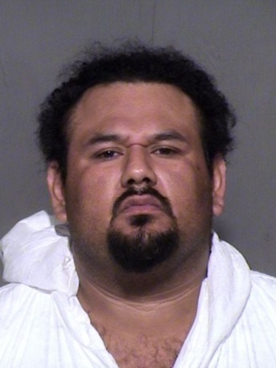
1 September 2017 Mr. Joseph M. Arpaio
Page 10 of 11

- I am confident that if Arizona law enforcement and the ICE were unhindered by the political condominium between federal judges and the US Department of Justice, unhindered by spurious accusations of profiling, that Mr. Ronnebeck would be alive.

- I am confident that Judge Bolton was “unavailable for comment” regarding Mr. Ronnebeck’s death.

- I am confident that had your office apprehended Mr. Altamirano prior to his murderous rampage, that Judge Bolton would have accused you of profiling or worse.

- I suspect that, like US Attorney General Loretta Lynch, Judge Bolton and federal judges of her ilk would be available for various political “tarmac” discussions but would routinely be unavailable to attend funerals for Arizona citizens such as Mr. Grant Ronnebeck.

- I am providing an open courtesy copy of this correspondence to both President Donald Trump and US Attorney General Jefferson Sessions:

- In practice the Mr. Sessions should be thoroughly involved in this matter, whereas the President should not have been compelled to issue a pardon. President Trump should instead rely on a presumed blind integrity and complete competence of the Federal Courts, and their bastions of the ‘Rule of Law’ at the US Department of Justice. Recent events confirm he could not do so.

- It is probable that by obeying the illicit court order against you, American citizens were placed in harm’s way, or indeed were victims of illegal aliens that otherwise would have been apprehended by your office. Again, death by a safety defect is no more final than murder by an illegal alien.

Regarding these Conclusions, we are dealing with, what is lauded as, the #1 law enforcement agency of the United States government . . . and time-and-time-again they have confirmed that they, their US Senate pundits, and their courthouse judges, cannot be trusted. If there is any portion of the Swamp that needs to be drained, it is the United Stated Department of Justice.

In response to those who would attempt to trifle with me, I would offer them the current contact information of Brandon Auer’s surviving family members.

Please do not hesitate to contact me at any time.

Respectfully,

Paul V. Sheridan

P.S. Admittedly there are well-founded concerns regarding the Ninth Circuit District Court of Appeals.

Attachments
1 September 2017 Mr. Joseph M. Arpaio
Page 11 of 11

Subject: The Horrific Consequences of OBEYING Illicit Court Orders

Reference 1: Pardon of Sheriff Arpaio by President Donald Trump

Reference 2: The United States Department of Justice (DOJ)

Reference 3: My Letter to Sheriff Joe Arpaio of 26 August 2016

Courtesy Copy List

President Donald J. Trump  The White House  1600 Pennsylvania Ave NW  Washington, DC 20500  202-456-1111 | Mr. Jefferson B. Sessions  US Attorney General  U.S. Department of Justice  950 Pennsylvania Avenue, NW  Washington, DC 20530-0001  202-514-2000
Mr. John F. Kelly  Chief of Staff  The White House  1600 Pennsylvania Ave NW  Washington, DC 20500  202-456-1111 | Ms. Kellyanne E. Conway  Counselor to the President  The White House  1600 Pennsylvania Ave NW  Washington, DC 20500  202-456-1111
Mr. R. Gil Kerlikowske  U.S. Customs and Border Protection  950 Pennsylvania Avenue, NW  Washington, DC 20530-0001  202-325-8000 | Secretary Elaine L. Chao  US Department of Transportation  1200 New Jersey Ave, SE  Washington, DC 20590  202-366-4000
Mr. John S. Leonardo  US Attorney for Arizona  Two Renaissance Square - Suite 1200  40 North Central Avenue  Phoenix, AZ 85004-4408  602-514-7500 | Judge Susan R. Bolton  United States District Court  Suite 522  401 West Washington Street, SPC 50  Phoenix, AZ 85003-2153  602-322-7570

