DDM Consulting
22357 Columbia Street
Dearborn, MI 48124-3431
313-277-5095
pvs6@cornell.edu

21 July 2017 VIA FEDEX Ground 1283181 – 00005081

President Donald J. Trump
The White House
1600 Pennsylvania Ave NW
Washington, DC 20500
202-456-1111

Subject 1: Withdrawal from the Paris Climate Accord

Subject 2: Upcoming Tyrannical Censorship of Climate Science Instigated by NGOs

Dear Mr. President:

Thank you for keeping your promise to withdraw the United States from the United Nations Framework Convention on Climate Change (UNFCCC), as re-specified by the Paris Climate Accord. You have made a brave, correct choice.

With the issue of integrity as central, I share an excerpt from a recent Washington Post (WP) article:

“The Arctic Ocean is warming up, icebergs are growing scarcer and in some places the seals are finding the water too hot, according to a report to the Commerce Department yesterday from
Consul Ifft, at Bergen, Norway.

Reports from fishermen, seal hunters and explorers, he declared, all point to a radical change in climate conditions and hitherto unheard-of temperatures in the Arctic zone. Exploration expeditions report that scarcely any ice has been met with as far north as 81 degrees 29 minutes. Soundings to a depth of 3,100 meters showed the gulf stream still very warm.

Great masses of ice have been replaced by moraines of earth and stones, the report continued, while at many points well known glaciers have entirely disappeared. Very few seals and no white fish are found in the eastern Arctic, while vast shoals of herring and smelts, which have never before ventured so far north, are being encountered in the old seal fishing grounds.”

The basis of this WP article was a report forwarded to the US Department of State . . . but please note, neither the original report or the WP article mentions the term “carbon dioxide.”

But let me apologize, my use of the phrase ‘recent’ is misleading . . . as is nearly everything we hear from the NGO news media . . . especially when they are regurgitating rants from the so-called climate scientists . . . or Big Academia, from whom many least expect a lack of integrity.

I apologize because the overleaf is the original source for the above WP article . . . entitled The Changing Artic . . . it is from the Monthly Weather Review of November 1922 !
21 July 2017 President Donald J. Trump
Page 2 of 28

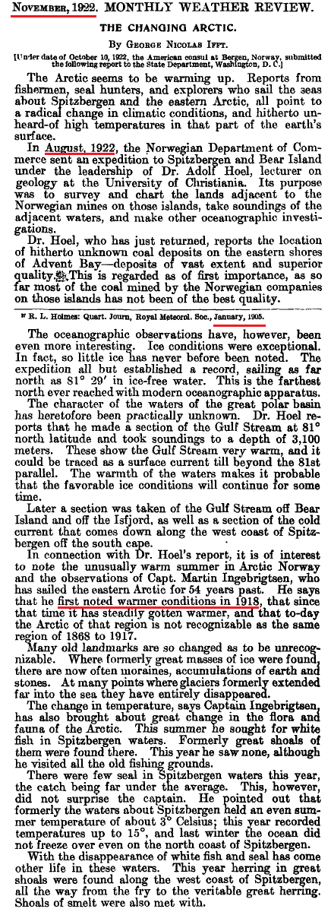

This November 1922 report predates the birth of the “Father of Anthropogenic Global Warming.”
21 July 2017 President Donald J. Trump
Page 3 of 28

The Climate Change Imbroglio: An Open Denunciation of Integrity by Big Academia

The archaic definition of imbroglio is “a confused heap.” It is an accurate descriptor of the current state of climate science. This imbroglio not only relates to the NGO news media, but to their condominium with Big Academia.

Regarding the latter, we quote the “Father of Anthropogenic Global Warming” (AGW), Stanford University Professor Stephen Schneider :

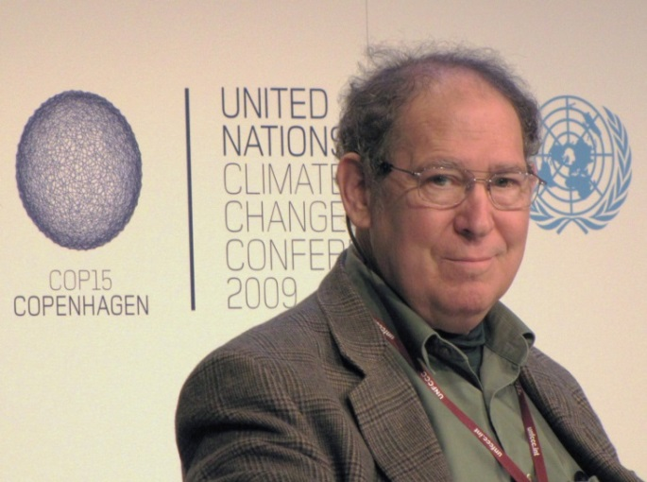

“ On the one hand, as scientists we are ethically bound to the scientific method. On the other hand, we are not just scientists but human beings as well.

To do that we need to get some broad based support, to capture the public’s imagination. That, of course, means getting loads of media coverage. So we have to offer up scary scenarios, make simplified, dramatic statements, and make little mention of any doubts we might have.

Each of us has to decide what the right balance is between being effective and being honest.”

But the open renunciation of (the strict requirements for) integrity by Big Academia is far more subtle, and esoteric, than that demonstrated by Professor Schneider . . . the esoterica involves a simple question that climate scientists refuse to answer.

21 July 2017 President Donald J. Trump
Page 4 of 28

The Climate Change Imbroglio: Big Academia versus a Simple Question

Note that I have copied the Ivy League, including my alma mater Cornell University. Not millions, but billions of taxpayer dollars pour into these institutions under the pretense of climate change research; now in response to their latest fund-raising term “sustainability.”

The Cornell home page (http://www.cornell.edu/ ) always emphasizes the following section:

Thee fundamental underpinning of the Cornell Center for Sustainability involves carbon dioxide. Big Academia in-general forcefully declares “what we know about climate change” . . . Their central thesis is:

Atmospheric carbon dioxide is positively correlated to global temperatures and, most emphatically, the CO2 that is attributable to human activity is thee primary cause of global warming; now re-marketed as “climate change.”

Whether visiting the Center for Sustainability, or Al Gore’s mansions, or the UNFCCC in Paris, the above declaration is deafening. They also claim that this rhetoric enjoys “the consensus of 97 per cent of scientists worldwide.” The latter is a lie.

For example, after our withdrawal from the Paris Accord, California Governor Jerry Brown reiterated this standard “carbon” rant:

“ Well immediate reaction is this is a crazy decision. It is against the facts. It is against science. It is against reality itself. We know we have to decarbonize our future. If we don’t, it is a horror. People will die. Habitat will be destroyed. Seas will rise. Insects will spread in areas they never have before. This is not a game. It is not politics to talk to your base. It is humanity and whether it makes it through the 21st century. California will stay the course.”

We “know” no such thing. In summary, the “consensus” has forcefully and loudly declared the following, and done so for decades :

- Carbon dioxide drives global climate, and is positively correlated to warming.

- Incremental “carbon” from human activity is THEE cause of recent global warming,
with other climate inputs being uncorrelated or of minor import.
21 July 2017 President Donald J. Trump
Page 5 of 28

The Climate Change Imbroglio: Big Academia versus a Simple Question - con’t

Perspective is needed before we get to my ‘Simple Question.’ The following is from the very good Learning Liftoff website. This screen shows that grammar school children can easily learn and calculate a statistical value called correlation coefficient:

I was taught the basic arithmetic concept of correlation in 8th grade by Mr. Robert Edebohls, my Junior High School math teacher at Washingtonville Central High School, in Washingtonville, New York.

21 July 2017 President Donald J. Trump
Page 6 of 28

The Climate Change Imbroglio: Big Academia versus a Simple Question - con’t

For decades the United Nations Intergovernmental Panel on Climate Change (IPCC) refuses to answer my Simple Question:

“ What is the correlation value, and the R-squared value, between atmospheric carbon dioxide in PPM and global temperatures;
please specify the time period for the values you offer? ”

The IPCC, in their never-ending parade of “assessment reports” (AR-1, AR-2, AR-3, AR-4 and AR-5), refuses to state an R-Squared value, and they only insinuate correlation. AR-5 muses, quote:

"It is extremely likely that more than half of the observed increase in global average surface temperature from 1951 to 2010 was caused by the anthropogenic increase in greenhouse gas concentrations . . .”

Their phrase ‘extremely likely’ is abusive, and has no connection to the rigors of science. We must emphasize, their crux is that atmospheric CO2, especially from human activity, drives global climate and is positively correlated to recent alleged “global warming.”

In late 2009, my suspicions about Big Academia in these matters were exposed, worldwide, by a travesty known as ClimateGate. Big Academia wants us to forget about ClimateGate. Not a chance.

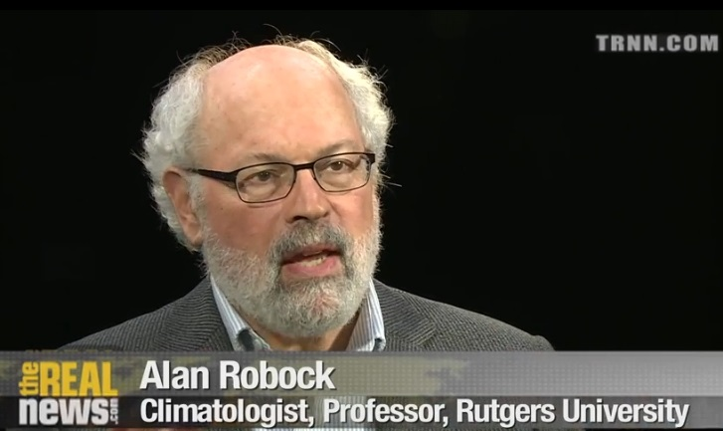
In the context of ClimateGate
I attempted to interview alleged climate experts. Of my twenty-odd attempts, only two had the courtesy and integrity to respond.

One cordial fellow was
Professor Alan Robock of Rutgers University, former researcher for the National Oceanic and Atmospheric Administration (NOAA), and “contributor” to the IPCC.

When I asked him my Simple Question (above), he stated:

“ That question is too simplistic. The correlation value is high but correlation does not mean cause and effect.”

Here we have a strident advocate of the Paris Accord declaring that its crux is “too simplistic” ?! Robock was very polite, and very generous with his time. But I had asked this climatologist for a number, not an unsubstantiated subjective personal assessment.

Even if you presume that Professor Robock had a basis for his claim that “the correlation value is high,” we are compelled by the second part of his, albeit, unsolicited response.
21 July 2017 President Donald J. Trump
Page 7 of 28

The Climate Change Imbroglio: Big Academia versus a Simple Question - con’t

(A quick tutorial on correlation.)

Professor Robock’s statement , “correlation does not mean cause and effect.” might seem to rebut the argument implied by my Simple Question. It is does not, it supports it !

We examine an example wherein he is correct; there are many. First, we measure and tabulate the increase in a boy’s height over a ten year period from age 1 to age 11. Then, for sake of argument, we assume this ten year period also includes a yearly rise in global temperatures. We then measure and tabulate the latter. We now have two data sets.

Now, we go to the grammar school website (Page 5), input these two data sets, and calculate the correlation value; a number that ranges from negative one to positive one. Because the boy’s height and the global temperatures are both increasing, the calculated R value would be “high” and positive. This would seem to suggest a ‘cause and effect’ connection.

Of course, it is absurd to suggest that this example has merit; there in no cause-effect connection between those data sets; here Robock is correct: “correlation does not mean cause and effect.”

But let us now examine the opposite; where the two data sets are already forcefully declared as being correlated, wherein the merit is so high that it enjoys a “97% consensus.” After all, the very crux of the Paris Accord asserts:

Atmospheric carbon dioxide is positively correlated to global temperatures and, most emphatically, the CO2 that is attributable to human activity is thee primary cause of global warming; now re-marketed as “climate change.”

There is nothing “too simplistic” in their marketing onslaughts directed at the naivety of humanity.

In terms of the Scientific Method, when an effect has a theoretical cause, but the correlation value is very small (positive, negative or zero), then the theory is discarded as false by scientists with integrity. The Paris Accord is based on the exact opposite:

So . . . If their ‘CO2 equals global warming’ connection is true, and therefore correlated, then climate scientists should be specifying/quantifying and proclaiming with unbridled pride their “high” R value . . . from every snow-covered mountain on Planet Earth!

Instead, they refuse to answer my Simple Question.

Al Gore also has no problem asserting the ‘CO2 equals global warming’ connection. In his discredited film, ‘An Inconvenient Truth,’ Gore stands before tabulated graphs, which he alleges depicts his fundamental claim ( these did not ); quote:

“ The relationship is actually very complicated, but there is one relationship that is far more powerful than all the others, and it is this, when there is more carbon dioxide the temperature gets warmer, because it traps more heat from the sun inside. ”

Gore singles-out the crux of the Paris Accord: CO2 is the culprit that drives global warming, as “more powerful than all the others.” That is, he asserts that CO2 is positively correlated to temperatures.
21 July 2017 President Donald J. Trump
Page 8 of 28

The Climate Change Imbroglio: Big Academia versus a Simple Question - con’t

First, they forcefully assert that the ‘CO2 equals global warming’ connection is absolutely true; that increases in CO2 and alleged increases in global temperatures are positively correlated.

But then my Simple Question is dismissed as “too simplistic.”

Confirming their duplicitous position, simplicity was deemed to be of great utility to the “Father of Global Warming,” Stanford University Professor Schneider who demanded :

“ So we have to offer up scary scenarios, make simplified, dramatic statements, and make little mention of any doubts we might have.” (Page 3 above)

There are many reasons why Big Academia refuses to answer my Simple Question. Some of these reasons involve the issue of integrity.

In 2009, when a blatant lack of integrity of Big Academia was exposed by ClimateGate, I interviewed the director at the Cornell Center for Sustainability, Professor Frank DiSalvo. I asked him to respond to the documented fraud and outright criminality of the scientists exposed by ClimateGate :

“There’s no doubt people know about it (ClimateGate), and are chagrined by it.”

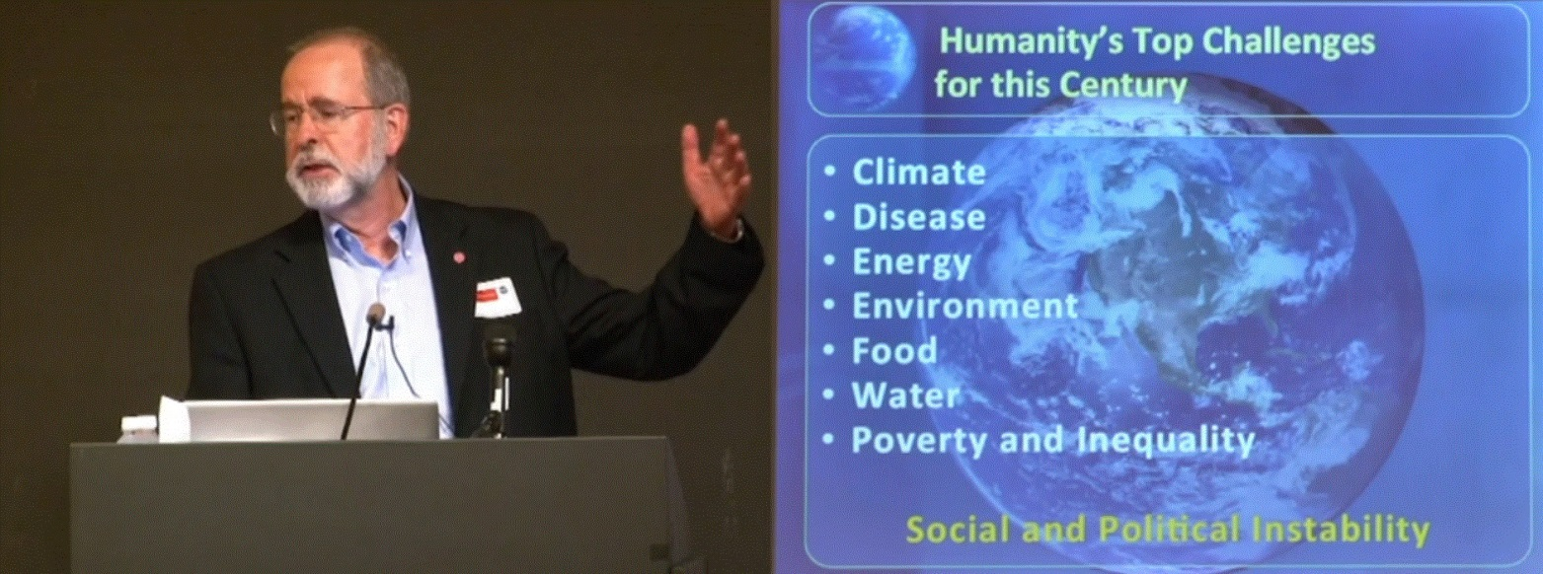

But note the irony . . . according to Cornell University, “Climate” is the priority facing humanity, not ethics or integrity. But to further his chagrin I then posed my Simple Question to Professor DiSalvo:

“ What is the correlation value, and the R-squared value, between atmospheric carbon dioxide in PPM and global temperatures;
please specify the time period for the values you offer? ”

Similar to Professor Robock, Professor DiSalvo was very cordial and generous with his time; unlike the other so-called “climate scientists” who refused to respond.
21 July 2017 President Donald J. Trump
Page 9 of 28

The Climate Change Imbroglio: Big Academia versus a Simple Question - con’t

Review of Page 4 above reveals that thee underpinning of the Cornell Center for Sustainability involves the decades-old assertion that there is a positive correlation between increased CO2 and the alleged increase in global temperatures.

In 2009, Professor DiSalvo responded to my Simple Question as follows:

“ There’s no simple one (answer) because so many other factors come in to it. That’s why it’s so difficult.

So, for example, if CO2 does start to cause atmospheric warming, that also causes increases of water vapor going into the atmosphere, which does one of two things, or it does both things. And it’s a question of which predominates. Water vapor itself is a greenhouse gas, in fact it’s the most predominant greenhouse gas in the atmosphere. So, that effect would tend to warm up the atmospheric even more. On the other hand if the water vapor condenses and forms clouds, then you ask what kind of clouds; certain clouds are very reflecting, so that they reflect the sunlight back out into space and that leads to cooling. Other clouds turn out to be absorbing, and they actually will heat the atmosphere; depends on their altitude and their shape, and what’s in the cloud. And so, trying to figure out; that’s just one example, there’s a whole bunch of other things that determine what happens, like ocean currents, and all, and all of these things have to be put it. And they’re all coupled to each other.

So it’s like a giant machine with about, you know, thousands of wheels that are all connected to each other, and I’m going to wiggle one wheel, and ask what happens to the other thousand or how the other thousand respond to produce something on the other side; that’s a hard question. That’s a really tough job.

So, in general, what you can say, what climate scientists try to do, is they look at all the different pieces that they at least presently know about, and say if that one increases what does it do to; and climate change is a lot more than temperature. It has to do with precipitation; not so much global temperature as local temperature that’s important, some places in climate change will actually get colder because they get much cloudier in those places, so it’ll get colder. But then the Artic; in every model that I have looked at, and at least current data suggests the Artic is warming up a lot more than the rest of the planet.

So the questions you ask have to be a lot more detailed than just what’s happening to global temperature. ”

DiSalvo’s very first utterance provokes further examination of Page 5 above.

But more importantly, what follows demonstrates that my Simple Question is not “a really tough job.”

21 July 2017 President Donald J. Trump
Page 10 of 28

The Climate Change Imbroglio: Big Academia versus a Simple Question - con’t

Of the twenty-odd non-responses and non-answers that I received, from so-called climate scientists, DiSalvo’s delivery and tone was the most polite. Unfortunately it too was no more than a convoluted, pseudo-sophisticated diversion.

But if this so-called “settled science” confirms that increased CO2 is positively correlated to increases in global temperatures, then my Simple Question should be welcomed, not shunned!

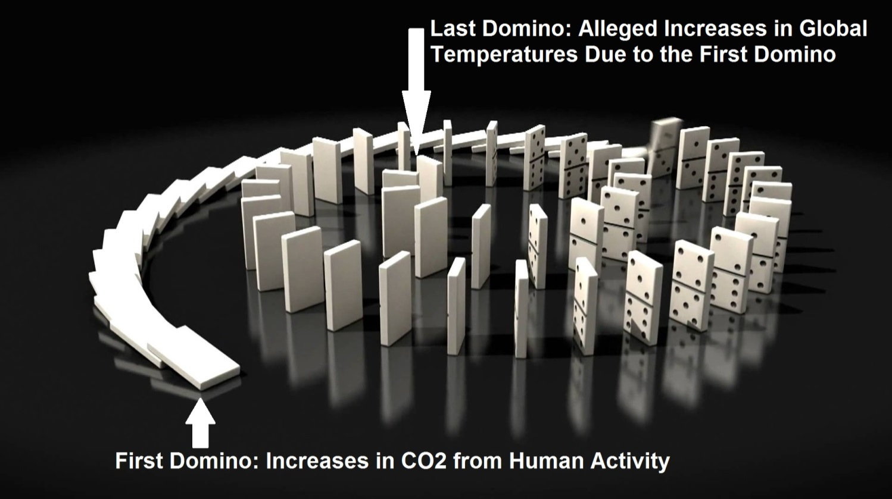

In fact, it was in that context that I did not ask him for the intermediate couplings and their individual correlation values. I asked for the correlation value between HIS first domino and HIS last domino (as depicted above). Consistent with the assertion that CO2 drives climate change :

- I did not ask for the correlation between CO2 and water vapor,
- I did not ask for the correlation between CO2 and clouds that reflect and cool,
- I did not ask for the correlation between CO2 and clouds that absorb and warm,
- I did not ask for the correlation between CO2 and shapes of clouds,
- I did not ask for the correlation between CO2 and what is inside clouds,
- I did not ask for the correlation between CO2 and ocean currents,
- I did not ask for the correlation between CO2 and “a whole bunch of other things”,
- I did not ask for the correlation between CO2 and wiggling wheels,
- I did not ask for the correlation between CO2 and “giant machines.”

His response (page 9) lacks professional etiquette . . . With a Bachelor’s degree in physics from MIT, a PhD in Applied Physics from Stanford, Professor DiSalvo is fully aware that the intermediate dominos do not, in any way, obviate an answer to my Simple Question. His was a non-answer:

In stark contrast, such is not what he conveys to Cornell students. And it certainly is not what he conveys to the public when fundraising for “reduction of Cornell’s carbon footprint.”
21 July 2017 President Donald J. Trump
Page 11 of 28

The Climate Change Imbroglio: Big Academia versus a Simple Question - con’t

Is it possible that all of this has changed? That their ‘CO2 equals global warming’ rant has been modified, or diminished as their public relations and climate science priority. Not a chance!
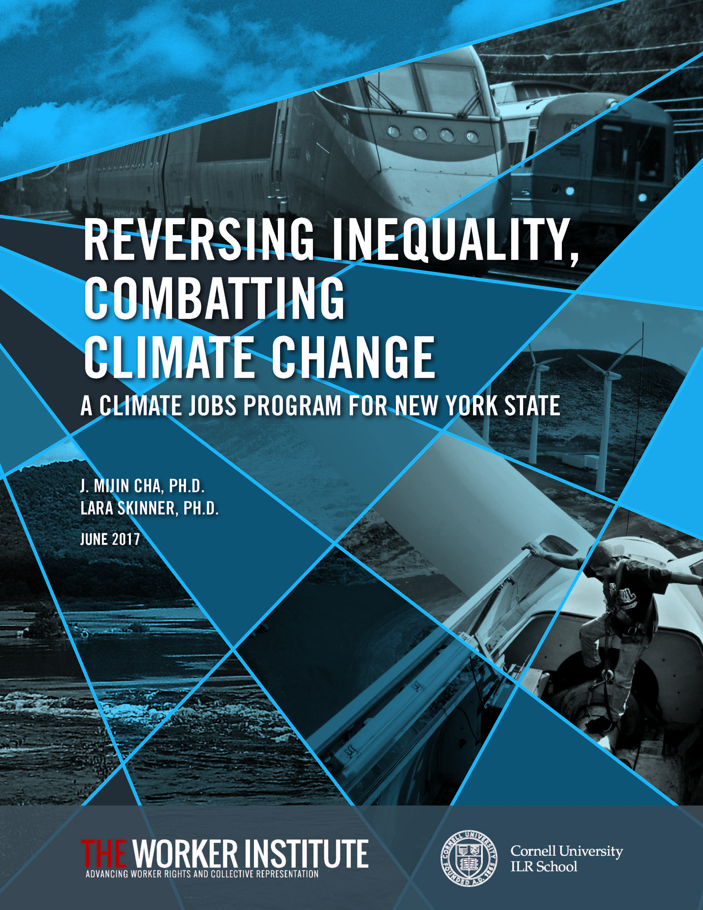
A few weeks ago, Cornell University published a taxpayer funded Malthusian ruse called:

REVERSING INEQUALITY, COMBATTING CLIMATE CHANGE : A Climate Jobs Program for New York State

Now, we have “climate jobs” ?!

But a direct question could be asked:

How many of the proposed “climate jobs” are oriented at quantities or factors other than carbon dioxide?!

I analyzed this 68-page report, searching for the “many other factors” mentioned by Professor DiSalvo in non-response to my Simple Question.

That is, in the context of Professor DiSalvo’s non-response, I searched for terms that allegedly obviate an answer to my Simple Question. A tabulation is shown in the table below:

“Many Other Factors” Terms Usage in  New York ‘Climate Jobs’ Report | Frequency of Usage in ‘Climate Jobs’ Report
water vapor | 0
clouds that reflect and cool | 0
clouds that absorb and warm | 0
shapes of clouds | 0
what is inside clouds | 0
ocean currents | 0
a whole bunch of other things | 0
wiggling wheels | 0
giant machines | 0
Memo: Carbon or Carbon Dioxide | 61

“ What is the correlation value, and the R-squared value, between
atmospheric carbon dioxide in PPM and global temperatures;
please specify the time period for the values you offer? ”
21 July 2017 President Donald J. Trump
Page 12 of 28

The Climate Change Imbroglio: Big Academia versus a Simple Question - CONCLUSION

Although unsolicited, Professor DiSalvo also emphasizes, “Water vapor itself is a greenhouse gas, in fact it’s the most predominant greenhouse gas in the atmosphere.” Correct.

Not relevant to my Simple Question, I did not ask him to assess the H2O emissions from nuclear power plants, such as Beaver Valley in Pennsylvania; a short drive from Cornell University:

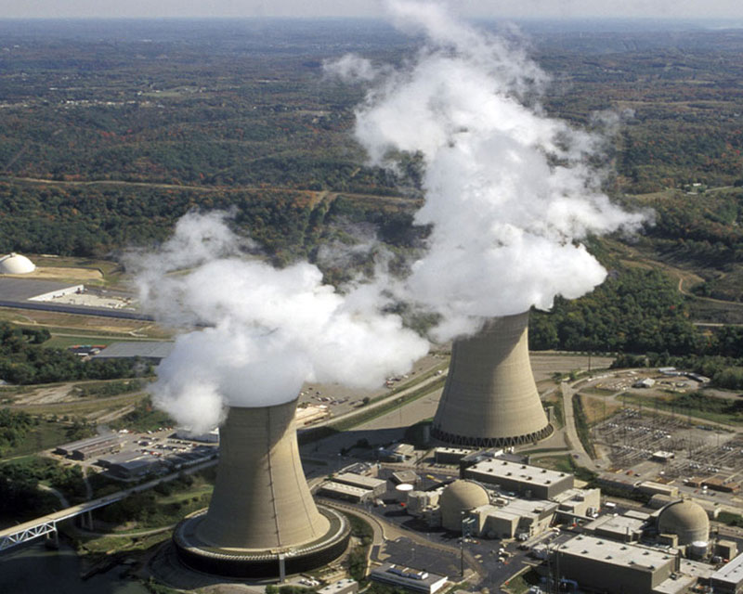

In his farcical film, Al Gore says we have data covering “650,000 years.” There is so much climate data, that an answer to my Simple Question can be calculated by grammar school students, or meteorologists . . . a calculation that implicitly accounts for the intermediate dominos (Page 10) :

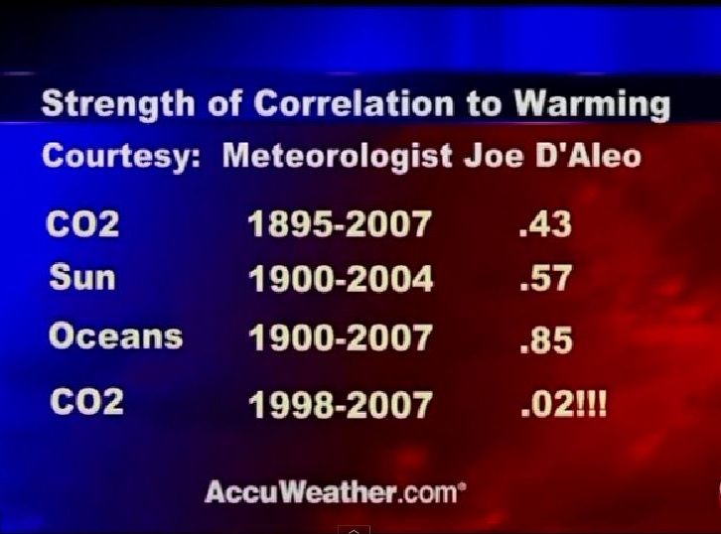

During the time that I was being rebuffed by NASA, NOAA, and various ClimateGaters, I interviewed retired meteorologist Mr. Craig James who had calculated conjoint values for similar time periods:

In James’ opinion, the solar-ocean conjoint calculated for similar periods is +0.88 !
21 July 2017 President Donald J. Trump
Page 13 of 28

Implicit Assumption of a Correlation Value in their Climate Models

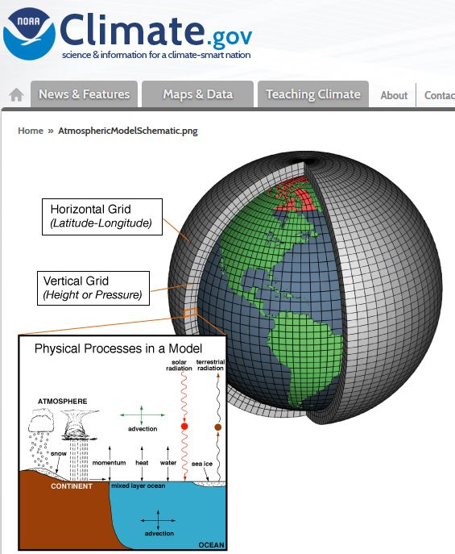
The US taxpayer funds the National Oceanographic and Atmospheric Administration (NOAA). Professor Alan Robock of Rutgers is very familiar with NOAA’s its work, especially the section dedicated to computer climate modeling (pages 6/7 above).

NOAA explains that its climate models use
“advanced equations which are based on the fundamental laws of physics, fluid motion, and chemistry.” Again, my Simple Question:

“What is the correlation value, and the R-squared value, between atmospheric carbon dioxide in PPM and global temperatures; please specify the time period for the values you offer? ”

The models, that the taxpayers have been funding for decades, implicitly use (or iterate) as part of their algorithmic structure the underlying assumption that there is a positive correlation between atmospheric CO2 and global temperatures. Note, this is not an actual correlation or R-squared valued, this is an assumed value:

But their lack of response to my Simple Question is insidious: The climate models implicitly will not run unless these assumed correlation values are “plugged in” to the data section. Most insidious, the correlation values that are necessarily assumed in the models, and the actual correlation of the climate system response, do not converge . . . and never have.

Their Open Accusation: You are Insane
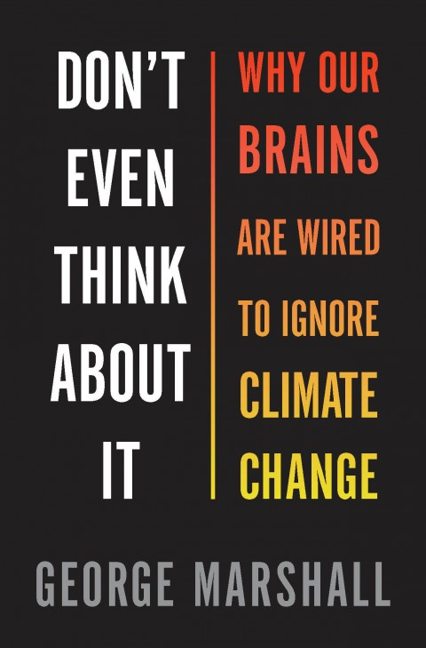

A popular yarn among so-called climate scientists is a book that openly declares that members of the human race are insane for merely questioning the notion that CO2 drives global climate.

In fact, during a recent visit with Professor DiSalvo, in his Clark Hall office on the campus of my alma mater, he proudly shared his copy of George Marshall’s book with me. He is among many who promote, not only its readership, but its portent.

The next section will also lay the context for Subject 2 of this letter. In the next section the truly insane will be exposed.

But . . . as we will see, the types of books shown at-left were not among those identified for censorship by a foreign NGO . . .

21 July 2017 President Donald J. Trump
Page 14 of 28

Their Unbridled Vileness

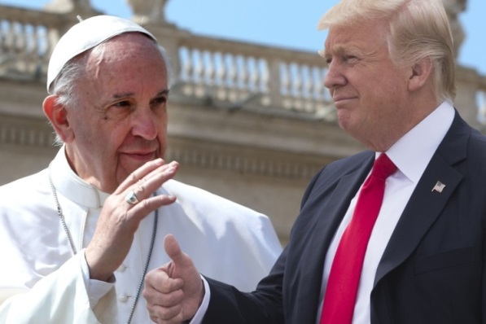
On May 24, 2017, Pope Francis handed you a signed copy of his 184-page ‘Encyclical Letter, Laudato Si` of the Holy Father Francis on Care for Our Common Home.’ The Washington Post declared that his letter:

“. . . called for a new partnership between science and religion to combat human-driven climate change.”

Reading this two-year-old tome, I noted he used the term carbon or carbon dioxide seven times.

That is, the Pope promotes the notion that carbon dioxide is positively correlated to “climate change.”

But for sake of comparison, let us presume his “partnership between science and religion” as a basis for enforcing a faith in the notion that ‘CO2 equals global warming.’ Picture the following . . .

The faithful have strayed; they do not act upon the papal edicts of “human-driven climate change.” Hearing of their blasphemy, Pope Francis pronounces the following diatribe to all Christians, Catholics in particular (fictional) :

‘ I would like to say we're at a point where global warming is impossible to deny. Let's just say that global warming deniers are now on a par with Resurrection Deniers, though one denies the past and the other denies the present and future.’

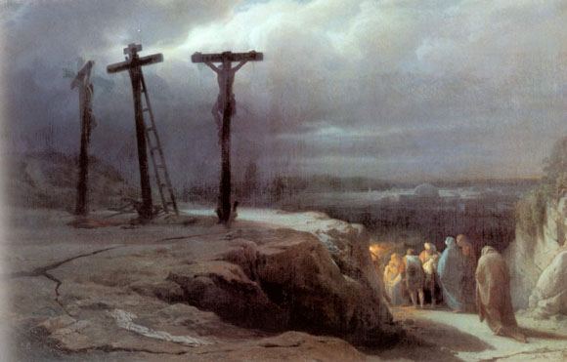

Pope Francis would never state anything so vile. And he certainly did nothing close in Laudato Si`. One can imagine the outrage from the NGO news media!

But you and the Pope, and Big Academia, have failed to chastise those that have already deployed the very same vileness; a vileness that is unprecedented in recent science . . . in fact, the above fiction is an exact paraphrasing of the next very well-known quote:
21 July 2017 President Donald J. Trump
Page 15 of 28

Their Unbridled Vileness – con’t

“I would like to say we're at a point where global warming is
impossible to deny. Let's just say that global warming deniers
are now on a par with Holocaust deniers, though one denies
the past and the other denies the present and future.”

Ellen Goodman of the Boston Globe.

- What follows is a small sampling of equivalent vileness:
“ Currently, about 300 thousand people die every year from the
effects of climate change, with another 325 million seriously
affected, primarily because of reduced access to fresh and
safe drinking water. At its core, global warming denial is like
Holocaust denial, an assault on common decency. ”

Banker, David Federer.

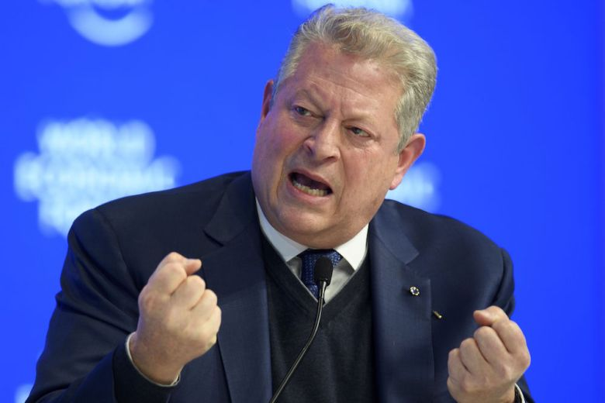
" Clouds of a different sort signal an environmental holocaust without precedent. Once again, world leaders waffle, hoping the danger will dissipate. Yet today the evidence is as clear as the sounds of glass shattering in Berlin."

Filmmaker Al Gore.

" I wonder what sentences judges might hand down at future international criminal tribunals on those who will be partially
but directly responsible for millions of deaths from starvation,
famine and disease in decades ahead. I put this in a similar
moral category to Holocaust denial."

Mark Lynas, author of the book, The God Species: How the Planet Can Survive the Age of Humans.’

21 July 2017 President Donald J. Trump
Page 16 of 28

Their Unbridled Vileness – con’t

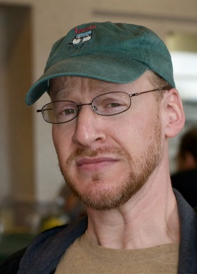
" A lot of them complain because they say the word denial puts
them in the same bin as holocaust deniers. That's too bad. But
the thing is, they do have something in common: a denial of
evidence and of scientific consensus. "

Phil Platt, Big Bang astronomer.

" An Inconvenient Truth is so convincing that it makes
opposers of the argument as credible as Holocaust deniers. "

Jon Niccum, NGO news reporter.

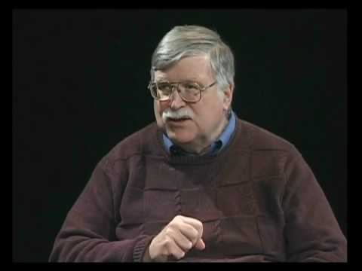
“Bluntly put, climate change deniers pose a
greater danger than the lingering industry that
denies the Holocaust.”

Joel Connelly, NGO News reporter

"Others working to derail this critical piece of legislation will
be seen as the Adolf Hitler’s of our day, contributing to a
holocaust vastly eclipsing the horrors of World War II."

Chad Kister, author of ‘How Global Warming is Destroying One
of the World's Largest Wilderness Areas’ (Kister is referring to the Artic, please review page 2 above).

21 July 2017 President Donald J. Trump
Page 17 of 28

Their Unbridled Vileness – con’t

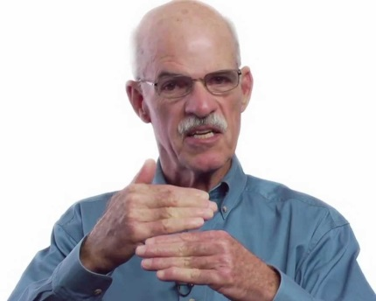
" Those who abjure global warming are not skeptics;
they are deniers. To call them skeptics is to debase
language as much as to call the Ku Klux Klan ‘prejudiced, Holocaust deniers ‘biased,’ or Flat-Earthers ‘mistaken.’ ”

James Powell, National Physical Science Consortium.

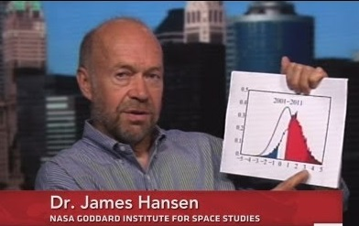
“ If we cannot stop the building of more coal-fired power plants, those coal trains will be death trains – no less gruesome than if they were boxcars headed to crematoria . . . ”

James Hansen, former member of the taxpayer funded vested interest NASA.

" Denialism, a concept that was first widely used,
as far as I know, for those who claimed that the
Holocaust was a fraud, is the concept I believe
we should use."

Professor Robert Manne of La Trobe University,
Melbourne, Australia

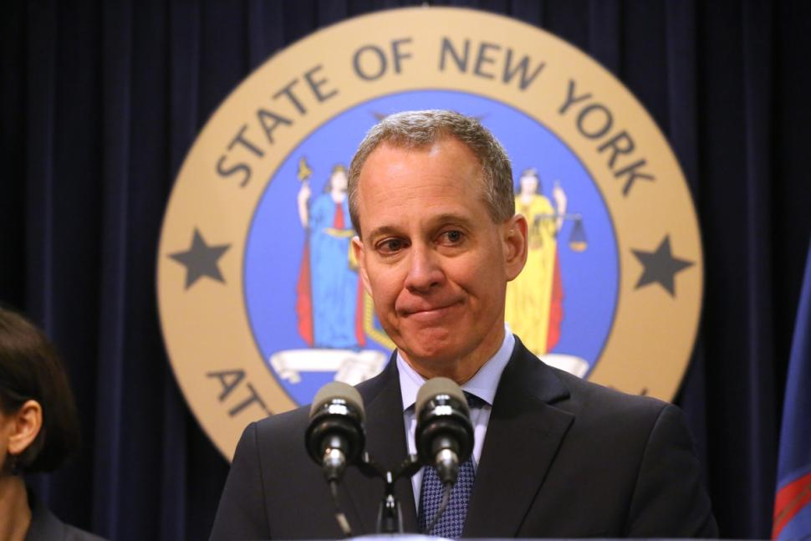

“They (Exxon-Mobil) have been funding organizations that are climate change
deniers.”

New York Attorney General Eric T. Schneiderman,
deploying “denier” vernacular when alleging fraud by now Secretary of State Rex Tillerson,
ex CEO of Exxon-Mobil.

21 July 2017 President Donald J. Trump
Page 18 of 28

Their Unbridled Vileness – CONCLUSION

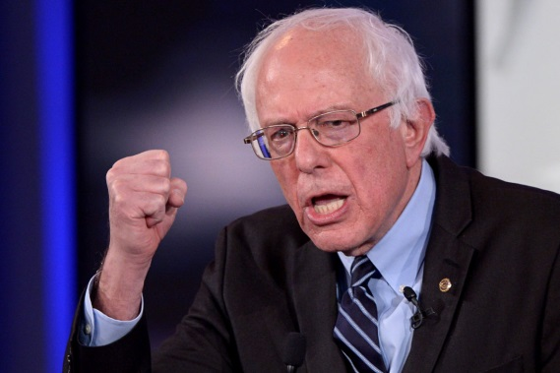

" It (climate change denial) reminds me in some
ways of the debate taking place in this country
and around the world in the late 1930s – there
were people - who said 'don't worry! Hitler's
not real! It'll disappear! "

Ex-Presidential Candidate Bernard Sanders.

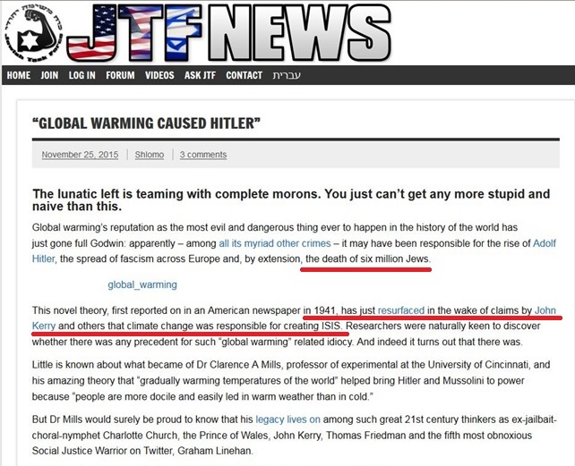

The above is a small sampling of the desperate status and ever diminishing stature of those academicians, climate scientists, and their mouthpieces in the NGO media, that are irretrievably tethered to their failed notion . . . the notion that ‘CO2 equals global warming.’

But this sampling is far more than that . . . it is indicative of their collective inveracity . . . an inveracity that will soon advocate, enact, and then enforce Subject 2 of this letter.
21 July 2017 President Donald J. Trump
Page 19 of 28

Subject 2: Upcoming Tyrannical Censorship of Climate Science Instigated by NGOs :
Yad Vashem, Climate Bolsheviks, and Big Academia

It is unknown if, during your May 24, 2017 visit to Yad Vashem, you questioned its director, Robert Rozett, regarding his solicitation and receipt of censoring what Americans are allowed to read:

21 July 2017 President Donald J. Trump
Page 20 of 28

Subject 2: Upcoming Tyrannical Censorship of Climate Science Instigated by NGOs :
Yad Vashem, Climate Bolsheviks, and Big Academia - con’t

But you are aware that Rozett characterized his demand to Amazon billionaire CEO Jeff Bezos as a request to “curb the spread of hatred.”

Since when in the history of humankind has intellectual censorship curbed hatred?

On the other hand, to the best of my knowledge, people like Director Rozett have never chastised, at any level, the charlatans on pages 15 thru 18 . . . for the repulsive blaspheming of the portent of Yad Vashem. It is not difficult to assert why no such revulsion has occurred.

In any case . . . it appears your role as the American president, and your declarations about “America First” have tacitly submitted to restrictions that potentially violate your duty under the United States Constitution.

At your June 1, 2017 Rose Garden news conference, you withdrew the US from the Paris Accord, declaring that you “were elected to represent the citizens of Pittsburgh, not Paris.”

But relevant to that laudable decision, you failed to alert Americans to the fact that a censorship of what they can read in regard to climate science is also a mere legalistic stepping stone away . . .

You are not alone in your accommodation, if not participation, in allowing a foreign NGO to dictate what America is allowed to read or watch or think . . . about . . . anything :

But . . . contrary to their self-absorbed self-image . . . Big Academia is in lock-step with Yad Vashem and Jeff Bezos (below) . . . we are at the point where making “Climate Denial” a criminal offense with mandatory incarceration . . . is merely . . . academic.

21 July 2017 President Donald J. Trump
Page 21 of 28

Subject 2: Upcoming Tyrannical Censorship of Climate Science Instigated by NGOs :
Yad Vashem, Climate Bolsheviks, and Big Academia - con’t

Is my last paragraph of Page 20 above the ranting of a loon? If so, I am apparently not alone . . .

. . . but in the opposite sense versus those that have debased science to a level not seen since the brutal murdering of the Christian czar and his family by Jacob Schiff and his Soviet era Bolsheviks:

If there was a single operative in the drawn-out existence of the Soviet Union, it was censorship.

In truth, millions were murdered, and the worst environmental disaster in the history of Planet Earth (World War II) occurred because of this “meddling” . . . and this “collusion”!

As you and Yad Vashem are fully aware, so-called “sovereign nations” have already made public disagreement with any aspect of the Shoah Theology punishable with mandatory incarceration. The list of “sovereign nations” continues to grow, and currently includes:

Australia, Austria, Belgium, Bosnia-Herzegovina, Czech Republic, France, Germany, Hungary, Israel, Liechtenstein, Lithuania, Luxembourg, Netherlands, Poland, Portugal, Romania, Spain, and Switzerland.
21 July 2017 President Donald J. Trump
Page 22 of 28

Subject 2: Upcoming Tyrannical Censorship of Climate Science Instigated by NGOs :
Yad Vashem, Climate Bolsheviks, and Big Academia - con’t

Again, is the undersigned a loon? Or has a Nuremburg-styled criminal connection already been publically proposed which connects the existing practice of imprisonment of “Holocaust Deniers” to that of “Climate Deniers”?

Similar to the recent readership ban implemented in the USA by Yad Vashem regarding “Holocaust Denial,” is this Climate Denier imprisonment proposal also advocated under the guise of “curbing the spread of hatred” ? A few examples among many:

" David Irving is under arrest in Austria for
Holocaust denial. Perhaps there is a case
for making climate change denial an offence –
it is a crime against humanity after all. ”

Margo Kingston, Member of the NGO News media
in Australia, where mandatory incarceration of
“Holocaust Deniers” is already law.

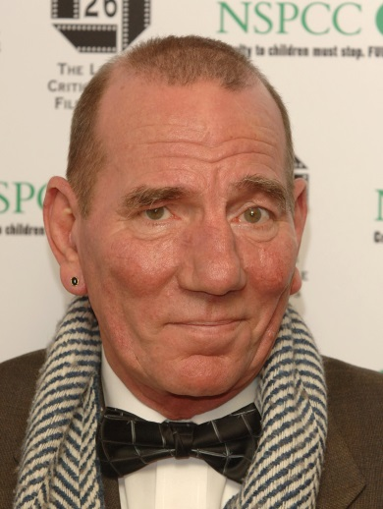

“There are now proposals that
‘global warming deniers’ be treated
the same as ‘Holocaust deniers:
professional ostracism, belittlement,
ridicule and, even jail.”

Peter William Postlethwaite, Movie Industry

" It's about the climate-change denial industry.
We should have war crimes trials for these
bastards - some sort of climate Nuremberg. "

David Roberts, NGO news reporter.

21 July 2017 President Donald J. Trump
Page 23 of 28

Subject: Upcoming Tyrannical Censorship of Climate Science Instigated by NGOs :
Yad Vashem, Climate Bolsheviks, and Big Academia - con’t

Cornell University welcomed its 14th president, Ms. Martha Pollack. A sampling of her quotes prior to inauguration:

“This is an educational institution, so I prefer to look at this as an opportunity where we, as a community, are
educating one another about the
value of free speech.”

“By far the most important (value) is integrity. Without integrity, you don’t have trust, and without trust, you don’t get anywhere. I think that when two people trust each other, you can make lots of progress even if you vehemently disagree. For me, starting from a point of integrity is essential.” *

* To her credit, President Pollack is in disagreement with Israeli Educational Minister Naftali Bennett who advocates limiting academic freedoms and free speech, on the basis of one’s “political worldview.”

Also reported in the Cornell Chronical:

“Her passion also shone through when describing her ‘fundamental, unwavering commitment’ to free speech. That means free speech should be afforded to everyone, she said, and not just people with whom you agree.

‘That can be difficult,’ she said. ‘That means you have to be willing to accept offensive speech. But history has shown that when you take away free speech and start clamping down on freedom of expression, it’s marginalized groups that suffer most.’”

Her background is mostly Big Academia, so these good, but trendy proclamations are not surprising. Her biography gives no indication that her alleged “fundamental, unwavering commitment” to these values has been thoroughly tested . . . at levels such as personal sacrifice, etc.

For example, I can assure you that Cornell President Pollack, as well as Big Academia, is fully aware of the “Holocaust Denial” censorship demanded by Yad Vashem and then deployed by their new lackey, Jeff Bezos lackey at Amazon.com:

Indeed . . . nowhere will you find President Pollack, or an administrator of any major educational institution, whom routinely tout trendy proclamations about “free speech,” and therefore having denounced this recent Bolshevik-styled censorship.

No outrage has been lodged by Big Academia regarding the condominium between Yad Vashem and Amazon.com, et al. Not a peep! Given how deeply vested they are, I am confident that Big Academia would similarly not oppose laws and censorship which support their dogmas of “climate change.”
21 July 2017 President Donald J. Trump
Page 24 of 28

Subject 2: Upcoming Tyrannical Censorship of Climate Science Instigated by NGOs :
Yad Vashem, Climate Bolsheviks, and Big Academia – CONCLUSION

We can presume that Cornell University President Pollack is aware of the statements of the charlatans shown on Pages 15 through 18, and 22 above.

We can presume Pollack’s familiarity with the statements of Professor Schneider (Page 3 above). She knows that such violates the tenets of the Cornell University Code of Academic Integrity. In that context and others, I am deeply “chagrined” if my alma mater is in-any-way associated with :

- The Climate Change imbroglio which openly requires renunciation of personal and professional integrity

- The enforcement or encouragement of censorship

- Operating philosophies and public posturing that reek of duplicity

- Slander / Libel and the many other forms of vitriol and diatribe

- The notion that the rigors of the Scientific Method will be subjected to and/or answerable to various belief systems (Shoah, Catholicism, etc.)

- Open or tacit threats of incarceration against those with whom there is alleged
“vehement disagreement.”

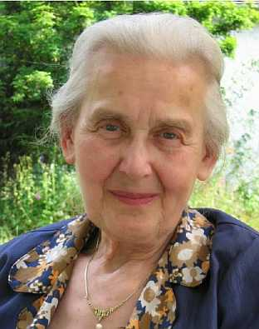
Nowhere will you find statements by any Big Academia administrator condemning the recent Bolshevik-styled
Yad-Vashem/Amazon censorship.

But this complicity already has a parallel precedent . . .

You will not find from Big Academia, most especially
from their highly vaunted “Law Schools,” open condemnation of the viciousness demonstrated in the
fate of 88-year-old Ms. Ursula Haverbeck:

With complicit behaviors, legal precedents, and now open promotions of “Climate Denier” laws already in plain view, will enactment of this Bolshevik-styled tyranny in the USA be attempted?

Mr. President, with the current epoch defined by the picture of Page 14; and with so much ego and money involved . . .

The answer is an emphatic, “YES!” The climate Bolsheviks are already preparing the public for acceptance of “Climate Denier” laws.
21 July 2017 President Donald J. Trump
Page 25 of 28

Observations

- Congratulations on your decision to withdraw from the Paris Climate Accord; its pundits refuse to state a defensible correlation value to its alleged genesis: ‘CO2 equals Global Warming.’

- At present, the taxpayer funded vested interest group called NASA is still ranting about:

“unprecedented loss of ice in the Artic.”

Many had challenged these absurd proclamations. Recently, since our push-back, NASA has now deployed a revised, coyly worded rhetoric:

“the lowest in the satellite record.”

When I broached the 1922 reports (Page 1/2 above), NASA refused to comment. When I asked their External Relations to acquire and assert an answer to my Simple Question, NASA refused to answer. As of this letter I have still not received a response.

In conversations I have asked about the well-known fact that for decades planet Mars and the outer planets have exhibited “Global Warming.” This planetary warming is ongoing.

- Central to the Paris Accord (and earlier IPCCs), the ‘CO2 equals Global Warming’ theory is asserted as true, and forms the central basis of that Accord. If this basis is true, that increases of CO2 drives increases in global temperature, then these two data sets will be mathematically correlated, and the value will be positive. If the cause-effect relationship is direct, or very strong, the correlation value will be “high.” Again, my Simple Question should be welcomed.

- You do not need to be a highly-trained scientist to calculate the correlation value between two data sets; grammar school children are routinely taught this basic arithmetic concept.

- Big Academia refuses to respond to my Simple Question (page 6), but participates in the vileness that, “Climate Deniers” are equivalent to “Holocaust Deniers.”

- The physical world and its processes have no regard for human beliefs or theological dogmas. The rigors of the Scientific Method dictate that pronouncement of a physical fact must be based on precise experimentation that is representative of the alleged fact, and is repeatable.

- Given that the groups which instigated the recent “Russia narrative” (and the “meddling” and the “collusion” rhetoric) are the same as those that enforce the ‘CO2 equals Global Warming’ dogma, and therefore share similar behavioral characteristics, it is unlikely that either group will ever fully admit that they were wrong about carbon dioxide.

- With complicit behaviors, legal precedents, and people openly advocating “Climate Denier” laws (which, similar to “Holocaust Denier” laws, would include mandatory imprisonment), enactment of this Bolshevik-styled tyranny in the USA will be attempted.

21 July 2017 President Donald J. Trump
Page 26 of 28

Personal Notes

- It would appear that I have singled out Rutgers University Professor Alan Robock and Cornell University Professor Frank DiSalvo for ridicule. In fact, my inclusion of them was for the opposite reason: Both were polite, and generous with their time; their professional demeanor indicates that they are open to debate/discussion. The other “scientists” that I attempted to interview were rude, condescending, and self-absorbed . . . a waste of time. One, a Cornell professor of Atmospheric Sciences, declared, without basis, that I was “just a denier,” and threatened “legal action” if I had further contact. Such people are not worthy of mention.

- What does anyone gain by studying the ‘CO2 equals global warming’ thesis, learning that it is false, and so stating?! In today’s NGO news media environment, such are subject to not merely ridicule but open tyrannical threats to their financial and physical well-being:

The lawsuit by New York AG Eric Schneiderman against Exxon-Mobil might prevail, but only if he can prove that this thesis is undebatable. In the context of public safety and service, it is criminal when these esoteric subjects are diverted from scientific rigor by the agendas of money and power agenda. These diversions are even more sinister/militant when motivated by global hegemony versus the sovereignty of nation-states . . .

But we are now beyond the criminal, all the way to the psychotic by the repulsive diatribe that a “Climate Denier equals a Holocaust Denier.”

But in answer to the question: I have nothing personal or professional to gain by expressing my doubts or concerns in regard to the ‘CO2 equals global warming’ thesis. If my doubts interrupt the cash flow of climate fund-raisers, I apologize; but such was consequential, not intentional.

Requests

- During the June 6 edition of ‘Morning Joe,’ EPA Administrator Scott Pruitt was pummeled by Joe Scarborough with the outburst, “It’s a simple question.” Neither offered an answer to my Simple Question. Please direct Mr. Pruitt to answer my Simple Question:

“ What is the correlation value, and the R-squared value, between atmospheric carbon dioxide in PPM and global temperatures; please specify the time period for the values you offer? ”

Please assume that we will scrutinize this EPA response, especially the sources of the so-called “temperature record.” ClimateGate?!

- When/if Mr. Pruitt confirms values as shown on Page 12, then it would be incumbent upon all of us to refocus our efforts on the good efforts, and true priorities of environmental protection:

In the context of true environmental protection, spending billions on trendy but demonstrably ineffective “wind farms,” or spending trillions on the ludicrous scheme of “Carbon Sequestration” is nearing criminal fraud. This folly must be scrapped immediately. There are far more crucial and meritorious environmental and infrastructure projects in need of our efforts and funding:
Flint, Michigan?

21 July 2017 President Donald J. Trump
Page 27 of 28

Conclusion

In case the following conclusion was overlooked . . . in the context of page 19 above:

By virtue of your kept promise, to withdraw the United States from the Paris Climate Accord . . . it is possible that charlatans such as those exemplified on pages 15 through 18 and 22 will proclaim that you are a “Holocaust Denier.”

Mr. President, I am confident that your new associates at Yad Vashem will find that objectionable.

Thanking you in advance, I remain,

Respectfully yours,

Paul V. Sheridan

Attachment

21 July 2017 President Donald J. Trump
Page 28 of 28

Subject 1: Withdrawal from the Paris Climate Accord

Subject 2: Upcoming Tyrannical Censorship of Climate Science Instigated by NGOs

Courtesy Copy List

Ms. Martha E. Pollack  Office of the President  Cornell University  300 Day Hall  Ithaca, NY 14853  607-255-5201 | Ms. Christina Hull Paxson, President  President’s Office  Brown University  Providence, RI 02912  401-863-2234
Mr. Lee C. Bollinger, President  Office of the President  Columbia University  Mail Code 4309  535 West 116th Street,  New York, NY 10027  212-854-1754 | Ms. Amy Gutmann, President  Office of the President  University of Pennsylvania  Room 100  1 College Hall  Philadelphia, PA 19104  215-898-7221
Mr. Philip J. Hanlon, President  Office of the President  Dartmouth College  207 Parkhurst Hall  Hanover, NH 03755  603-646-2223 | Ms. Drew Gilpin Faust, President  Office of the President  Harvard University  Massachusetts Hall  Cambridge, MA 02138 USA  617-495-1502
Mr. Christopher L. Eisgruber  Office of the President  Princeton University  1 Nassau Hall  Princeton, NJ 08544  609-258-6100 | Mr. Peter Salovey, President  Office of the President  Yale University  105 Wall Street  New Haven, CT 06511  203-432-2550
Secretary Rex W. Tillerson  US Department of State  2201 C Street, NW  Washington, DC 20520  202-647-4000 | Mr. Scott Pruitt, Administrator  Mail code: 1101A  Environmental Protection Agency  1200 Pennsylvania Avenue, N.W.  Washington, DC 20460  202-564-4700
Mr. Jared C. Kushner  Senior Advisor  The White House  1600 Pennsylvania Ave NW  Washington, DC 20500  202-456-1111 | Ms. Sarah E. Huckabee-Sanders  Press Secretary  The White House  1600 Pennsylvania Ave NW  Washington, DC 20500  202-456-1111

Attachment 1
Page 1 of 4

The Farce that Venus is a “Sister Planet” to Earth

If you visit the city of my alma mater, you will encounter, on City of Ithaca property, the following:

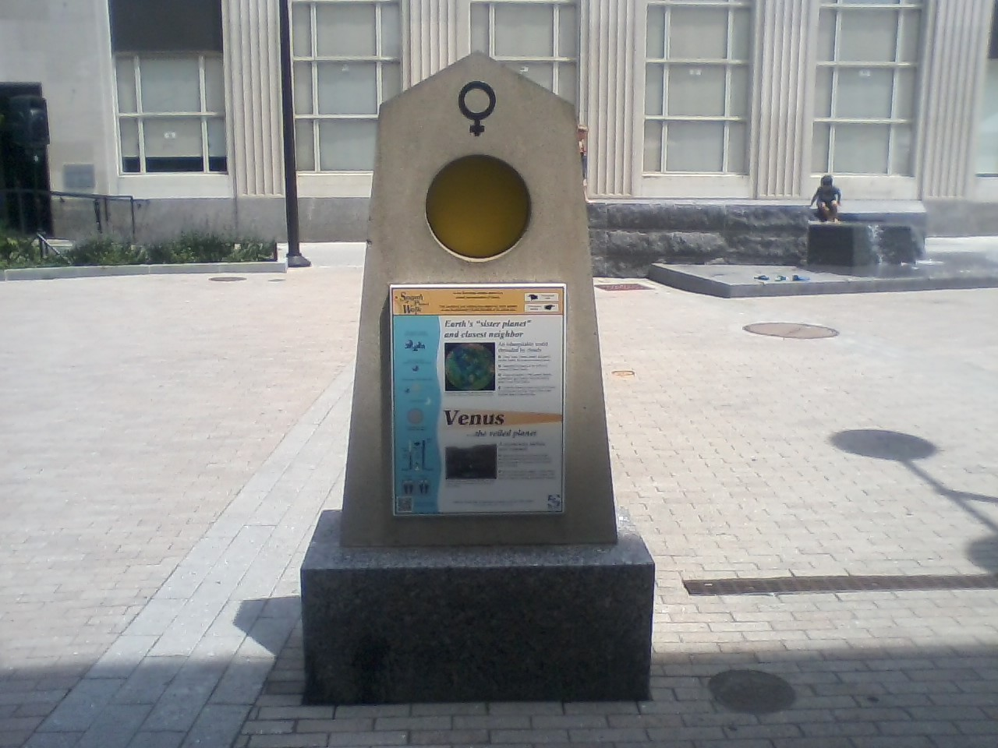

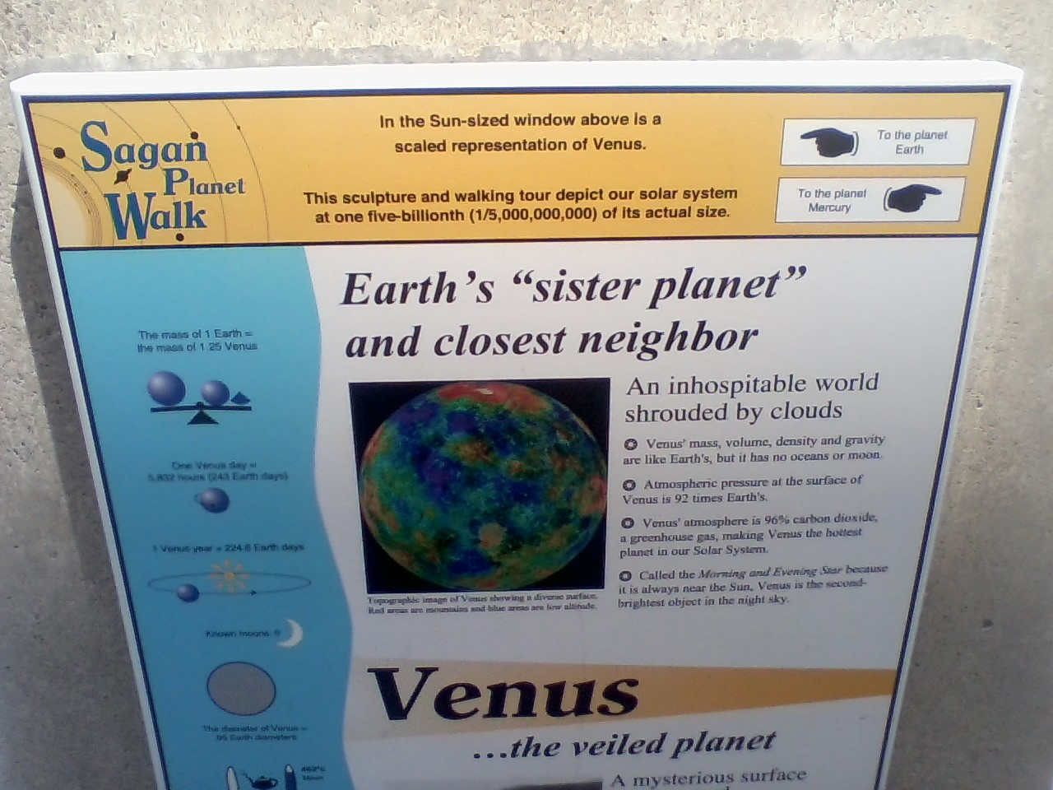
Attachment 1
Page 2 of 4

This public display above asserts the following:

“Venus’ atmosphere is 90% carbon dioxide, a greenhouse gas,
making Venus the hottest planet in the Solar System.”

That wording implies (as does the ongoing nonsense spewed by so-called climate scientists and their assets in the NGO news media) a direct cause-and-result relationship. That the cause of Venus being “the hottest planet in the Solar System,” is directly caused by its high carbon dioxide atmosphere. Nothing could be further from the truth. But similar to others of its kind, note that this Ithaca, New York display is targeting the innocent . . . the common woman and man and child.

We are far beyond the status that such is merely astronomical rubbish; we are well into outright fraud. This is especially egregious in the context of Cornell University’s otherwise unmatched and laudable contributions to Space Science.

The outrage is further justified by the fact that Cornell University astronomers and cosmologists are all in receipt-of or have access-to the enormous amounts of data and detailed reports that resulted from the American and Russian probes to the planet Venus; the planet that currently occupies the second orbital position from the Sun.

For example, in a recent news program, Cornell B.S. degreed mechanical engineer Mr. Bill Nye posed the following implicitly fraudulent question:

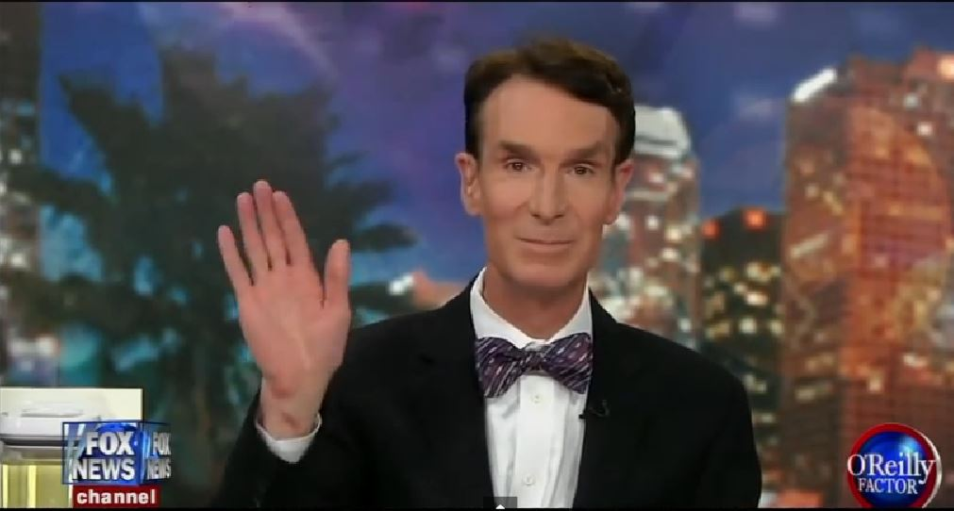

“Do you agree that the planet Venus is warm because it has a lot of carbon dioxide in its atmosphere? And when I say warm, I mean warm enough to melt lead on its surface. Do you agree with that?”

Of course not. But to understand that Nye’s question is a ruse, and that the hype from Al Gore, that he too is “saving us from the hellish fate of Venus!” . . . that the “runaway greenhouse effect” . . . is laughable . . . the following four-point introduction to basic Venusian science is offered.
Attachment 1
Page 3 of 4

Point 1 : As kindergarteners know, hot air rises. When greenhouse manufacturers offer temperature control, their primary mechanisms are vents located AT THE VERY TOP where the temperature reaches maximum, and control is most effective.

When measuring the temperature gradients inside a greenhouse, one finds that the highest readings are at the top, and the lowest are at the floor.

Is this what the American and Russian probes showed regarding the hyped “runaway greenhouse effect” forcefully alleged as the cause of high temperatures on planet Venus?

Of course not . . . in fact . . . as is WELL-KNOWN to Cornell astronomers . . . the Venusian probes confirmed the exact opposite! As the probes approached the outer/upper atmosphere of Venus, initial temperature readings were taken; as the probes descended, the temperature data acquisition continued . . . and these showed increases, not a decrease ala the expected thermodynamics of a greenhouse.

Point 2 : The other data acquisition conducted by the Venusian probes, and this is very important, was measurements of the solar irradiance or energy arriving from the Sun . . . the alleged culprit that heats Venus, allowing the other culprit, CO2, to trap that solar heat; the so-called greenhouse effect.

As is well-known to Cornell astronomers, the behavior of solar heating of any planet or moon relies on the physical concept called albedo . . . NASA defines albedo as follows:

“Albedo is ratio of the light received by a body to the light reflected by that body. Albedo values range from 0 (pitch black) to 1 (perfect reflector).”

NASA lists the albedo of Venus as 0.84 . . . in my opinion a low estimate . . . this value states that of the 100% solar radiation reaching Venus (from the Sun), a full 84% is NOT absorbed to effect a greenhouse effect, but is instead reflected. It would be like painting the roof of the greenhouse pictured above with a nice thick coat of white paint!

Point 3 : Perhaps the most important rebuttal, to the fraud that Venus is suffering from a “runaway greenhouse effect,” is what is called energy flux. Applied to the planet Venus, this term refers not only to a magnitude of energy flow, but also to its direction.

As is well-known to Cornell astronomers . . . the amount of energy that is arriving from the Sun TO Venus is miniscule when compared to the energy, especially heat energy, that is being transmitted FROM Venus. In fact . . . the amount of heat energy coming from Venus is orders-of-magnitude higher than what is alleged to be sourced/caused by its alleged greenhouse effect:

Specifically, the amount of heat pouring from Venus is internally generated . . . not externally stimulated by the 16% solar albedo / CO2 greenhouse effect thesis. Venus is its own heat source! To understand Venusian physics, its true genesis must be understood; Point 4 follows.
Attachment 1
Page 4 of 4

Point 4 : A recent headline in the NGO news media read:

Hawking attacks Trump: US president will cause ‘250 degree temperatures - like VENUS’

Professor Stephen Hawking has sent a strong warning to President Donald Trump by stating the businessman-turned-politician’s stance on environmental issues could DESTROY Earth and leave it with similar conditions to Venus.

Utterly shameless . . . the underlying implication promoted by Hawking, and the global warming condominium, is that ‘Venus is a “Sister Planet to Earth.’ It is not. This scientifically baseless but highly subjective deployment amounts to psychosociological exploitation to the point of ponerology.

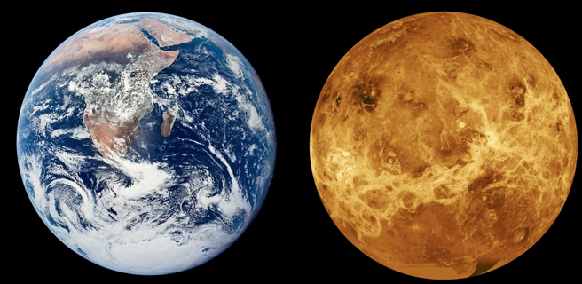

As a very brief introduction to this scientific fact, I have enclosed a dvd copy of a talk given by science writer and investigator Mr. Charles Ginenthal:

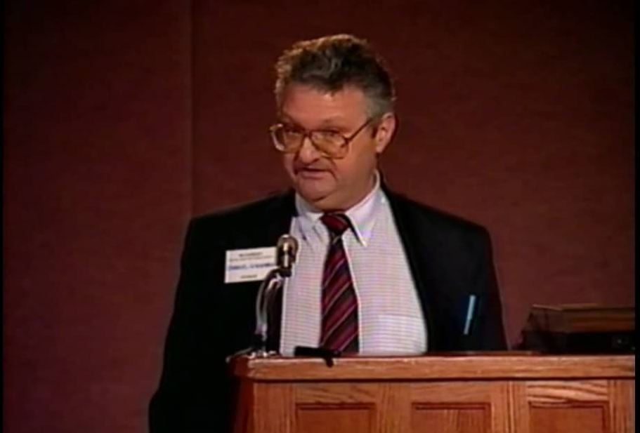

Mr. Ginenthal’s talk is also widely available on the internet, search: Charles Ginenthal on Venus

END OF DOCUMENT

21 July 2017

President Donald J. Trump
The White House
1600 Pennsylvania Ave NW
Washington, DC 20500
202-456-1111

Subject 1: Withdrawal from the Paris Climate Accord

Subject 2: Upcoming Tyrannical Censorship of Climate Science Instigated by NGOs

Electronic Copy Available at: http://pvsheridan.com/Sheridan2Trump-3-21July2017.pdf

