Hospital Protocols During COVID-19 Pandemic That Led to “vaccine” Injury and Death

Homeland Security – Government Affairs – Permanent Subcommittee on Investigations ;
Chairman Senator Ron Johnson, Ranking Member Senator Richard Blumenthal

Joint Testimony: Former Medical Assistant, Mrs. Jummai Nache and Pastor Dr. Philip Nache

My name is Mrs. Jummai Nache. My family and I emigrated from Nigeria in TBD, and became naturalized United States citizens on 15 August 2025. I am a former Medical Assistant at the University of Minnesota Health System (UMinn). I was employed at UMinn from July 2019 until September 2021.

The cessation of my medical career is the direct result of hospital protocols coerced by my employer, upon both patients and hospital staff, subsequent to the granting of an Emergency Use Authorization (EUA) by the Food & Drug Administration (FDA) on 11 December 2020. That EUA was granted for what Pfizer, government officials, and my former employer (UMinn) promoted as a “vaccine” for COVID-19.

Throughout my UMinn Medical Assistant work, my hospital employer demanded that the only remedy for combatting the COVID-19 virus disease was a vaccine. At no time did UMinn disclose that they were directly involved in censorship of non-vaccine remedies. UMinn did not disclose to their nursing staff that they were funding the Surgisphere research that was conducted for quashing information regarding hydroxychloroquine. Dr. Anthony Fauci was interviewed by Politico wherein he praised the Surgisphere research, derided hydroxychloroquine, but then emphasized that a “vaccine” was in trials beginning in January 2020 (?!). Later the UMinn/Surgisphere research was deemed “falsified,” and was so flawed, that it was retracted by all publication platforms, including Lancet.

The testimony proposed by Pastor Dr. Philip Nache and I, will not profess expertise in vaccinology. But the UMinn/Surgisphere scandal is contextual to the illicit, tyrannical and BigPharma-entangled behaviors of my former employer. Our hospital protocols testimony will detail why, administratively, our “vaccine” injury occurred. Unlike other COVID-19 hospital protocol/BigPharma victims, we survived :

  Mrs Nache pre-Pfizer modRNA | 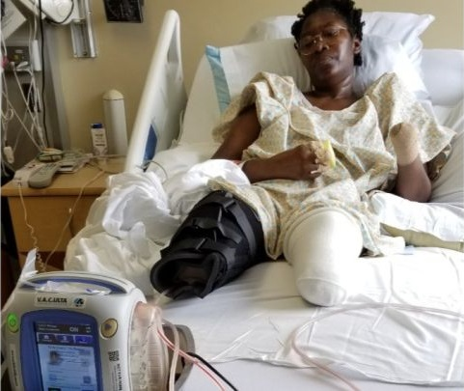  Mrs Nache after hospital-mandated Pfizer modRNA |   Mrs Nache and Pastor Nache on prosthetic limbs

SUMMARY: In January 2021 the UMinn hospital administrators announced that employees that did not submit to their “vaccine” mandate would be terminated, regardless of performance history, COVID-19 test negative results, or overall health status. Our brief testimonial summary next:

If the UMinn hospital administrators had disclosed their knowledge of the fact that (1) the COVID-19 needle was NOT a vaccine; that in truth it was an experimental gene therapy technology, (2) that under the EUA (of mere weeks earlier) the modRNA was shielded by LIABILITY IMMUNITY, and therefore (3) we were offered basic Nuremberg levels of INFORMED CONSENT; we would have refuted the UMinn hospital employment dismissal coercion, and forfeited the Medical Assistant position in the name of ongoing perfect health.

