22357 Columbia Street

Dearborn, MI 48124-3431

607-280-9790 / pvs6@cornell.edu

8 February 2025

|  |  |  |
| --- | --- | --- |
| Addressees | | Courtesy Copy |
| Ms. Martha E. Pollack  c/o Office of the President  300 Day Hall  Cornell University  Ithaca, NY 14853  607-255-5201 Hand Delivery | Mr. Kraig Kayser  c/o Office of General Counsel  Cornell University  118 Sage Place  Ithaca, NY 14850  607-255-5124 Hand Delivery | President Donald J. Trump  The White House  1600 Pennsylvania Ave NW Washington, DC 20500  202-456-1111 UPS  Cover letter only |

**Subject : Your True “Contribution” and True Legacy of Inflicting Embarrassment, Inveracity and Criminality Upon My Alma Mater - Cornell University**

Dear Mr. Kayser / Ms. Pollack :

You are already in possession of *some* of the documentation that supports the Subject. Not limited to my *many* letters, the public record is also rife with similar evidence, involving a variety of issues. Transgender beagles?! (See Page 3 below)

Interestingly, but not unpredictable, thee central character that ostensibly requested and received your abject servility is pictured here:

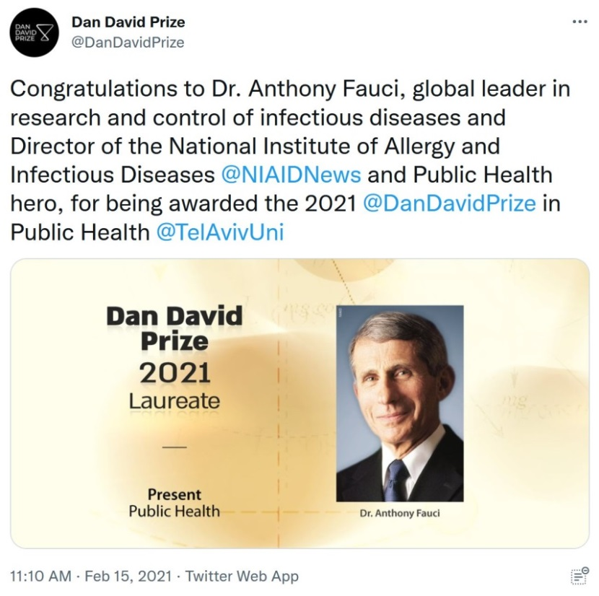

**MEMO :** That award date of early 2021 is connectable to the early 2021 contracts enforced upon nations that did not offer LIABILITY IMMUNITY; a legal ruse that shielded the manufacturers of the modRNA poisons . . . poisons that you repeatedly declared were *“95% safe & effective.”*

8 February 2025 Ms. Martha Pollack / Mr. Kraig Kayser

Page 2 of 9

**MEMO conclusion :** My letter to Mr. Douglas Lankler, Cornell Law School graduate and Counsel to Pfizer CEO Mr. Albert Bourla, discusses the Supply Agreement verbiage used exclusively wherein the nation in-focus did not offer LIABILITY IMMUNITY:

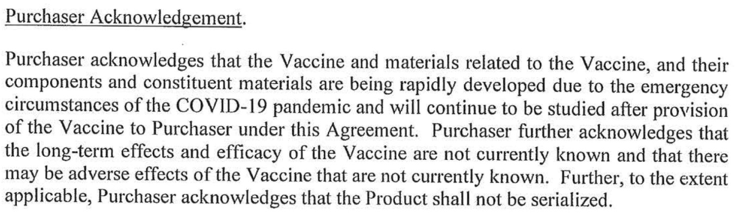

The date of the above Albert Bourla/Pfizer contract, and *many* more like it, is 30 March 2021.

***“Purchaser further acknowledges that the long-term effects and efficacy of the Vaccine are not currently known . . . ” ??!!***

***“ . . . there may be adverse effects of the Vaccine that are not currently known” ??!!***

***“95% safe & effective”?!*** The Supply Contract ‘Purchaser Acknowledgement’ was well-known to you Ms. Pollack; you were directly connected to Mr. Bourla throughout 2020/2021:

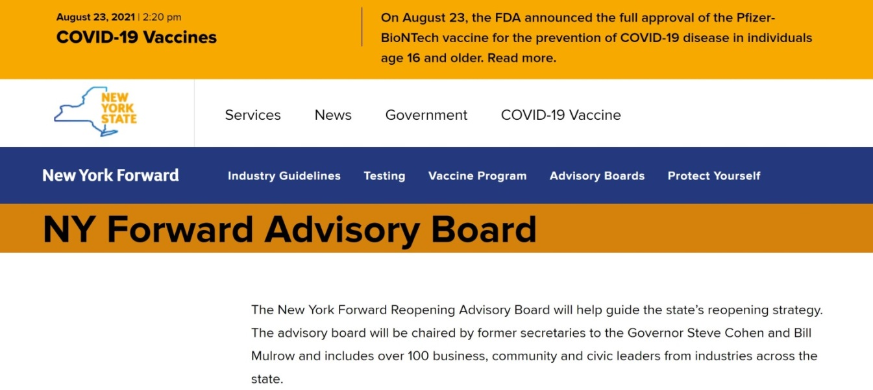

Again, during the time that Cornell Medical College graduate Mr. Anthony Fauci was accepting the DanDavid Prize, he and you two were “navigating” the mandating of the Pfizer modRNA poisons upon the staff, faculty and students of my alma mater . . . while simultaneously being fully aware that Bourla/Pfizer were demanding the above 30 March 2021 go-around in situations where LIABILITY IMMUNITY was not available.

8 February 2025 Ms. Martha Pollack / Mr. Kraig Kayser

Page 3 of 9

**$20,000,000,000.00 Transgender Beagles : Complements of Mr. Anthony Fauci**

On 6 February 2025, the House Oversight Committee held a hearing on the horrific torture inflicted upon mice, dogs, cats, and monkeys by Anthony *“I am science”* Fauci. It is now documented that over 20 billion US taxpayer dollars was secretly expended on the torture of beagles alone!

In prior sworn testimony, Mr. Fauci adamantly denied knowing or in-any-way being directly involved with such. **However, the person whose Cornell medical degree I have demanded be revoked . . . Not only was he involved; he was “personally” involved. Mr. Fauci is a liar.**

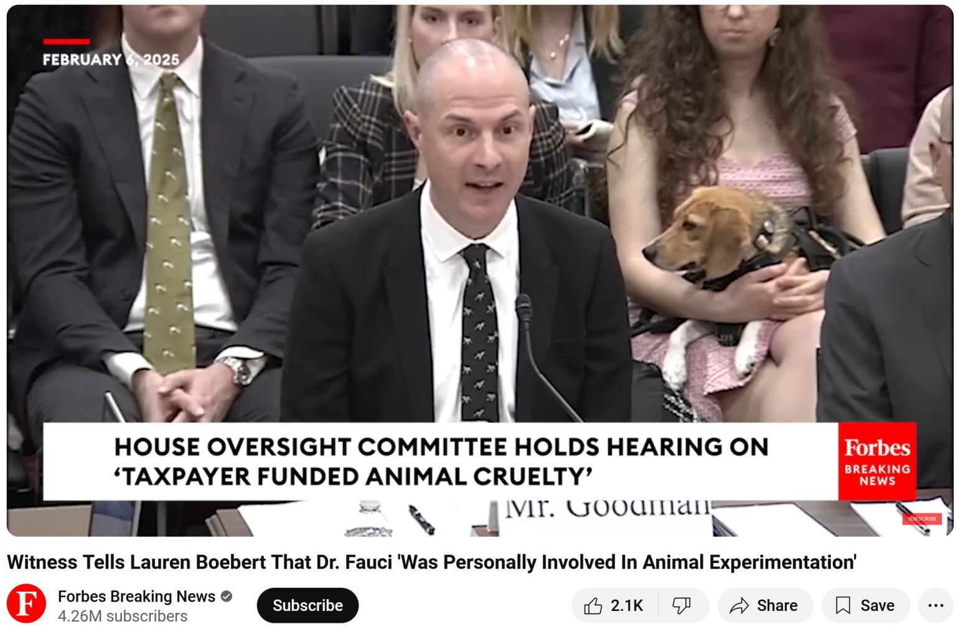

In lockstep with Ms. Pollack’s prior personal involvement at the University of Michigan, these experiments included sex change operations, hormone “therapy,” the transgendering of innocent beagle puppies and even mice! Although animal pronouns were not researched, when asked about the transfer to human health & well-being, the expert panel described such as follows:

**“Zero.”**

The overleaf insinuates that your “contribution” to these perversions is long-standing and preferred by the endorsed Cornell Board of Trustees . . . exactly what characterized USAID . . . and typifies the servility that someone as grotesque as Mr. Fauci would appreciate.

8 February 2025 Ms. Martha Pollack / Mr. Kraig Kayser

Page 4 of 9

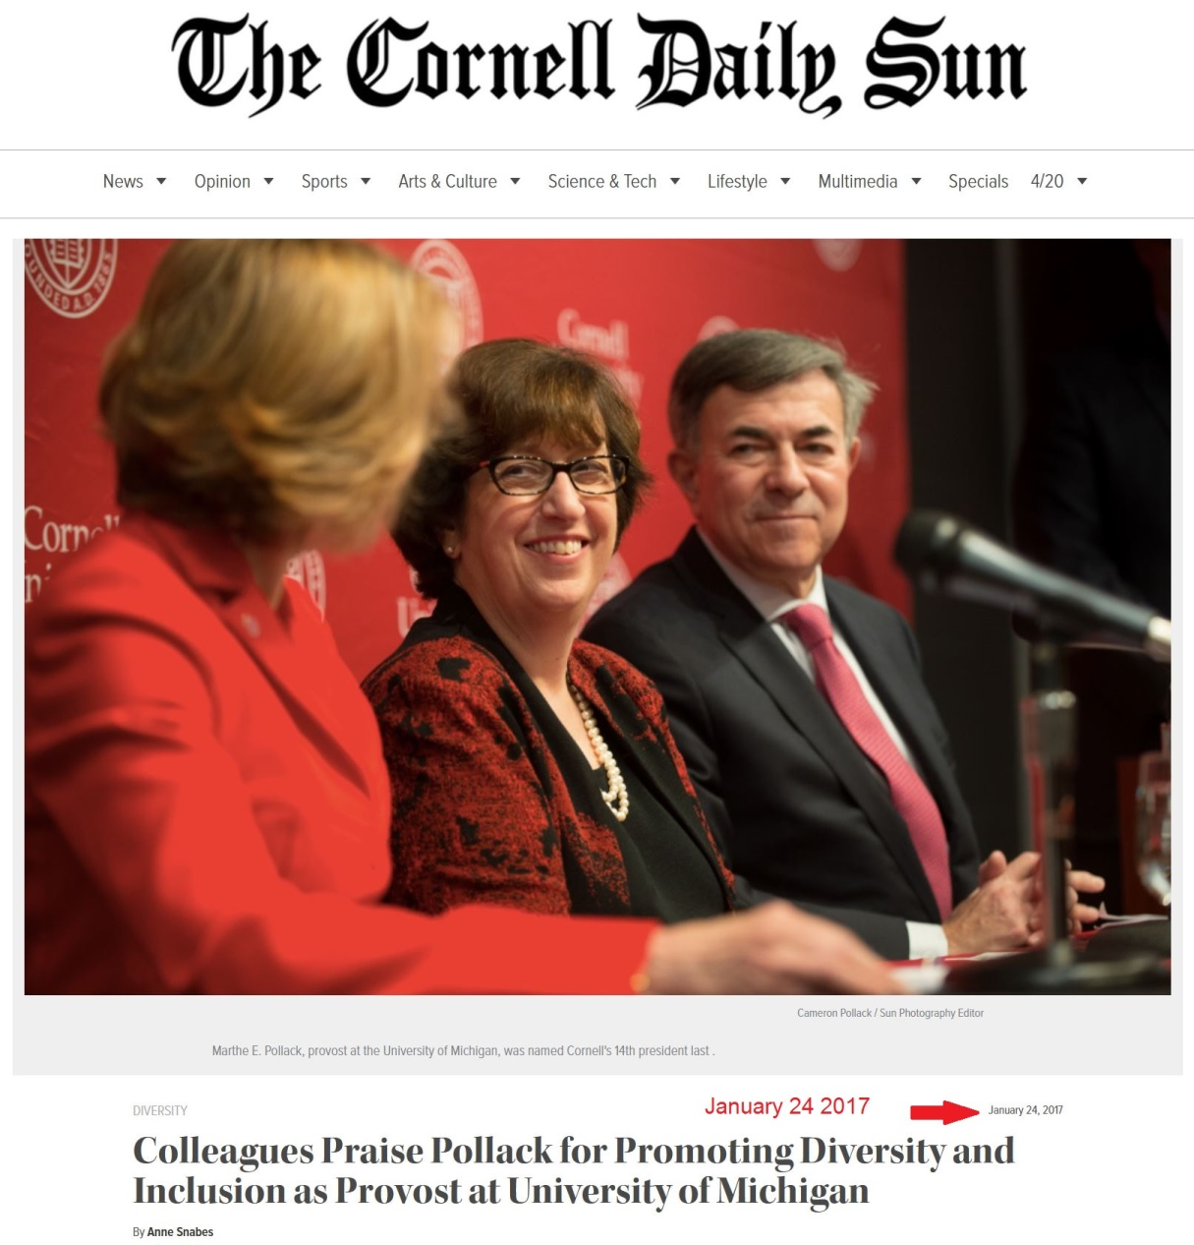

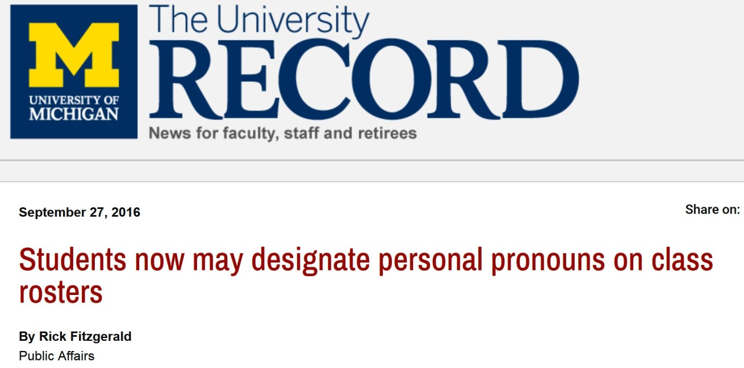

8 February 2025 Ms. Martha Pollack / Mr. Kraig Kayser

Page 5 of 9

**Commemoration**

None of your words and deeds, especially regarding COVID-19, resulted from incompetence; all were conscious and purposeful. To *further* commemorate your “contribution” and true legacy of inflicting embarrassment, inveracity and criminality upon my alma mater, I am enclosing:

1. The Biden Executive Order pardoning the terrorist Mr. Anthony Fauci who **has not yet**

**been charged and/or convicted**, but is well-known for his guilt for crimes against humanity, medical malpractice, fraud, perjury before the US Senate, animal cruelty, etc.

1. My letter of 28 May 2024 to Cornell Law School graduate Mr. Doug Lankler, Legal Counsel to Pfizer Inc. (See Page 2 above).
2. The Executive Order of 20 January 2025 issued by President Donald Trump entitled:

DEFENDING WOMEN FROM GENDER IDEOLOGY EXTREMISM AND RESTORING BIOLOGICAL TRUTH TO THE FEDERAL GOVERNMENT

1. The Executive Order of 20 January 2025 issued by President Donald Trump entitled:

RESTORING FREEDOM OF SPEECH AND ENDING FEDERAL CENSORSHIP

1. The Executive Order of 28 January 2025 issued by President Donald Trump entitled:

PROTECTING CHILDREN FROM CHEMICAL AND SURGICAL MUTILATION

1. The Executive Order of 5 February 2025 issued by President Donald Trump entitled:

KEEPING MEN OUT OF WOMEN’S SPORTS

1. A special wearable gift commemorating your dedication and servility in-behalf of, *not a loyal Cornell alumnus of 45 years,* but instead to a bunch of New World Order psychological, economic, sociological (ponerological), and spiritual parasites.

**Condolences**

Enclosure #4 connects to the recent, foreseeable sudden death of YouTube CEO Ms. Susan Wojcicki. Her predilection for and use of the term “vaccine” (the misnomer promoted by Cornell University as the descriptor for the Pfizer modRNA contraption) led to her COVID-19 “vaccination.” May Jesus forgive her, and retrieve her soul for an eternity in Heaven with Him.

Please feel free to contact me at any time.

Cordially,

Paul V. Sheridan

MBA: Class of 1980

Winner: Civil Justice Foundation National Champion Award

Enclosures

8 February 2025 Ms. Martha Pollack / Mr. Kraig Kayser

Page 6 of 9

**CONDOLENCES *Page A of D***

**Ms. Susan Wojcicki, Former CEO of YouTube –**

**Death Victim of COVID-19 modRNA “vaccine”**

***“Susan has been at the forefront of censoring ‘medical misinformation’ on the Google platform and also promoting the Covid vaccine to billions of people.”*** (see Page C below)



8 February 2025 Ms. Martha Pollack / Mr. Kraig Kayser

Page 7 of 9

**CONDOLENCES *Page B of D***

**Ms. Susan Wojcicki, Former CEO of YouTube –**

**Death Victim of COVID-19 modRNA “vaccine”**

***“Susan has been at the forefront of censoring ‘medical misinformation’ on the Google platform and also promoting the Covid vaccine to billions of people.”*** (see Page C below)

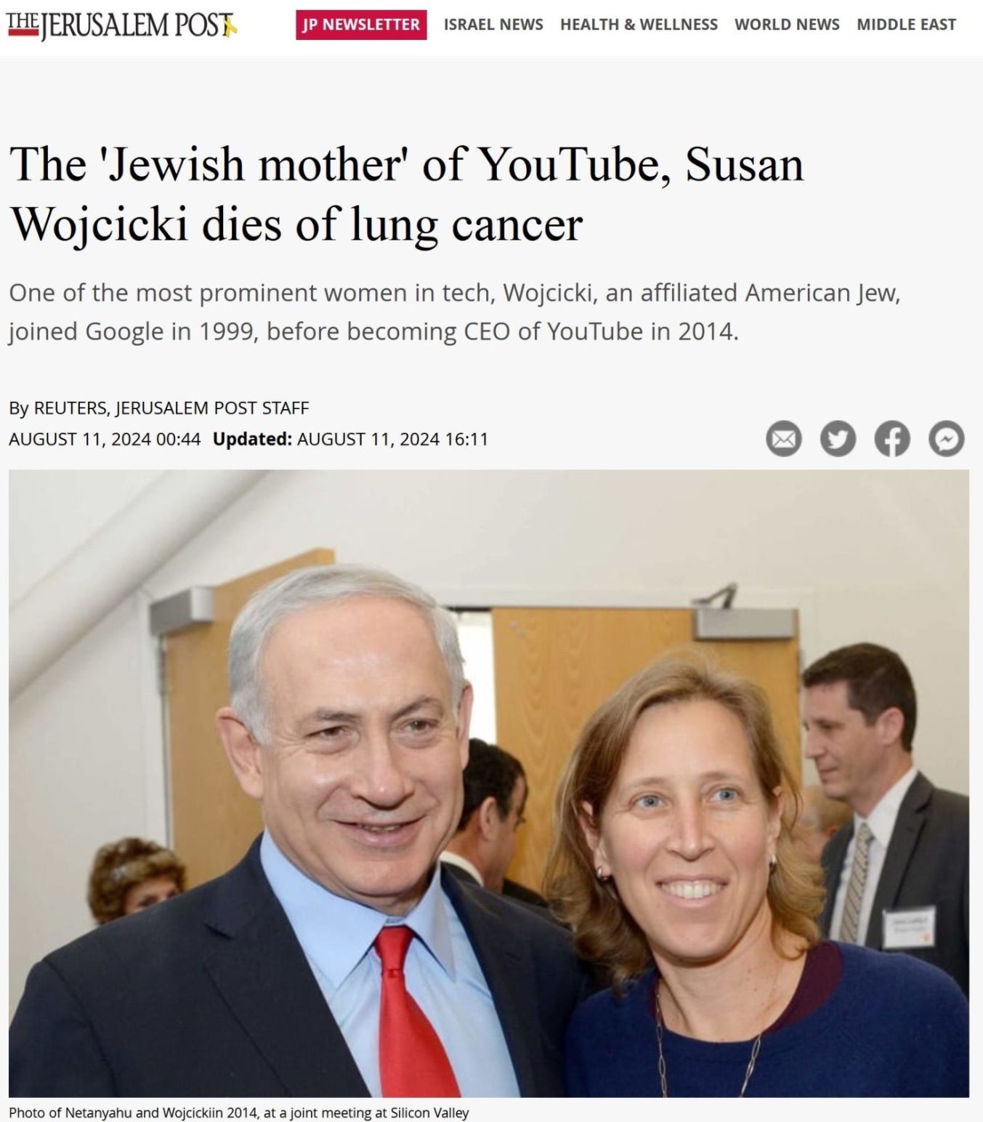

8 February 2025 Ms. Martha Pollack / Mr. Kraig Kayser

Page 8 of 9

**CONDOLENCES *Page C of D***

**Ms. Susan Wojcicki, Former CEO of YouTube –**

**Death Victim of COVID-19 modRNA “vaccine”**

***“Susan has been at the forefront of censoring ‘medical misinformation’ on the Google platform and also promoting the Covid vaccine to billions of people.”*** (see Page 4 below)

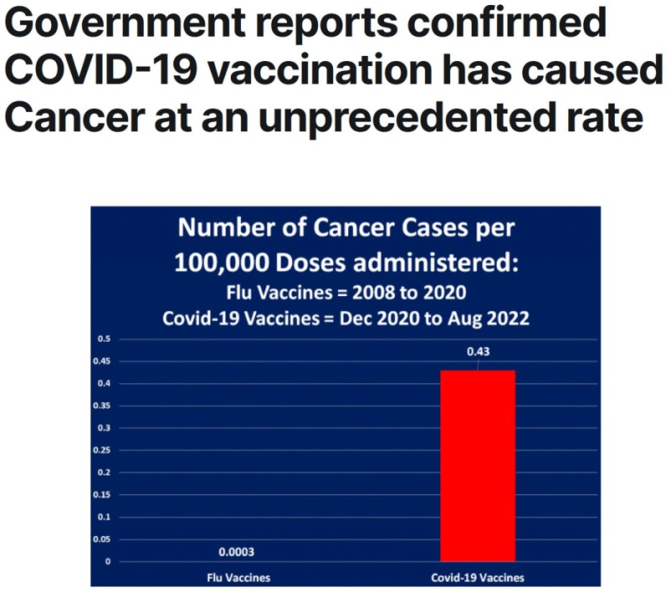

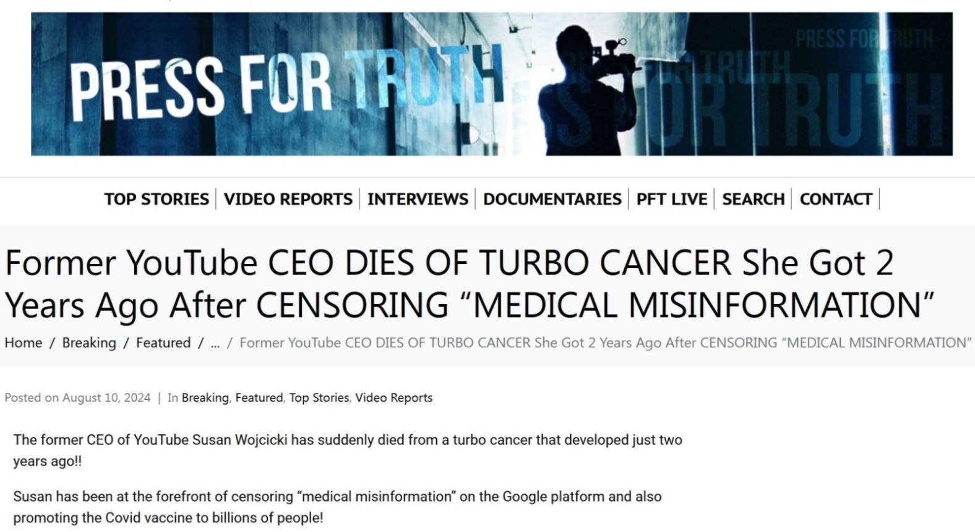

8 February 2025 Ms. Martha Pollack / Mr. Kraig Kayser

Page 9 of 9

**CONDOLENCES  *Page D of D***

**Ms. Susan Wojcicki, Former CEO of YouTube –**

**Death Victim of COVID-19 modRNA “vaccine”**

***“Susan has been at the forefront of censoring ‘medical misinformation’ on the Google platform and also promoting the Covid vaccine to billions of people.”*** (See Page C above)

After uploading my interview, which details how *“willful misconduct”* voids liability immunity . . .

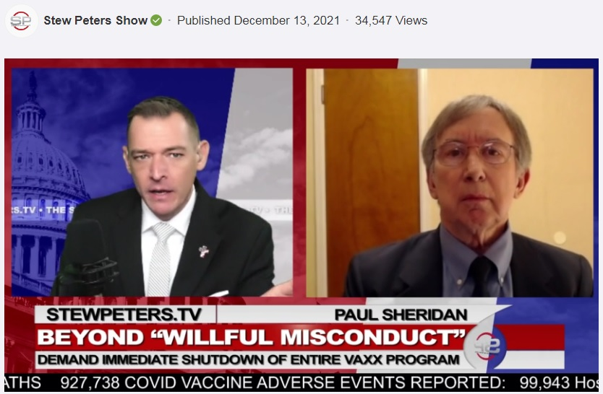

. . . I received the following notice from YouTube, from Ms. Wojcicki :



**. . . my interview did no such thing.**